Contents
Article I General
Article II Base Zoning Districts
Article III Overlay Zoning Districts
Article IV Uses
Article V Design and Performance Standards
Article VI Signs

ARTICLE II. BASE ZONING DISTRICTS.

Sec. 115-XX. Open Space/Reserve District (OSR).
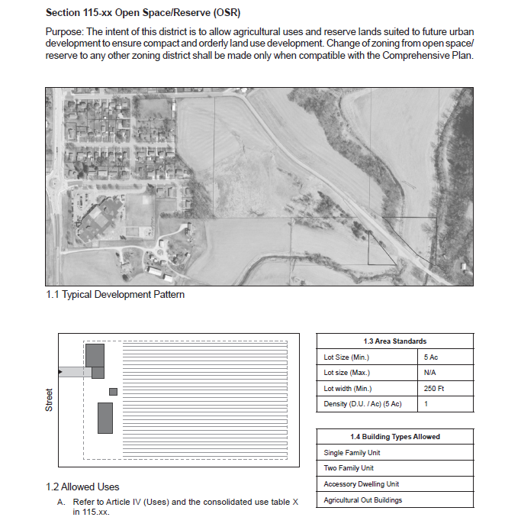

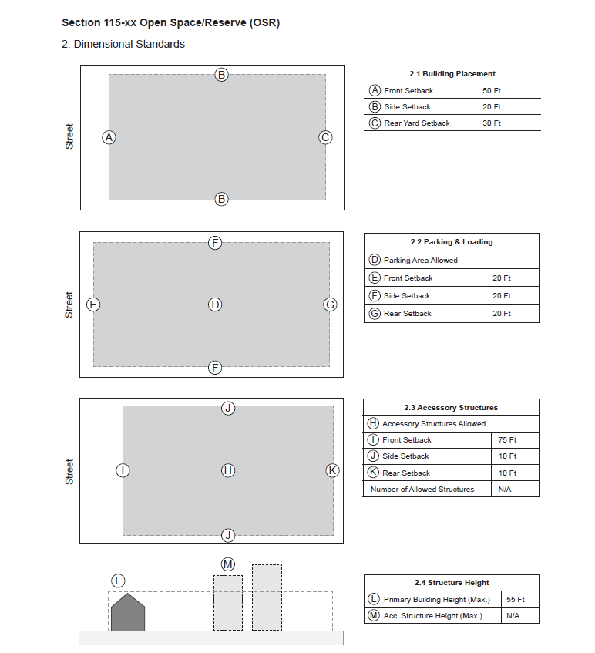

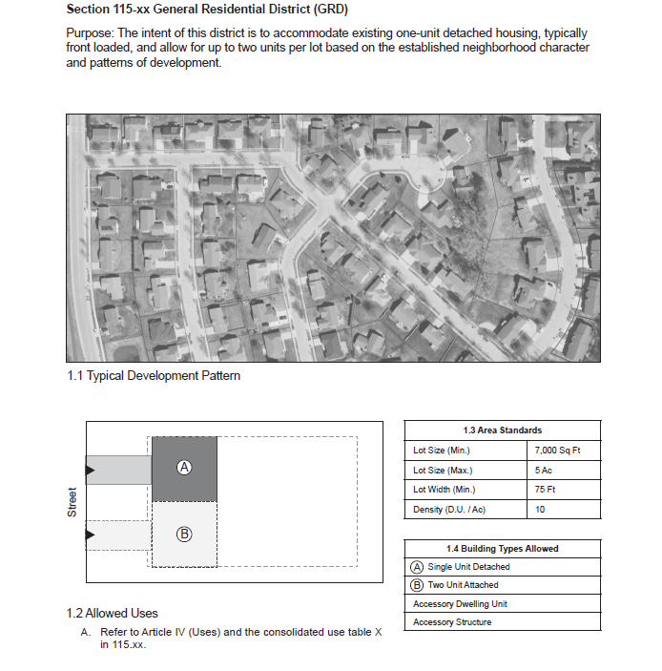
Sec. 115-XX. General Residential District (GRD).

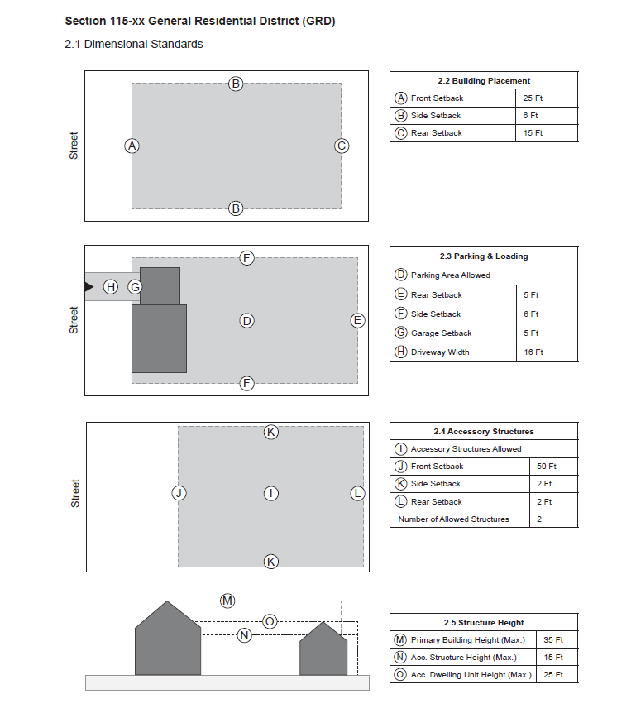
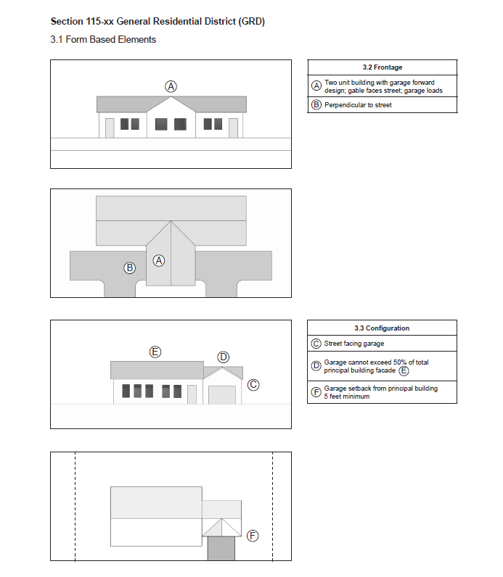

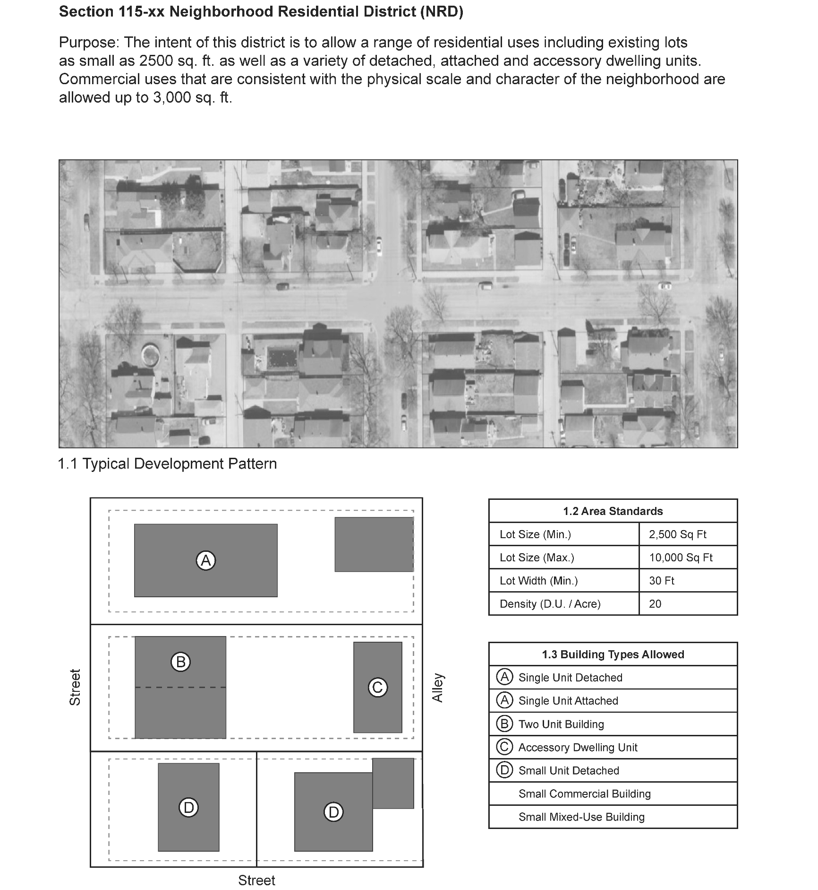
Sec. 115-XX. Neighborhood Residential District (NRD).

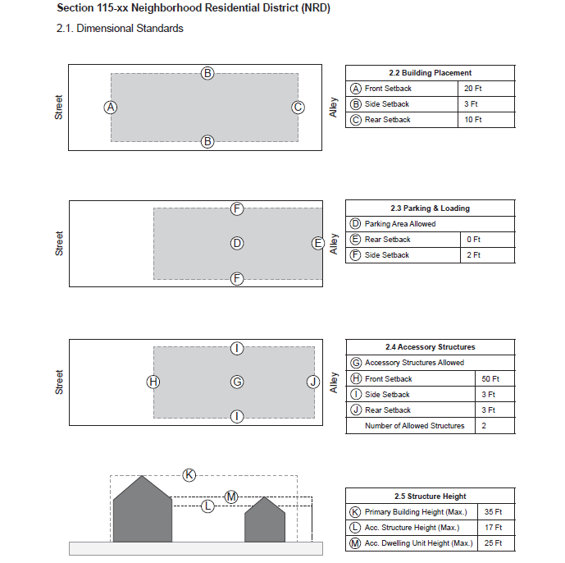

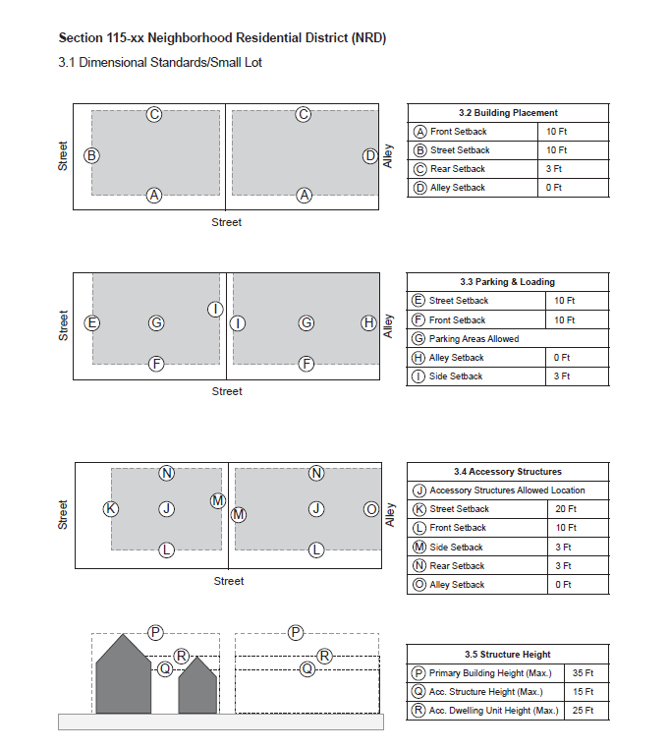

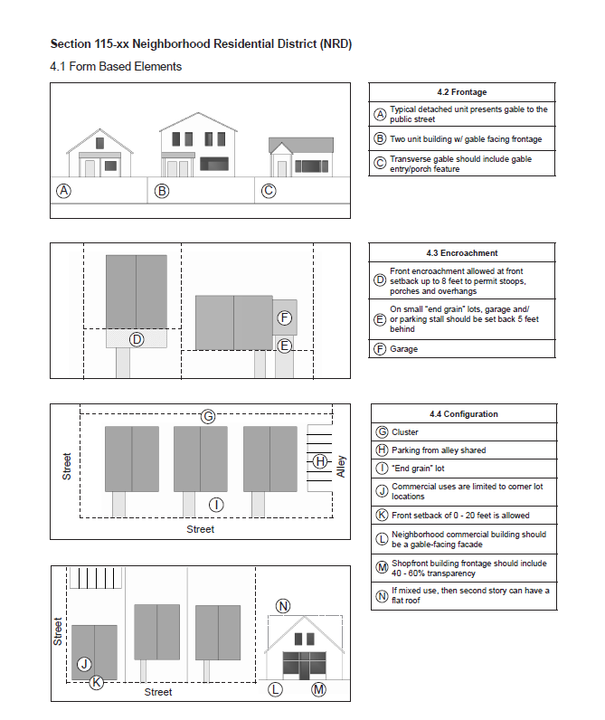

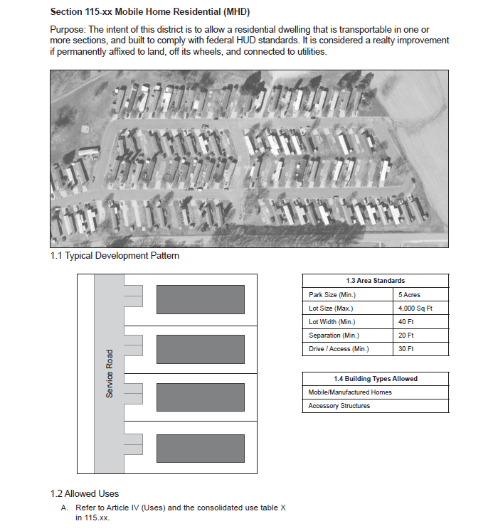
Sec. 115-XX. Mobile Home Residential District (MHD).

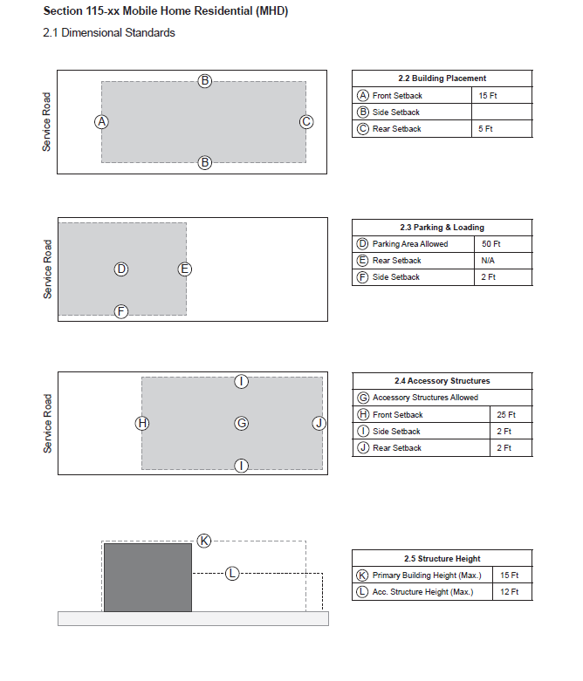

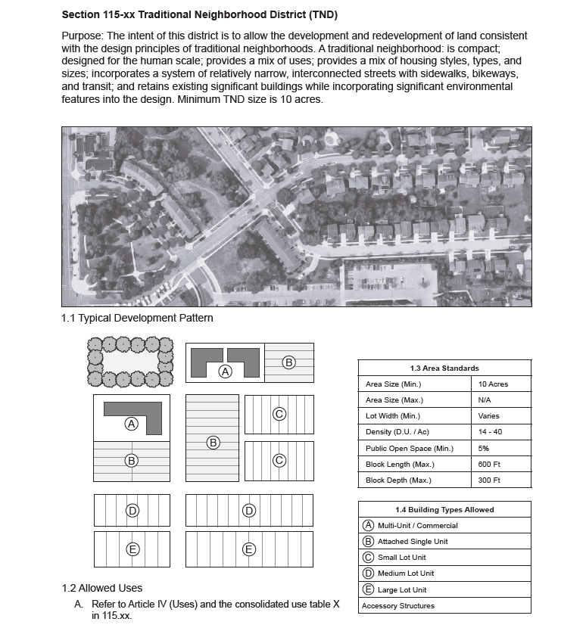
Sec. 115-XX. Traditional Neighborhood Development District (TND).

TND Design Standards. In the Traditional Neighborhood Development District there shall be no predetermined specific lot size, lot width, height, bulk or floor area ratio, yard, usable open space, sign and off-street parking requirements but are determined as part of an approved specific and precise comprehensive development plan and shall be, along with the plan itself, construed to be and enforced as a part of this section. Height, yard, vision, setback, parking, lot coverage, and other related standards applicable to similar uses in other comparable zoning districts along with neighboring properties shall be considered by the City Plan Commission and the Common Council when reviewing proposed developments under this zoning district.

The Common Council shall have final approval on all proposed developments. The Common Council may approve, deny or amend any proposed development in accordance with subsection (a)(2) of this section.

(1) Traditional Neighborhood Development Uses. A traditional neighborhood development should consist of a mix of residential uses, mixed use areas, and open space.
a. A mix of residential uses of the following types can occur anywhere. For infill development, the mix of residential uses may be satisfied by existing residential uses adjacent to the proposed development.
1.Single-unit detached dwellings, including manufactured homes.
2.Single-unit attached dwellings, including duplexes, townhouses, row houses.
3.Multi-unit dwellings, including senior housing.
4.Accessory dwelling units .
5.Special needs housing, such as community living arrangements and assisted living facilities.
b. Mixed use areas can include commercial, residential, civic or institutional, and open spaces.
1.Commercial uses.
i. Food services. (Neighborhood grocery stores; butcher shops; bakeries; restaurants, cafes; coffee shops; neighborhood bars or pubs);
ii. Retail uses (florists or nurseries; hardware stores; stationery stores; bookstores; studios and shops of artists and artisans);
iii. Services (day care centers; music, dance or exercise studios; offices, including professional and medical offices; barber; hair salon; dry cleaning);
iv. Accommodations (bed and breakfast inns, hotels or motels).
2.Residential uses.
i. Single-unit attached dwellings, including duplexes, townhouses, row houses.
ii. Multi-unit dwellings, including senior housing.
iii. Residential units located on upper floors above commercial uses or to the rear of storefronts.
iv. "Live/work" units that combine a residence and the resident's workplace.
v. "Special needs" housing, such as community living arrangements and assisted living facilities.
3.Civic or institutional uses.
i. Municipal offices, fire stations, libraries, museums, community meeting facilities, and post offices.
ii. Transit stations.
iii. Places of worship.
iv. Educational facilities.
4.Open space uses.
i. Central squares.
ii. Neighborhood parks.
iii. Playgrounds.
iv. Community gardens.
c. Open space uses.
1.Environmental corridors.
2.Protected natural areas.
3.Community parks.
4.Streams, ponds, and other water bodies.
5.Stormwater detention/retention facilities.
6.Community gardens.

(2) Development Density. The number of residential dwelling units and the amount of nonresidential development (excluding open spaces) shall be determined as follows:
a. The number of single-unit attached and detached units permitted shall be four—15 dwelling units per net acre.
b. The number of multi-unit dwellings shall be 15—40 dwelling units per net acre.
c. Accessory dwelling units are calculated into the dwelling's units per acre as stated above.
d. All dwelling units constructed above commercial uses shall be permissible in addition to the number of dwelling units authorized under this section. However, the total number of dwelling units shall not be increased by more than ten dwelling units or ten percent, whichever is greater.

(3) Allowed Uses.
- Refer to Article IV (Uses) and the Consolidated Use Table X in 115-XX.

Sec. 115-XX. Neighborhood Mixed Use District (NMX).
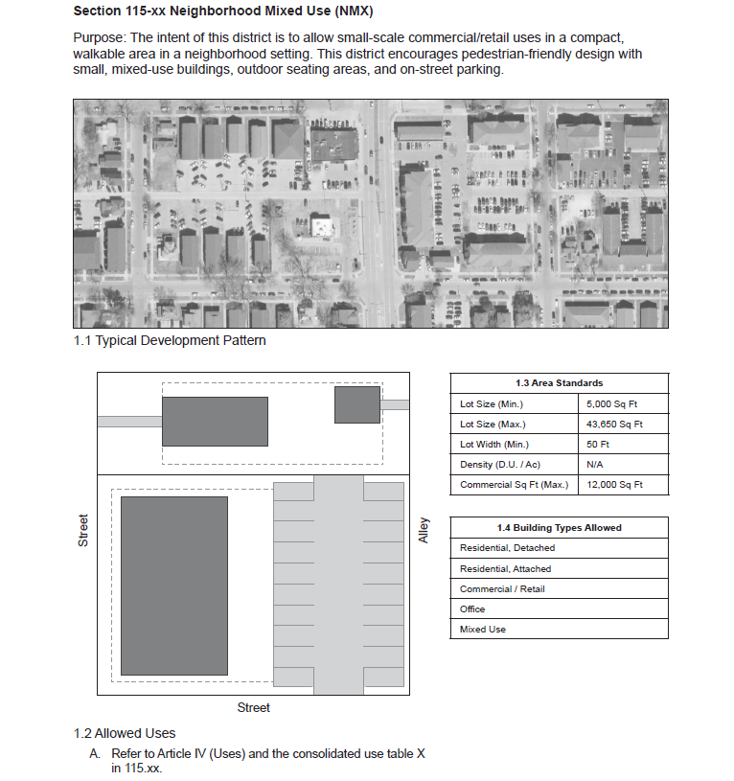

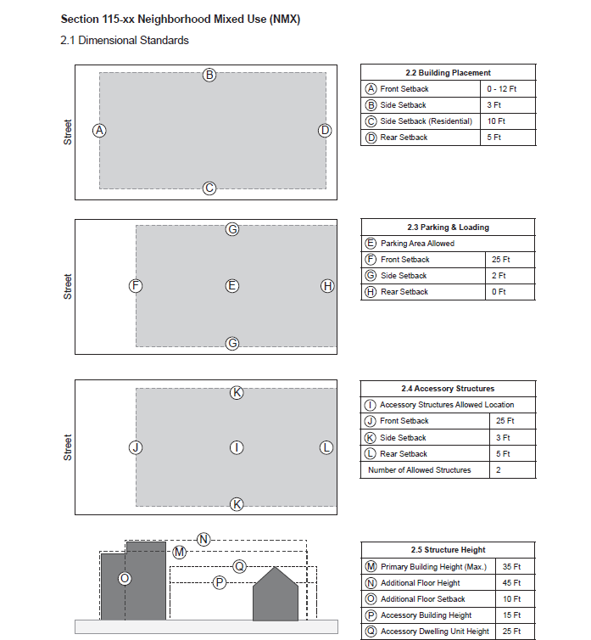
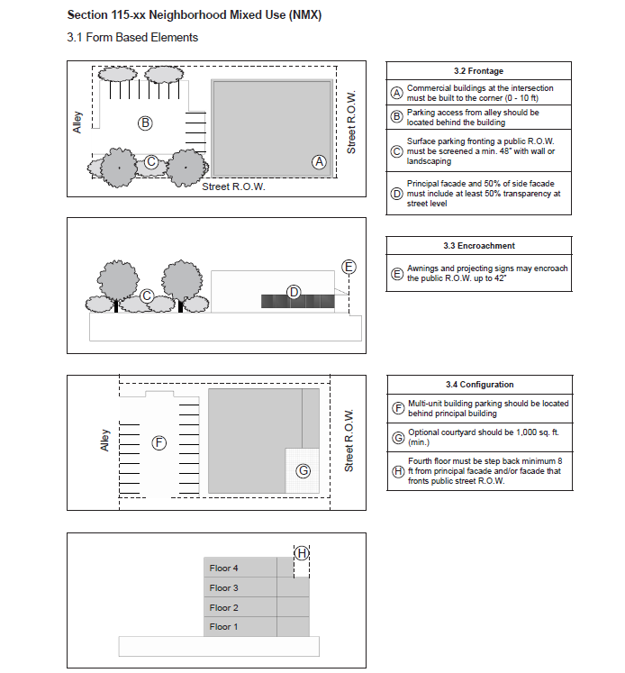

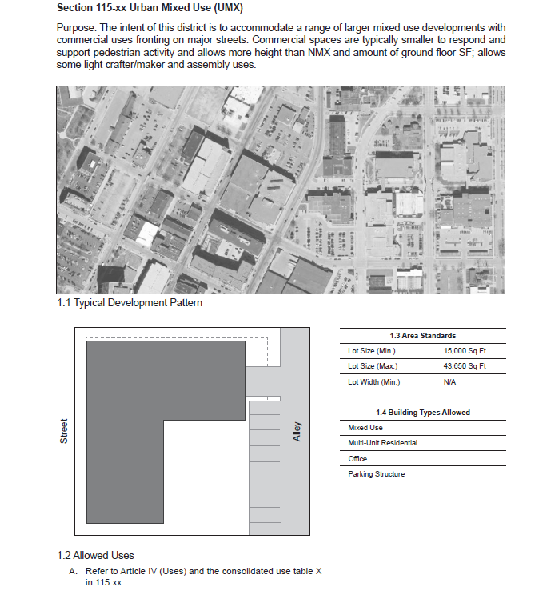
Sec. 115-XX. Urban Mixed Use District (UMX).

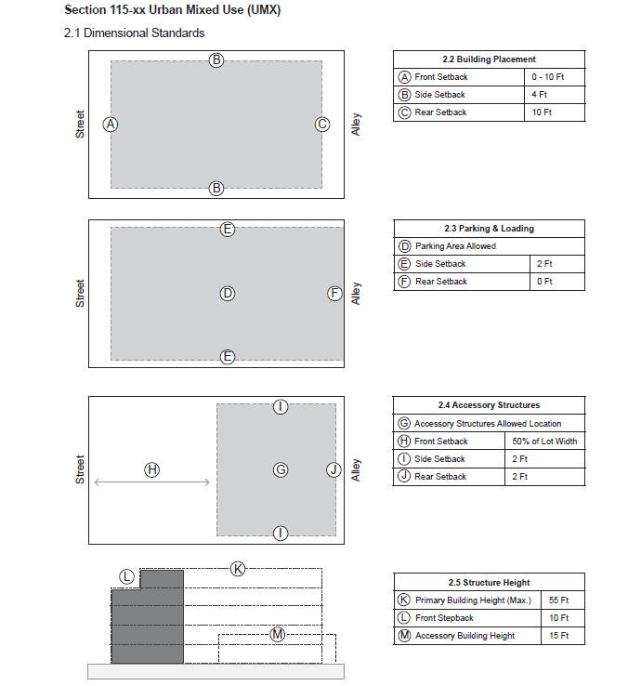
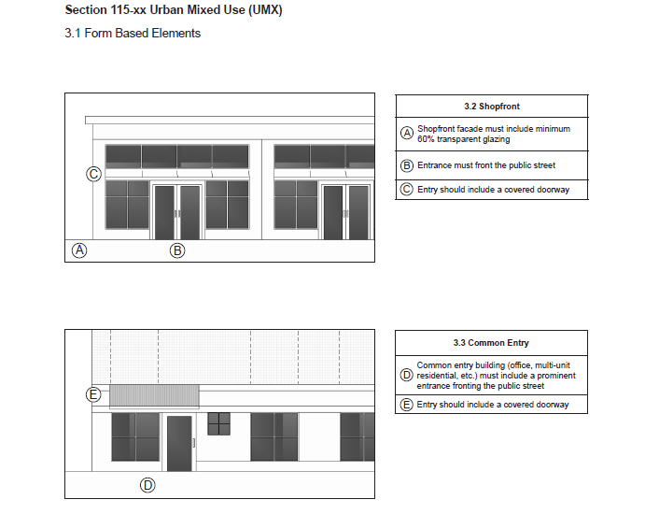

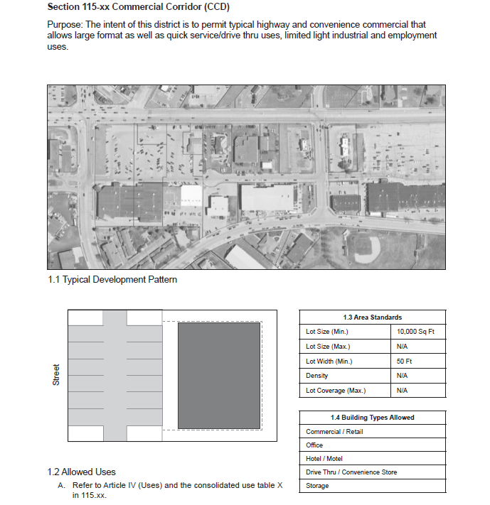
Sec. 115-XX. Commercial Corridor District (CCD).

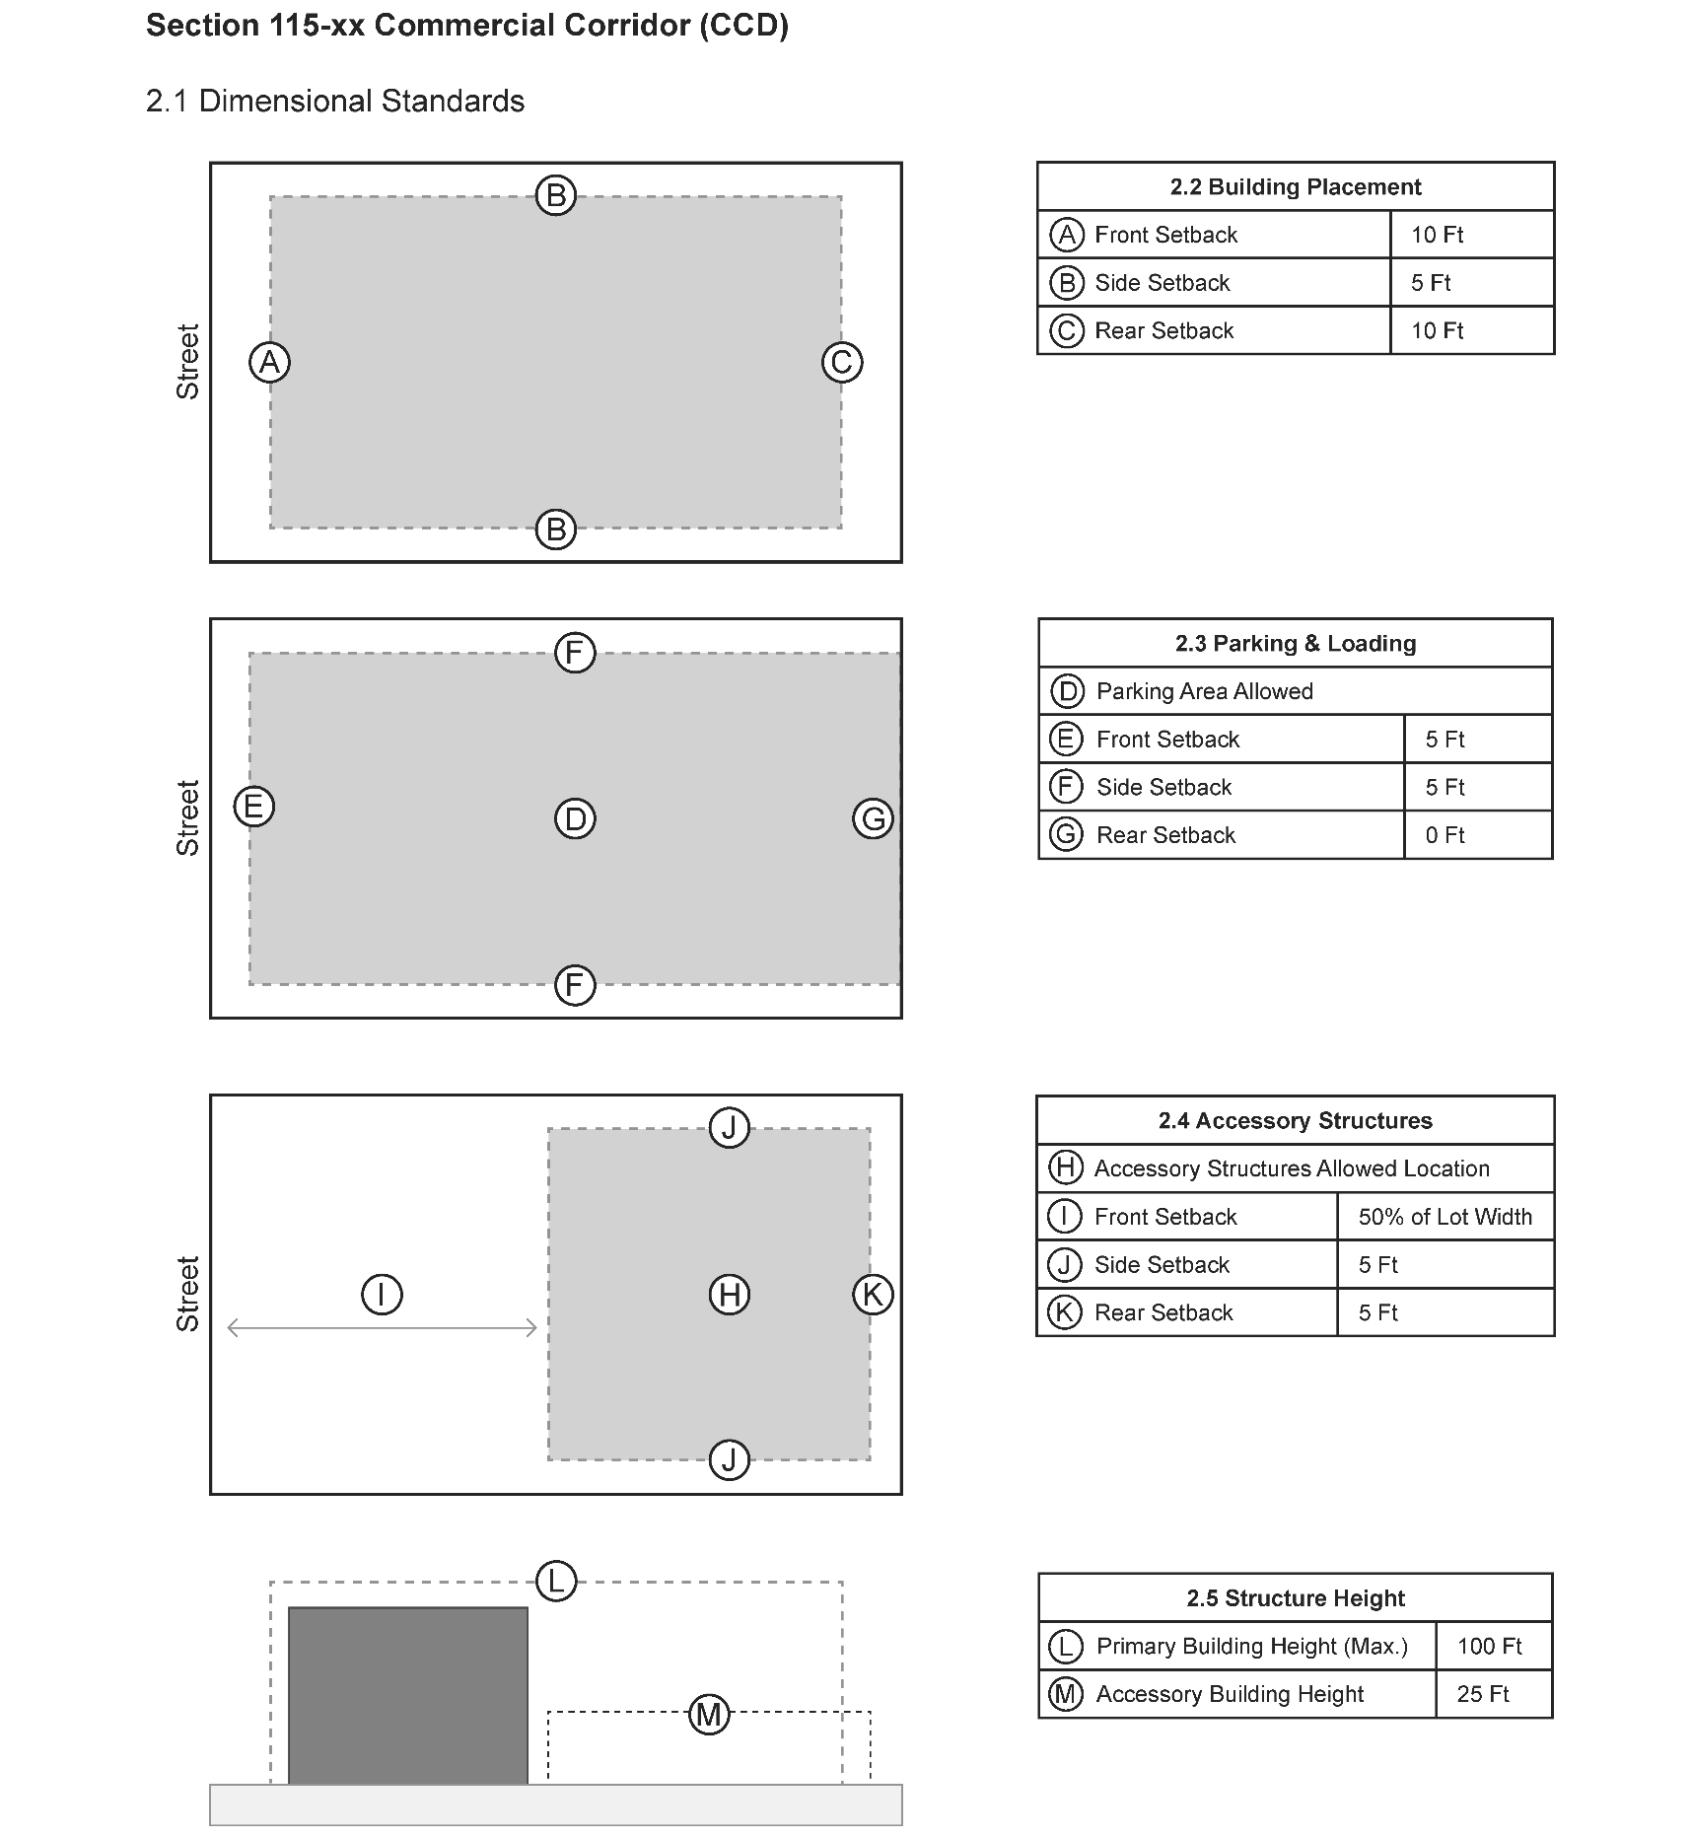

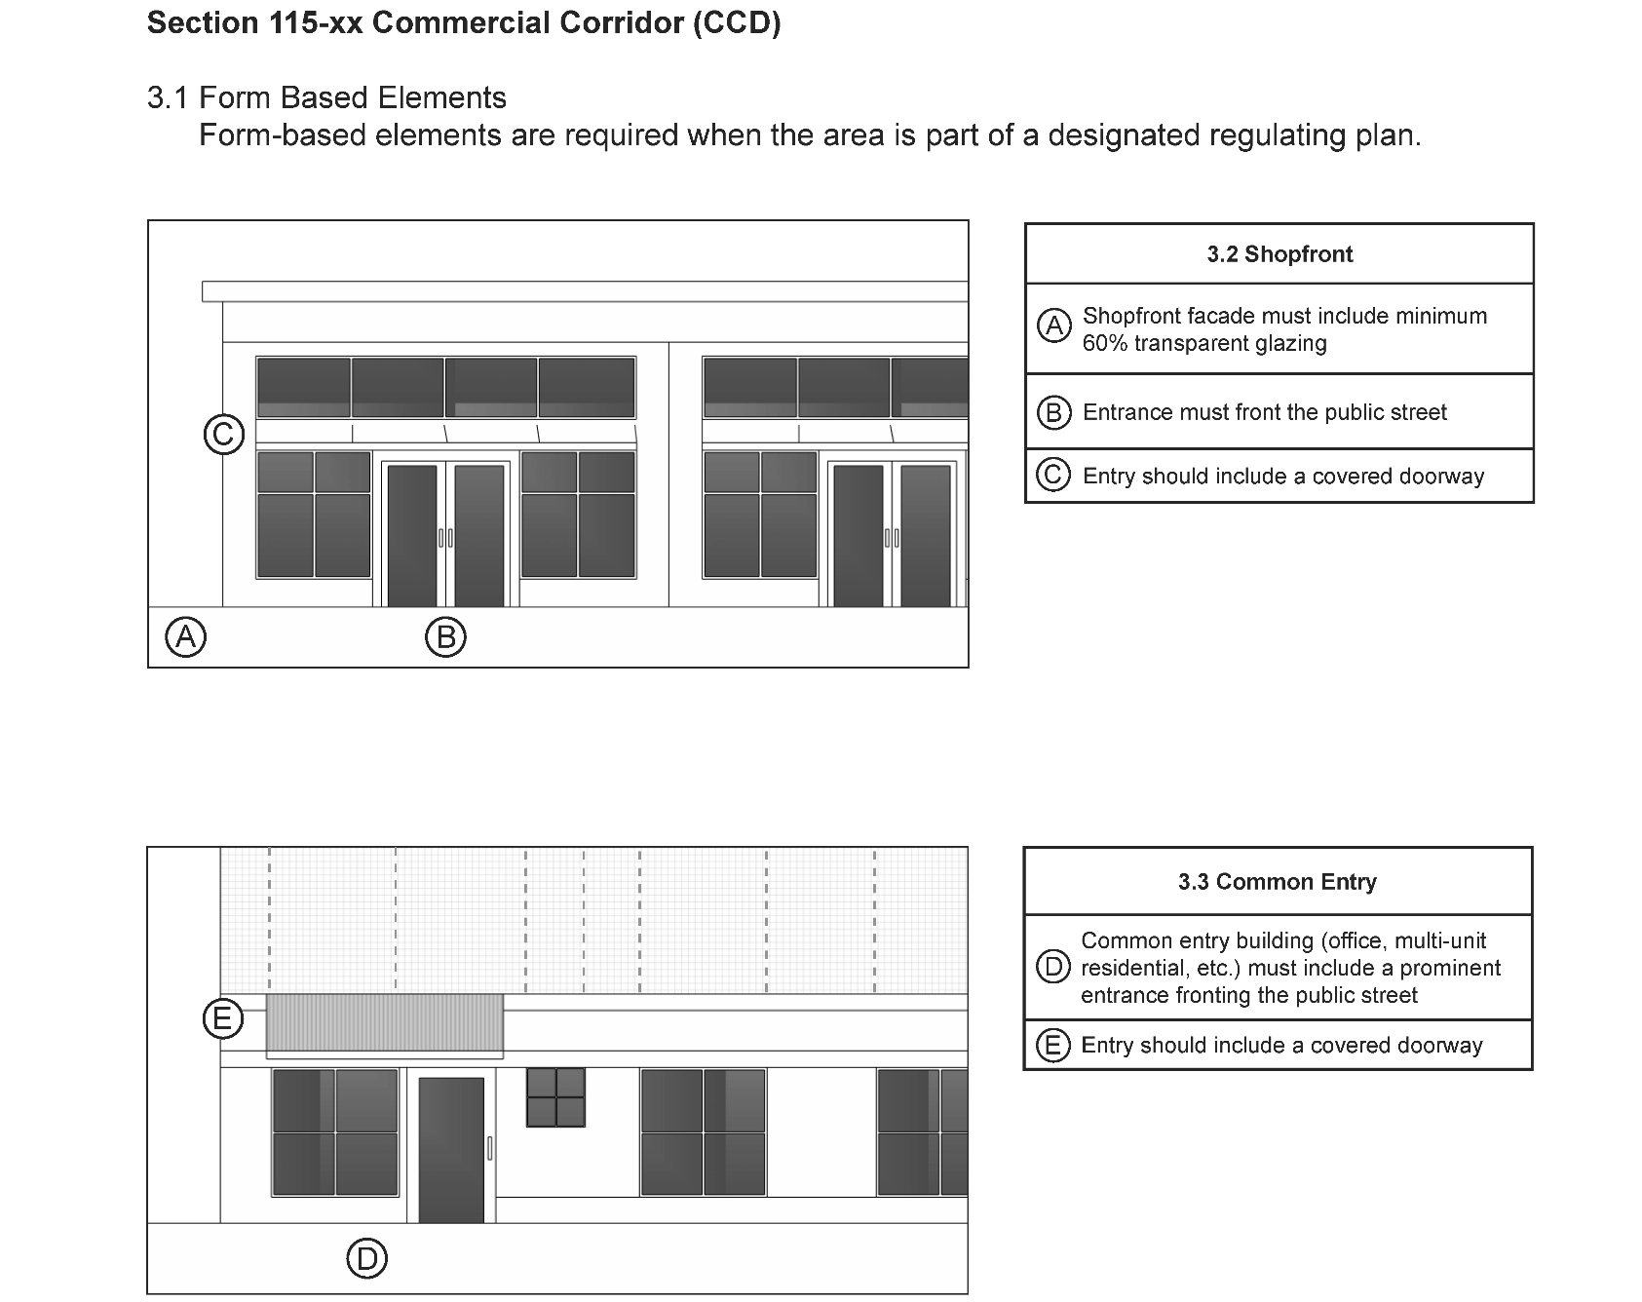

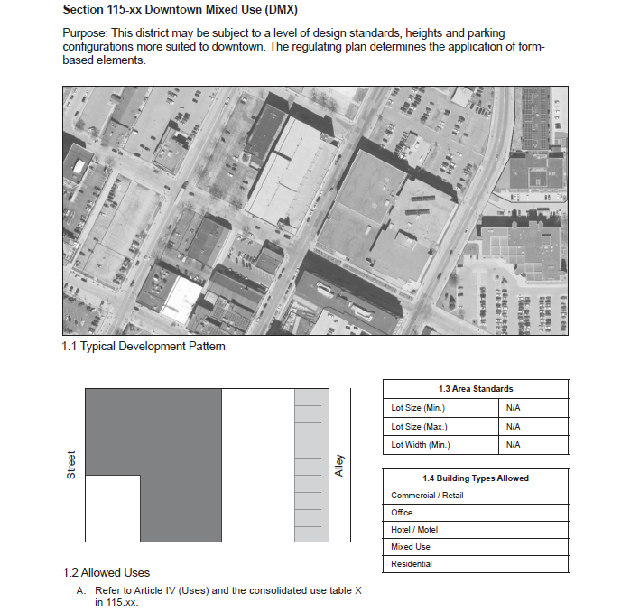
Sec. 115-XX. Downtown Mixed Use District (DMX).

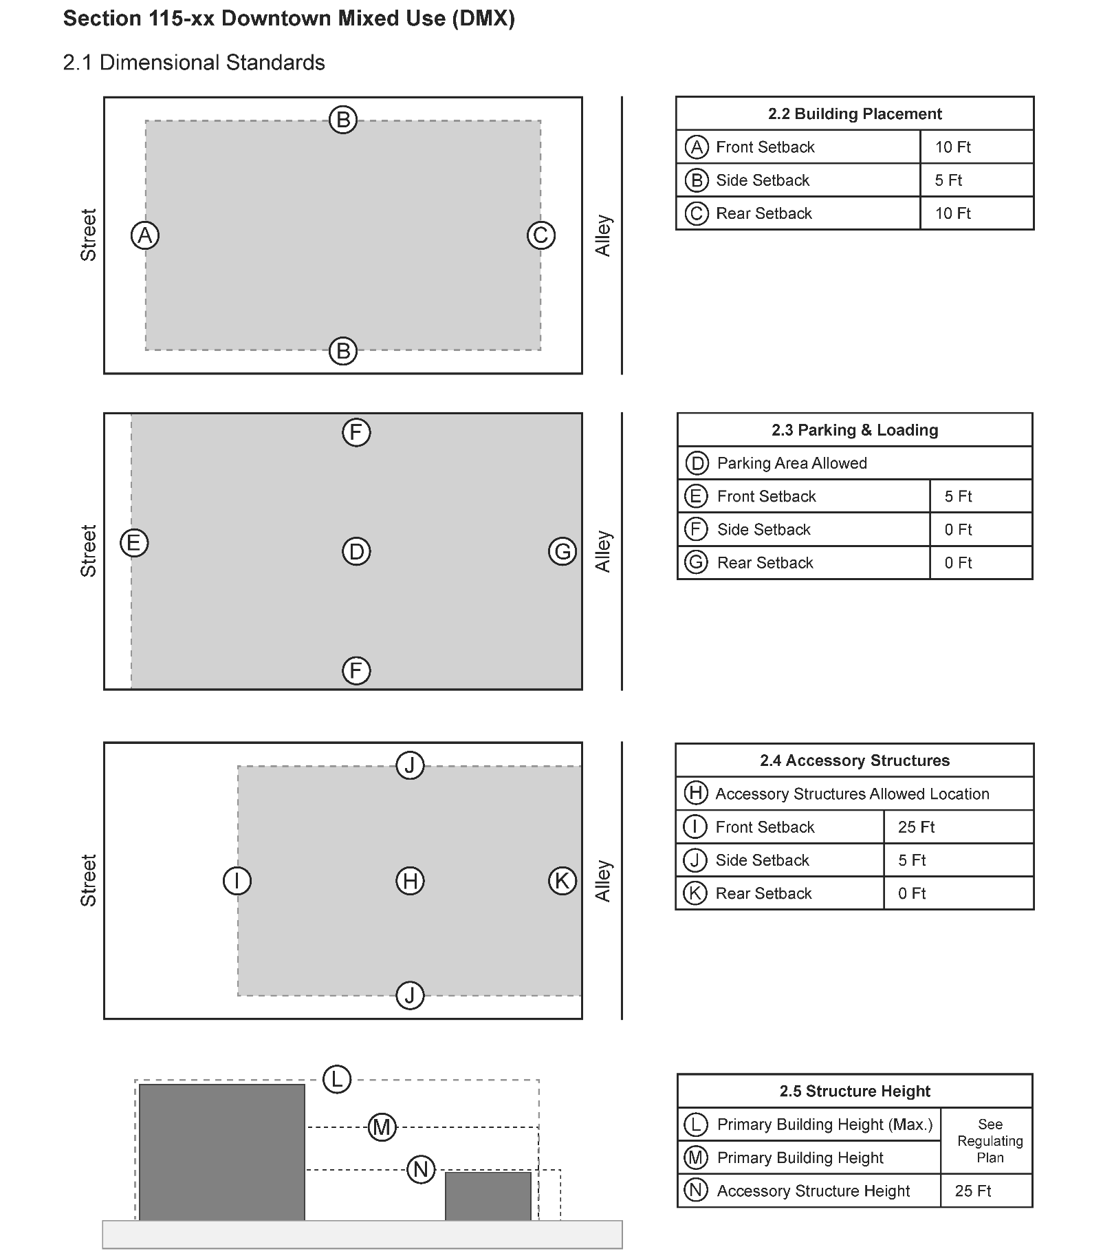

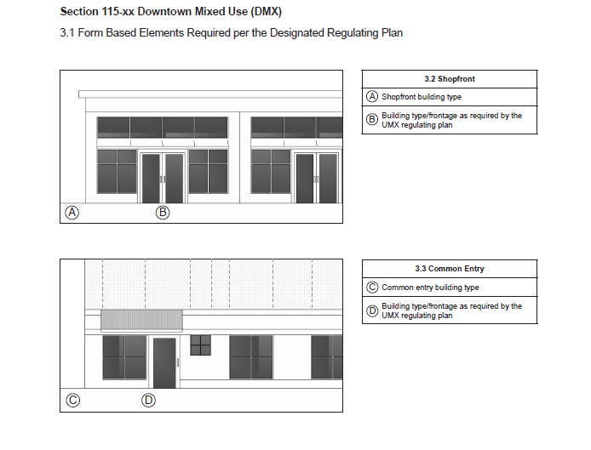

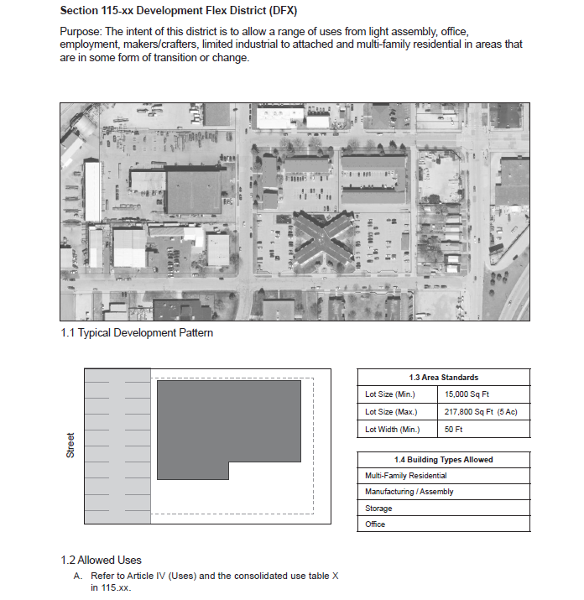
Sec. 115-XX. Development Flex District (DFX).

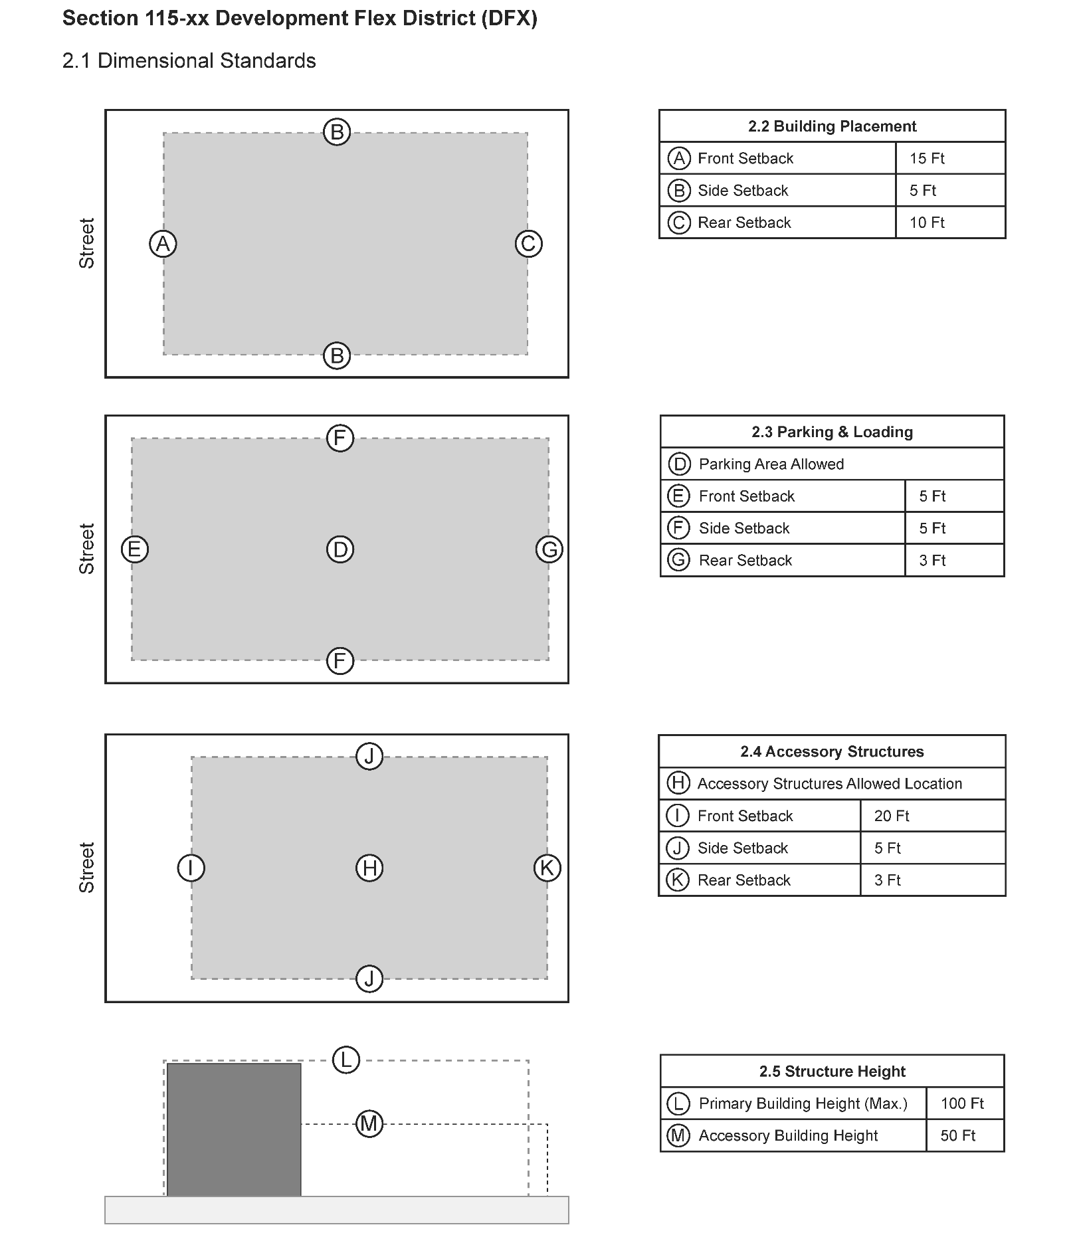

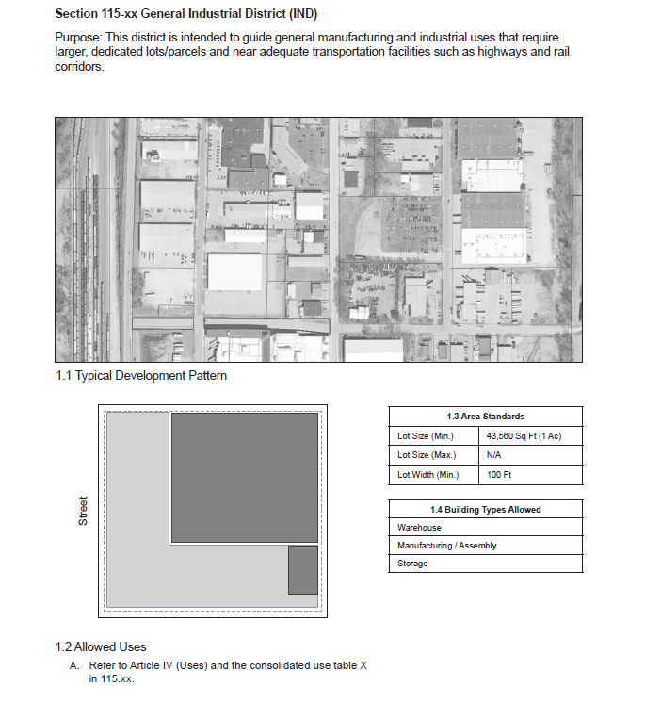
Sec. 115-XX. General Industrial District (IND).

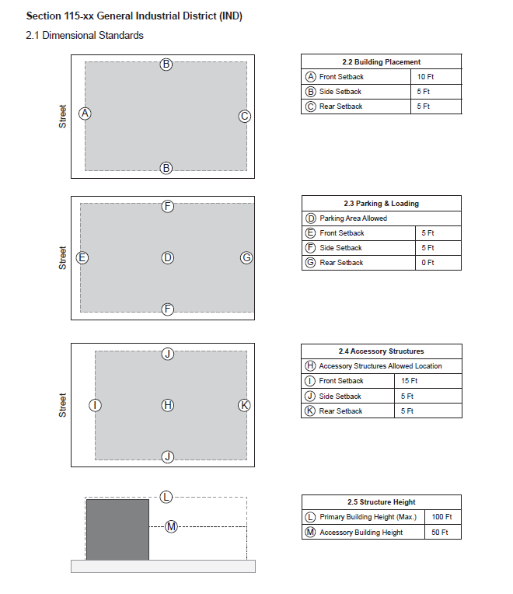

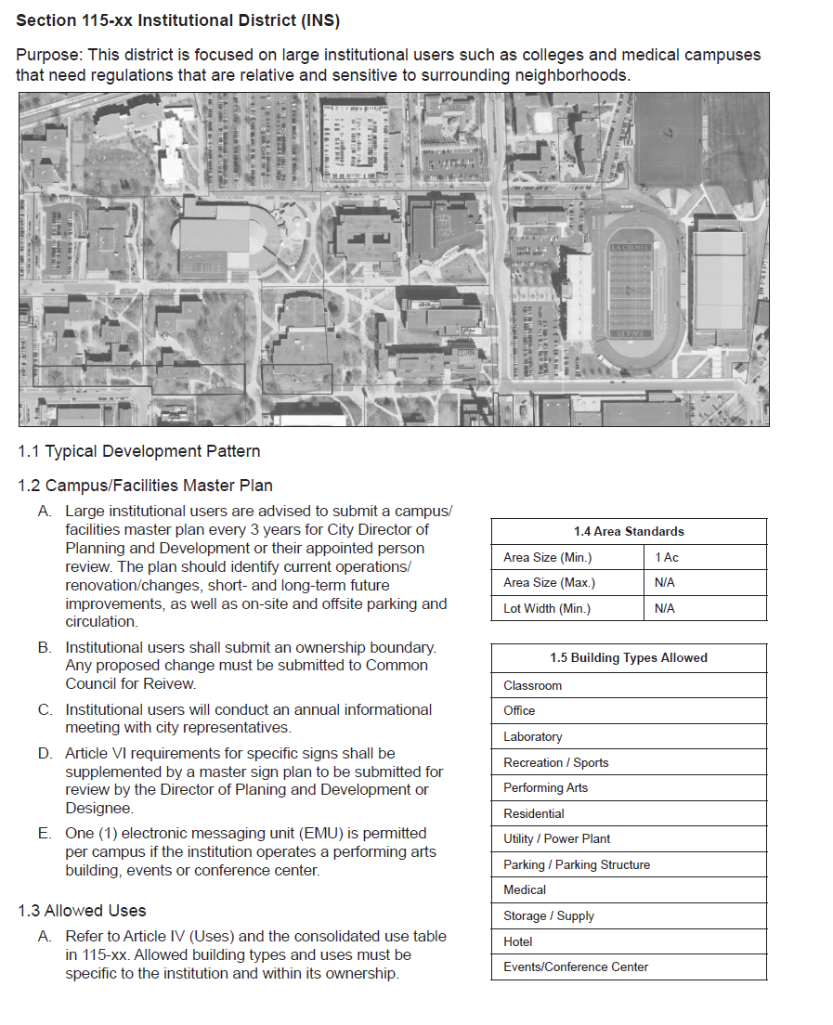
Sec. 115-XX. Institutional District (INS).

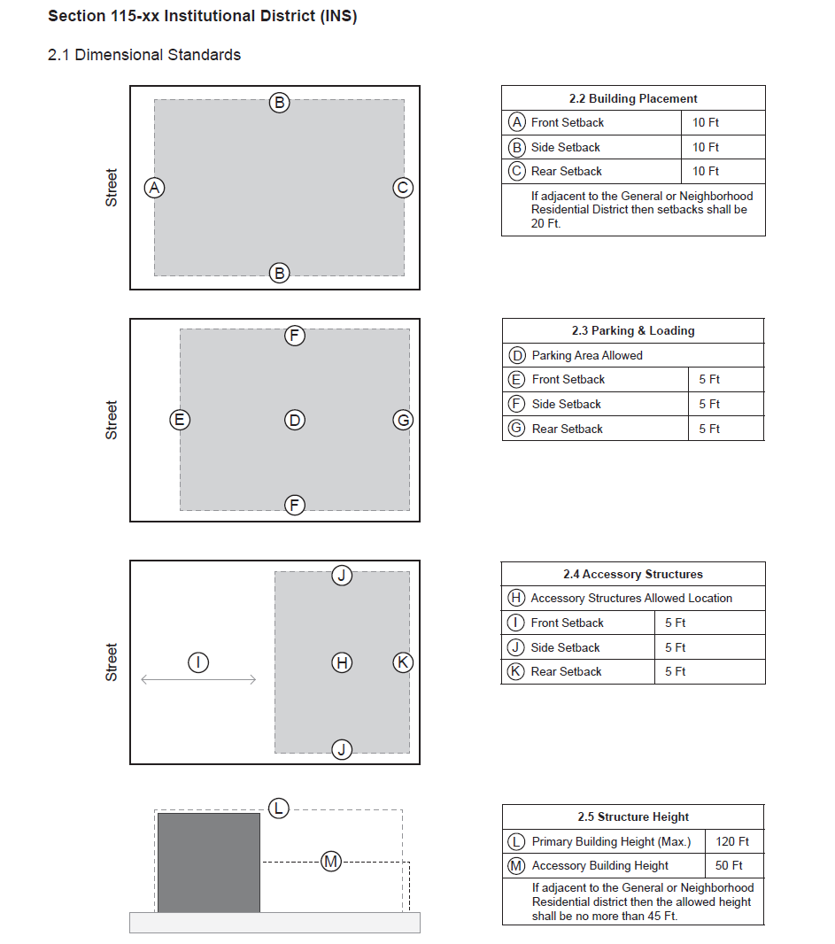

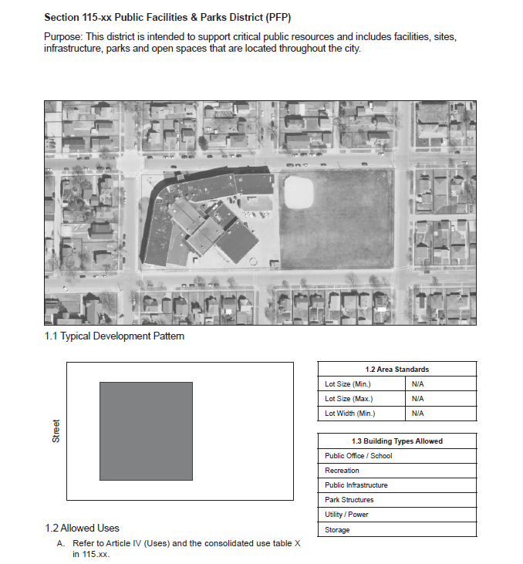
Sec. 115-XX. Public Facilities & Parks District (PFP)

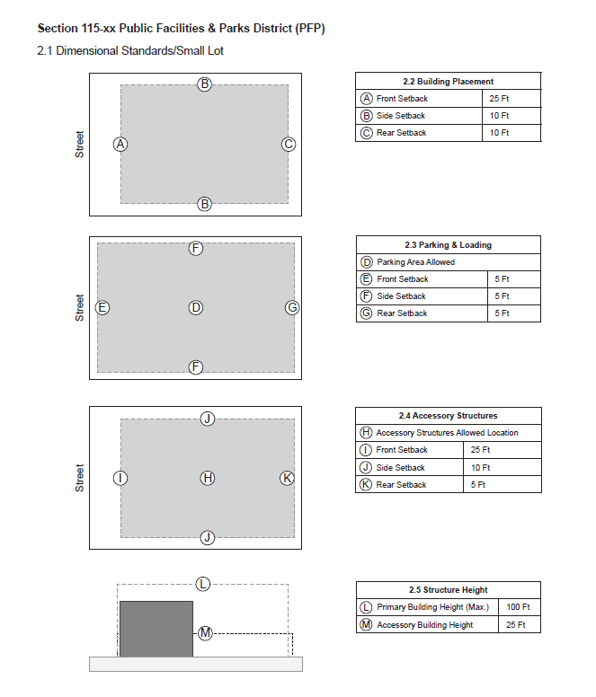

Sec. 115-XX. Conservancy District (CON).
Purpose: This district is established to preserve and perpetuate in an open state certain areas, such as lakes and waterways, wetlands and marshes, floodplains and stream beds, certain agricultural lands, slopes, and other areas of aesthetic value which, because of their unique physical features, are deemed desirable and functional as natural drainageways, water retention and erosion control areas, natural habitat for plant and animal life, green belts and other multipurpose uses beneficial to the community.

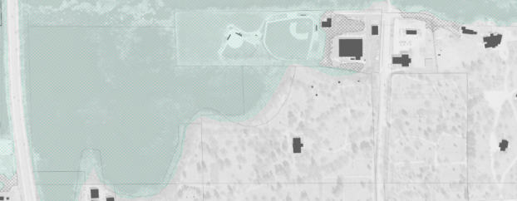
1.1 Typical Development Pattern.

1.2 Allowed Uses. Refer to Article IV (Uses) and the Consolidated Use Table X in 115.XX.

  - Orchards, tree farms, tree nurseries and other tree crop agricultural uses provided that harvesting does not remove protective watershed tree cover.
  - Public, semi-public and/or private wild game preserves, wildlife areas and bird sanctuaries.
  - Public or semi-public parks and/or recreation areas, forest reserves, forest experimental stations and historic areas.
  - Fishing, public fish hatcheries, stream bank and lakeshore protection, and water retention uses.
(5) Conditional or permitted uses as provided in Article VII of this Chapter.
  - Notwithstanding any other provisions of this section, the repair, maintenance, replacement, or upgrades to existing utility infrastructure so long as such activity is confined to the same utility corridor owned or controlled by the utility.
  - Bridle paths and hiking trails, toboggan runs, ski resorts, archery ranges and accessory buildings. Class "A" cabarets are not permitted in the accessory buildings.
1.3 Height Regulations. No structure shall exceed 25 feet in height at its greatest distance from the natural slope of the ground.
1.4 Dimensional Standards.
- Area Regulations.
  - Orchards, tree farms, tree nurseries and other tree crop agricultural uses provided that harvesting does not remove protective watershed tree cover.
  - No use permitted in this district shall be located on a lot of less than five acres.
  - No structure shall be located less than 50 feet from any property line.
- Vision Clearance. The vision clearance requirements for this district shall be the same as for the Local Business District
- Development Standards >>DRAFT PRELIMINARY<<
Standards and requirements to consider:
- Create a 50 foot buffer around the entire Conservancy District
- Potential to establish standards that reduce impervious cover inside the buffer (e.g., allow up to 25% impervious cover)
- Specify appropriate plantings (within the buffer)
- Create a “sponge zone” within 10 feet of the property line – no development allowed
- Limit physical improvements (such as foundations, etc.)
- Regulate/prohibit any surface/subsurface water runoff
- Apply new standards to all public properties as a priority

(Code 1980, § 15.13)

Sec. 115-XX. Planned Development District (PDD).
- Statement of purpose. The intent of this district is to permit developments that will, over a period of time, be enhanced by coordinated area site planning, diversified location of structures and/or mixing of compatible uses. Such developments are intended to provide a safe and efficient system for pedestrian and vehicular traffic; to provide attractive recreation and open spaces as integral parts of the developments; to enable economic design in the location of public and private utilities and community facilities; and to ensure adequate standards of construction and planning. The Planned Development District under this chapter will allow for flexibility of overall development design with benefits from such design flexibility intended to be derived by both the developer and the community.
This is a zoning district that may be developed only in accordance with a specific comprehensive development plan. The approved specific comprehensive development plan is an integral part of this zoning district and all development shall comply with said plan. The Planned Development District is designed and intended to enable and encourage the development of large tracts of land or urban infill sites which are planned under unified ownership or control, or lands which by reason of existing or planned land uses are appropriate for development under this section, to achieve land development patterns which will maintain and enhance the physical, social and economic values of an area.
The unified and planned development of a site under a specific comprehensive development plan in an individual, single entity, partnership or corporate ownership or control or in common ownership under the Condominium Ownership Act set forth in Wis. Stat. Ch. 703 (condominiums) may be permitted by the City upon specific petition, with such development encompassing one or more principal uses or structures and related accessory uses or structures when all regulations and standards as set forth in this section have been met.
(b) Use regulations. In the Planned Development District, such development may encompass one or more principal uses or structures and related accessory uses or structures with a continuity of design and development, under a unified specific and precise comprehensive development plan, where the implementation of said plan is conducted by single, partnership, corporate, limited liability company, condominium or association ownership. The use or uses of each Planned Development District shall be individually or specifically approved, and may be a use permitted in the GRD, NRD, MHD, NMX, UMX, DMX, CCD, DFX, IND, INS, INC?, PFP, and PBU Districts, or a combination of uses permitted in different zoning districts. There may be provided within Planned Development Districts a combination of land uses, including a variety of residential types, commercial, industrial, public and semi-public areas, arranged and designed in accordance with sound land planning principles and development techniques; and in such a manner as to be properly related to each other, the surrounding community, the planned thoroughfare system, and other public facilities such as water and sewer systems, parks, schools and utilities.
(c) Area regulations. Areas designated as Planned Development Districts shall be under single or unified ownership or control as specified above and shall contain a minimum gross development area as follows:
Planned Development | Minimum Area of Principal Uses
Residential Planned Development | Two acres
Commercial Planned Development | Two acres
Industrial Planned Development | Two acres
Mixed Compatible Use | Two acres

(d) Other regulations. Height, yard, vision, setback, parking, lot coverage, and other related standards applicable to similar uses in other comparable zoning districts shall be considered by the City Plan Commission and the Council in establishing specific regulations for each Planned Development District. In the Planned Development District there shall be no predetermined specific lot area, lot width, height, bulk or floor area ratio, yard, usable open space, sign and off-street parking requirements, but such requirements as are made a part of an approved specific and precise comprehensive development plan and shall be, along with the plan itself, construed to be and enforced as a part of this section. For Residential Planned Development Districts over ten acres in gross area, there shall be a minimum of 20 percent of the gross acreage dedicated for useable permanent open space, which open space area shall not include land set aside for utility easements (with the exception of easements which provide permanent open space), rights-of-way, roadway or lot area. Areas of steep slopes and wetlands which are permanently reserved for open space may be included in the calculation of open space. For all other Planned Developments over ten acres, which do not include a residential component, the open space requirement shall be ten percent. All Planned Developments less than ten acres in gross area shall provide for useable permanent open space in an amount to be determined by the City, which amount shall be based on location, site conditions and proposed land use. The petition for zoning shall be accompanied by written terminology, graphic material, and will illustrate the conditions that the modified standards will produce, to enable the City Plan Commission and the Council to make the determination that the modification will produce a living environment, landscape quality and lifestyle superior to that produced under existing standards. The individual regulations for each such District created shall be adopted and published in ordinance form. All other applicable regulations, including, but not limited to, those applicable regulations continued in the Subdivision Ordinance shall apply and be reviewed as part of the development review process.
(e) Special application procedure for Planned Development District.
(1) Pre-petition conference. At least 30 days prior to filing the petition for approval of the designation of a Planned Development District, the owner or his agent making such petition shall meet with the Department of Planning and Development and City Engineer's Office to discuss the scope and proposed nature of the contemplated development. This pre-petition conference will be coordinated by the Department of Planning and Development. A letter of intent shall be submitted to the Department of Planning and Development prior to the pre-petition conference which letter of intent shall include a preliminary sketch of the project.
(2) The petition. Following the pre-petition conference, the owner or his agent may file a petition with the Office of the City Clerk for an amendment to the City's Official Zoning Map requesting designation as a Planned Development District. The procedure for rezoning to a Planned Development District shall be as required for any other change in zoning district boundaries, except that in addition to the Planned Development District rezoning process, the rezoning may only be considered in conjunction with a comprehensive development plan and shall be subject to the following additional requirements. The comprehensive development plan may be in the form of a general development plan in order to receive concept approval therefore requiring a two-step process or in the form of a combined general and specific comprehensive development plan in order to receive final approval in a simultaneous, single step approval process. Such petition shall be accompanied by a permit fee in in the amount established by resolution, as well as ten copies of the following information:
a. General Development Plan. A General Development Plan encompassing all of the property which the developer owns or controls which includes a statement which sets forth the relationship of the proposed Planned Development District to the City's adopted General Plan for the La Crosse Area or any applicable component of the plan and the general character of and the uses to be included in the proposed Planned Development District, including the following information:
1. Total area to be included in the Planned Development District, area of open space in acres and percent, proposed uses of land keyed to the comparable existing zoning districts, residential density computations (gross and net), proposed number of dwelling units, the approximate location of different types or densities of dwelling units, population analysis, availability of or requirements for municipal services and utilities and any other similar data pertinent to a comprehensive evaluation of the proposed development.
2. A general summary of the estimated value of structures and site improvement costs, including landscaping and special features.
3. A general outline of the organizational structure of a property owner's or management's association, which may be proposed to be established for the purpose of providing any necessary private services including proposed restrictive covenants.
4. Any proposed departures and requested waivers from the standards of development as set forth in other City zoning regulations, land division ordinance, sign ordinance and other applicable regulations.
5. The expected date of commencement of physical development as set forth in the proposal and an outline of any development staging which is planned.
6. A sketch plan depicting the proposed lot layout, street configuration, utilities, and open space.
7. A legal description of the boundaries of lands included in the proposed Planned Development District.
8. A description of the relationship between the lands included in the proposed Planned Development District and surrounding properties.
9. The location of institutional, recreational and open space areas, common areas and areas reserved or dedicated for public uses, including schools, parks, and drainageways.
10. Characteristics of soils related to contemplated specific uses.
11. Existing topography on site with contours at no greater than two-foot intervals City Datum where available.
12. General landscaping treatment.
b. Referral and hearing.
1. Within 60 days after completion of the filing of the petition for rezoning under a general development plan, the City Plan Commission shall forward the petition to the Common Council with recommendations, that the plan be approved as submitted, approved with modifications or disapproved. A public hearing shall be held prior to Common Council action on the proposed rezoning.
2. Approval of the rezoning and related general development plan shall establish the basic right of use for the area when in conformity with the general development plan as approved, which shall be an integral component of the district regulations, but such plan shall be conditioned upon approval of a specific comprehensive development plan, and shall not make permissible any of the uses as proposed until a specific comprehensive development plan is submitted and approved for all or a portion of the area included within the general development plan. If a specific comprehensive development plan is not filed within 18 months of the date of approval by the Common Council, the approval shall become null and void and a new petition and approval process shall be required to reobtain general development plan approval. If the general development plan and comprehensive development plan are approved at the same time and construction has not commenced within 12 months of the date of approval by the Common Council, the approval shall become null and void and a new petition and approval process shall be required to obtain general development plan and specific comprehensive development plan approval.
c. Specific comprehensive development plan. Within 18 months of the date of approval by the Common Council of a general development plan, a specific comprehensive development plan must be submitted for review and approval by the appropriate City officials and committees including the City Plan Commission and Common Council which shall include all information required in subsection (e)(2)a of this section, as well as the following detailed construction and engineering plans and related detailed documents and schedules:
1. A plat plan including all information required for a preliminary plat and applicable provision of Wis. Stat. ch. 236, together with areas to be reserved for vehicular and pedestrian traffic, utilities, parking, public uses and easements. For commercial, industrial, public or semi-public, or mixed use developments, a detailed site plan showing the dimensions and locations of all proposed structures, areas to be reserved for vehicular and pedestrian traffic, utilities, parking, public uses and easements.
2. A legal description of the boundaries of lands included in the proposed Planned Development District.
3. A description of the relationship between the lands included in the proposed Planned Development District and surrounding properties.
4. The location of public and private roads, driveways and parking facilities.
5. The size, arrangement and location of any individual building sites and proposed building groups on each individual lot (not applicable to single-unit attached or detached residential projects).
6. The location of institutional, recreational and open space areas, common areas and areas reserved or dedicated for public uses, including schools, parks and drainageways.
7. The type, size and location of all temporary advertising signs and permanent entrance features or signs.
8. Detailed landscaping plans including plant listings.
9. Final architectural plans, elevations and drawings and sketches illustrating the design and character of proposed structures (not applicable to single-unit attached or detached residential projects).
10. The existing and proposed location of public sanitary sewer, water supply facilities and stormwater drainage facilities in the form of engineering plans.
11. The existing and proposed location of all private utilities or other easements.
12. Characteristics of soils related to contemplated specific uses.
13. Existing topography on-site with contours at no greater than two-foot intervals City Datum.
14. Provide for anticipated uses of adjoining lands, whether owned by the developer or not, in regard to roads, surface water drainage, utilities, and compatibility with existing adjacent land uses.
15. If the development is to be staged, a staging plan describing each stage of the development and how it will function by itself and the relationship to other development stages/units within the district or on adjacent property.
16. All restrictive covenants.
17. Proposed erosion control plan and final grading plan in conformance with Article II of Chapter 105.
18. All conditions agreed to by the applicant which are not included in the written documentation required under subsection (2)c.1 through 12 of this section shall be part of the development plan.
d. Additional material. Additional material and information shall be provided for specific types of uses when petitioning for a change in zoning under a general development plan as follows, with the exception that the standards of height, open space, buffering, landscaping, pedestrian and vehicular circulation, off-street parking and loading, signs, and nuisance controls intended for the development shall only be required to be submitted as part of a specific comprehensive development plan:
1. Wherever residential development is proposed within a Planned Development District, the general development plan shall contain at least the following information:
(i) The approximate number of dwelling units proposed by type of dwelling and the density (i.e., the number of dwelling units proposed per gross and net acre for each type of use).
(ii) The standards of height, open space, buffering, landscaping, pedestrian and vehicular circulation, off-street parking and loading, signs, and nuisance controls intended for the development.
2. For Planned Development Districts or proposed areas within the Planned Development District for which a commercial development plan is proposed, the general development plan shall contain at least the following information:
(i) The approximate retail sales floor area and total area proposed for commercial development.
(ii) The types of uses proposed to be included in the development, which uses shall be consistent with the commercial zoning district.
(iii) The standards of height, open space, buffering, landscaping, pedestrian and vehicular circulation, off-street parking and loading, signs, and nuisance controls intended for the development.
3. For Planned Development Districts or proposed areas within the Planned Development District for which an industrial development is proposed, the general development plan shall contain at least the following information:
(i) The approximate total area proposed for such use.
(ii) The types of uses proposed to be included in the development. (Generally those industrial, office, laboratory and manufacturing uses shall be allowed which do not create any danger to health and safety in surrounding areas and which do not create any offensive noise, vibration, smoke, dust, odor, heat or glare and which by reason of value in relation to size and weight of merchandise received and shipped, generate a minimum of truck traffic.)
(iii) The anticipated employment in the entire development and in each major portion. This may be stated as a range.
(iv) The standards of height, open space, buffering, landscaping, pedestrian and vehicular circulation, off-street parking and loading, signs, and nuisance controls intended for the development.
4. For Planned Development Districts or units proposed within the Planned Development District containing institutional, recreational or other public or quasi-public development, the general development plan shall contain the following information:
(i) General types of uses proposed in the entire development and each major section.
(ii) Significant applicable information with respect to enrollment, , attendance, or other social or economic characteristics of development.
(iii) The standards of height, open space, buffering, landscaping, pedestrian and vehicular circulation, off-street parking and loading, and signs intended for the development.
5. For Planned Development Districts or units proposed within the Planned Development District containing more than one land use as outlined in subsection (2)d.1 through 4 of this section, the general development plan shall contain the information as appropriate for the proposed use.
(3) Consideration and approval of application. Prior to referral to the City Plan Commission and any Standing Council Committee, the application shall be referred to the Department of Planning and Development and the City Engineer's Office, which two Departments shall verify all variations from this chapter applicable to similar uses in other districts and all variations from the Subdivision Ordinance as submitted by the petitioner and shall make a report and recommendations for the benefit of the City Plan Commission and the Council.
(4) Basis for approval.
a. The Department of Planning and Development, in making its recommendations to the City Plan Commission and the Council, shall consider:
1. Whether the petitions for the proposed Planned Development District have indicated that they intend to begin construction of the designation Planned Development within 18 months following the approval of the petition for a Planned Development District and that the development will be carried out according to a reasonable construction schedule satisfactory to the City.
2. Whether the proposed Planned Development District is consistent in all respects to the purpose of this section and to the spirit and intent of this chapter; is in conformity with the general plan for the La Crosse Area or any applicable component plans for community development; would not be contrary to the general welfare and economic prosperity of the City or of the immediate neighborhood; and, that the benefits and improved design of the resultant development justifies the establishments of a Planned Development District.
3. Whether the proposed site shall be provided with adequate drainage facilities for surface waters and stormwaters.
4. Whether the proposed site shall be accessible from public roads that are adequate to carry the traffic that can be expected to be generated by the proposed development.
5. Whether any undue constraint or burden will be imposed on public services and facilities, such as fire and police protection, all City utilities, street maintenance and maintenance of public areas by the proposed development.
6. Whether the streets and driveways on the site of the proposed development shall be adequate to serve the residents of the proposed development and would not create a traffic or parking demand incompatible with the existing or proposed facilities to serve it unless jointly resolved.
7. Municipal public water and sanitary sewer facilities shall be provided.
8. Adequate guarantee is provided for permanent preservation of open space areas as shown on the approved comprehensive development plan either by private reservations and maintenance agreements, covenant, financial surety, special assessment or by dedication to the public. Stormwater conveyance and detention systems shall not be dedicated to the public with the exception of storm sewer within public right-of-way.
9. Adequate guarantee is provided for permanent maintenance and ownership of waterways, stormwater conveyance and detention systems including ponds, etc., either by private reservations and maintenance agreements, covenants, financial surety or special assessment. Water and sanitary sewer systems shall be dedicated to the public when constructed in conformance to the City's design criteria.
b. Usual procedures shall otherwise be followed, recognizing that specific regulations are to be approved for each such district which may be at variance with other general ordinances. The City Plan Commission and the Council may also establish requirements and limitations to reduce traffic congestion and hazards, establish adequate landscaping, buffering and screening, and eliminate undesirable effects on nearby development.
(f) Changes or additions. Any subsequent change or addition to the plans or uses shall first be submitted for approval to the City Plan Commission. Any requested change or amendment need only include the pertinent portion of the plan and drawings to delineate the amendment to the plan and need not include those items or plans that are not being changed or modified. Said changes or additions made in accordance with this subsection shall not substantially modify the previously approved specific comprehensive development plan to the extent that the same is not inconsistent with said changes or additions. The specific comprehensive development plan shall not be approved or modified, unless adopted by two-thirds vote of the members of the Council.
(g) Plat or certified survey map.
(1) All Planned Developments are required to follow the subdivision procedures set forth in the Subdivision Ordinance, including the requirements for filing a preliminary and final plat. Within six months of the approval of a Planned Development District or any amendment to the district, through the approval of a specific comprehensive development plan, the owner shall record in the Register of Deeds office either a final plat in compliance with Wis. Stat. Ch. 236 and the Subdivision Ordinance for the applicable phase of the development or a certified survey map in accordance with Wis. Stat. § 236.34, whichever may apply, except when there already is a plat or certified survey map recorded.
(2) Proof of such recording shall be filed with the City Clerk within said six months.
(h) Building permits.
(1) No building permits shall be issued for any structure not in strict compliance with the approved specific comprehensive development plans, drawings and regulations as approved by the Council. Subsequent alterations, changes or amendments shall require the same prior approvals as the original zoning.
(2) Certificates of Compliance shall be withheld until the recording of a plat or certified survey map as set forth in subsection (g)(1) of this section.
(i) Construction.
(1) A certified copy of the final approved comprehensive development plan shall be filed in the Department of Planning and Development and the Office of the City Clerk prior to issuance of any form of development permits including building permits and if no construction has begun within 18 months of the approval of said plan, the plan shall lapse and be of no further effect. The Council may extend the period for the beginning of construction or the establishment of use prior to the expiration date in conformance with subsection (f) of this section. Failure to comply with the approved comprehensive development plan shall justify action to rezone the area or portion of the property requesting to be rezoned .
(2) All construction within a phase shall be completed within three years of final approval. This period may be extended by the Council for good cause. Failure to comply with the time periods in this section shall justify action to rezone the area or portion of the property requesting to be rezoned.
(Code 1980, § 15.16)

