RESOLUTION NO. 23-XX

A RESOLUTION OF THE CITY COUNCIL OF THE CITY OF RIALTO, CALIFORNIA, APPROVING SPECIFIC PLAN AMENDMENT NO. 2022-0006 TO ESTABLISH A RESIDENTIAL OVERLAY IN THE FOOTHILL BOULEVARD SPECIFIC PLAN TO ACCOMMODATE HOUSING IN ACCORDANCE WITH THE HOUSING ELEMENT REZONE PROGRAM IMPLEMENTATION PROJECT.

WHEREAS, on March 8, 2022, the City Council adopted the 2021-2029 (6th Cycle) General Plan Housing Element, a mandatory element of the City’s General Plan and the City’s main housing policy and planning document that identifies housing needs and constraints, sets forth goals, policies and programs that address these needs and constraints, and plans for projected housing needs for all income levels based on the City’s assigned Regional Housing Needs Allocation (RHNA); and
WHEREAS, the 2021-2029 (6th Cycle) General Plan Housing Element identified a shortage of affordable housing within the City of Rialto; and
WHEREAS, California Government Code Section 65580(d) states that all cities have a responsibility to use the powers vested in them to facilitate the improvement and development of housing and to make adequate provisions for the housing needs of all economic segments of the community; and
WHEREAS, the Housing Element includes a Sites Inventory, which identifies suitable sites throughout the City that can adequately accommodate the required capacity set forth by the City’s RHNA which for the 2021-2029 (6th Cycle) planning period is 8,272 housing units; and
WHEREAS, consistent with State Law, Housing Goal #2 is to “Promote and encourage housing development that adequately meets the needs of all socioeconomic segments of the community and region”; and
WHEREAS, in order to implement Housing Element Goal #2, Housing Program 2B, referred to as the Rezone Program, the City will need to rezone parcels to provide adequate sites to accommodate RHNA; and
WHEREAS, the City’s Rezone Program includes a residential overlay in the Foothill Boulevard Specific Plan over approximately 159 acres and permitting residential development at a maximum density of thirty-five (35) dwelling units per acre; and
WHEREAS, on January 11, 2023, the Planning Commission of the City of Rialto conducted a duly noticed public hearing, as required by law; heard public testimony; discussed Specific Plan Amendment (SPA) No. 2022-0006; closed the public hearing; and
WHERAS, the Planning Commission voted 5-0 to recommend the City Council approve the amendment to the Foothill Boulevard Specific Plan; and
WHEREAS, on February 14, 2023, the City Council of the City of Rialto conducted a duly noticed public hearing, as required by law; heard public testimony; discussed SPA No. 2022-0006; and closed the public hearing; and
WHEREAS, all legal prerequisites to the adoption of this Resolution have occurred.
NOW, THEREFORE, the City Council of the City of Rialto, California, does hereby resolve as follows:
SECTION 1. The City Council hereby specifically finds that the facts set forth in the recitals above of this Resolution are true and correct.
SECTION 2. In conjunction with the Project, the City has prepared an addendum to the previously adopted Mitigated Negative Declaration for the 2021-2029 (6th Cycle) General Plan Housing Element (“MND 6th Cycle Housing Element”) under the California Environmental Quality Act (“CEQA”) because the proposed Specific Plan Amendment will not result in any change with respect to the circumstances or require major revisions to the previously approved MND 6th Cycle Housing Element.
SECTION 3. The City Council hereby amends the Foothill Boulevard Specific Plan to add the following section in the manner shown, with underlined text representing added language.
“18.111.020 – Intent and Purpose
….
E. Residential Overlay (RO)
The Residential Overlay is intended to provide additional capacity for residential development along Foothill Boulevard on specified sites with the most development potential. The provisions of Rialto Municipal Code Chapter 18.116 – Residential Overlay, as those provisions and regulations may be amended from time to time, are made a part of this Specific Plan by reference with the same force and effect as if the provisions therein were specifically and fully set out herein. The residential overlay applies in the areas appearing on the zoning map on the following page.”
SECTION 4. The City Council hereby amends the Foothill Boulevard Specific Plan to apply the residential overlay zone to sites described in the Housing Element Sites Inventory and as depicted in Exhibit “A” attached hereto and incorporated herein and the map depicted in Exhibit “A” shall replace the zoning map of the Foothill Boulevard Specific Plan.

SECTION 5. The Mayor shall sign the passage and adoption of this Resolution and thereupon the same shall take effect and be in force.

PASSED, APPROVED AND ADOPTED this 14th day of February, 2023.

_________________________________
DEBORAH ROBERTSON, MAYOR
ATTEST:

__________________________________
BARBARA MCGEE, CITY CLERK

APPROVED AS TO FORM:

__________________________________
ERIC S. VAIL, CITY ATTORNEY

State of California )
County of San Bernardino )
City of Rialto )

I, Barbara McGee, City Clerk of the City of Rialto, do hereby certify that the foregoing Ordinance was introduced and first read on the ___ day of __________ 2023, and had its second reading at the regular meeting of the Rialto City Council on the ___ day of _____________, 2023, and was passed by the following vote:

AYES:

NOES:

ABSTAIN:

ABSENT:

_________________________________
Barbara McGee, City Clerk

Exhibit “A”
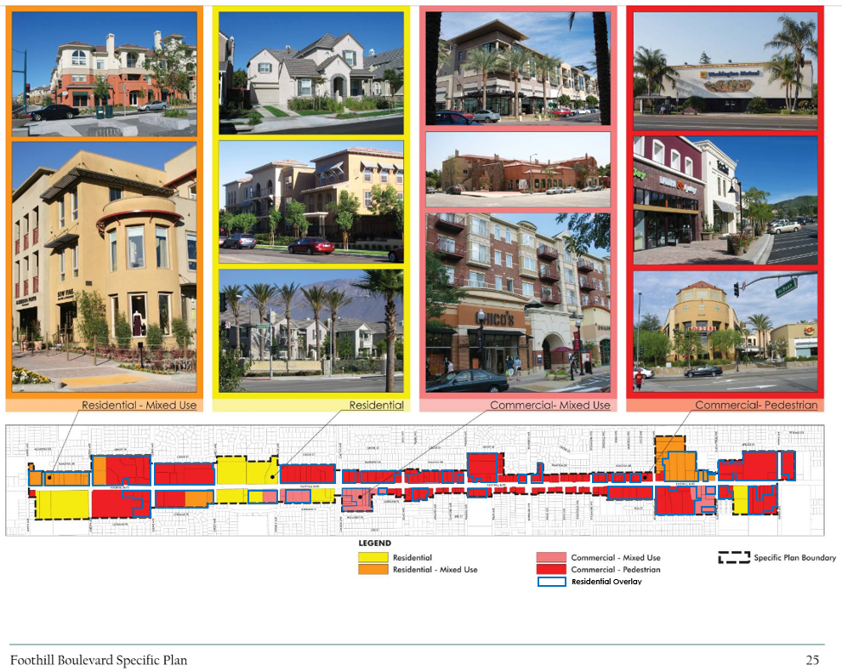
Exhibit “A”

