

PROFESSIONAL SERVICES AGREEMENT
BETWEEN THE CITY OF RIALTO AND
GEORGE HILLS COMPANY

THIS SERVICES AGREEMENT (herein “Agreement”) is made and entered into this 16th day of December 2025, by and between the City of Rialto, a municipal corporation and California general law city (“City”), and George Hills Company, a California Corporation, (“Consultant”). City and Consultant are sometimes individually referred to as “Party” or collectively as “Parties”.
RECITALS
A. City has sought, by Request for Proposals No. 26-007, the performance of professional services related to general liability claims administration services, as defined and described particularly in Article 1 of this Agreement.
B. Following the submission of a proposal for the performance of the services defined and described particularly in Article 1 of this Agreement, Consultant was selected by the City to perform those services.
C. Pursuant to Chapter 2.48 of the Rialto Municipal Code, City has authority to enter into and execute this Agreement.
D. The Parties desire to formalize the selection of Consultant for the performance of those services defined and described particularly in Article 1 of this Agreement and desire that the terms of that performance be as particularly defined and described herein.
OPERATIVE PROVISIONS
NOW, THEREFORE, in consideration of the mutual promises and covenants made by the Parties and contained herein and other consideration, the value and adequacy of which are hereby acknowledged, the parties agree as follows:
ARTICLE 1. SERVICES OF CONSULTANT
1.1 Scope of Services.
In compliance with all terms and conditions of this Agreement, Consultant shall provide those professional services associated with general liability claims administration services, and as specified in the “Scope of Services” attached hereto as Exhibit “A” and incorporated herein by this reference, which services may be referred to herein as the “services” or “work” hereunder. As a material inducement for City to enter into this Agreement, Consultant represents and warrants that it has the qualifications, experience, and facilities necessary to properly perform the services required under this Agreement in a thorough, competent, and professional manner, it meets all local, state, and federal requirements in performing the services, and it is experienced in performing the work and services contemplated herein. Consultant shall at all times faithfully, competently, and to the best of its ability, experience, and talent, perform all services described herein. Consultant covenants that it shall follow the highest professional standards in performing the work and services required hereunder and that all materials will be of good quality, fit for the purpose intended. For purposes of this Agreement, the phrase “highest professional standards” shall mean those standards of practice recognized by one or more professional firms performing similar work under similar circumstances.
1.2 Consultant’s Proposal.
The Agreement between the Parties shall consist of the following: (1) this Agreement; (2) the Scope of Services; (3) the City’s Request for Proposals No. 26-007; and (4) the Consultant’s signed, original proposal submitted to the City (“Consultant’s Proposal”), (collectively referred to as the “Contract Documents”). The Contract Documents and Accepted Proposal shall be incorporated herein by this reference as though fully set forth herein. In the event of any inconsistency between the Scope of Services, Consultant’s Proposal, and/or this Agreement, the terms of this Agreement shall govern.
1.3 Compliance with Law.
Consultant shall keep itself informed concerning, and shall render all services hereunder in accordance with, all ordinances, resolutions, statutes, rules, and regulations of the City and any federal, state, or local governmental entity having jurisdiction in effect at the time service is rendered.
1.4 Licenses, Permits, Fees, and Assessments.
Consultant shall obtain, at its sole cost and expense, such licenses, permits, and approvals as may be required by law for the performance of the services required by this Agreement. Consultant shall have the sole obligation to pay for any fees, assessments, and taxes, plus applicable penalties and interest, which may be imposed by law and arise from or are necessary for the Consultant’s performance of the services required by this Agreement, and shall indemnify, defend, and hold harmless City, its officers, employees or agents of City, against any such fees, assessments, taxes penalties, or interest levied, assessed, or imposed against City hereunder.
1.5 Familiarity with Work.
By executing this Agreement, Consultant warrants that Consultant (i) has thoroughly investigated and considered the scope of services to be performed, (ii) has carefully considered how the services should be performed, and (iii) fully understands the facilities, difficulties, and restrictions attending performance of the services under this Agreement. If the services involve work upon any site, Consultant warrants that Consultant has or will investigate the site and is or will be fully acquainted with the conditions there existing, prior to commencement of services hereunder. If Consultant discovers any latent or unknown conditions that will materially affect the performance of the services hereunder, then Consultant shall immediately inform the City of such fact and shall not proceed except at City’s risk until written instructions are received from the Contract Officer.
1.6 Care of Work.
Consultant shall adopt reasonable methods during the life of the Agreement to furnish continuous protection to the work, and the equipment, materials, papers, documents, plans, studies, and/or other components thereof, to prevent losses or damages, and shall be responsible for all such damages to persons or property, until acceptance of the work by City, except such losses or damages as may be caused by City’s own negligence.
1.7 Prevailing Wages.
Consultant is aware of the requirements of California Labor Code Section 1720, et seq. and 1770, et seq., as well as California Code of Regulations, Title 8, Section 1600, et seq., (“Prevailing Wage Laws”), which require the payment of prevailing wage rates and the performance of other requirements on “Public Works” and “Maintenance” projects. It is the understanding of City and Consultant that the Prevailing Wage Laws may not apply to this Agreement because the Agreement does not involve any services subject to prevailing wage rates pursuant to the California Labor Code or regulations promulgated thereunder. However, Consultant shall defend, indemnify, and hold City, its elected officials, officers, employees and agents free and harmless from any claim or liability arising out of any failure or alleged failure by Consultant to comply with the Prevailing Wage Laws in connection with the performance of services under this Agreement.
1.8 Further Responsibilities of Parties.
Both Parties agree to use reasonable care and diligence to perform their respective obligations under this Agreement. Both Parties agree to act in good faith to execute all instruments, prepare all documents, and take all actions as may be reasonably necessary to carry out the purposes of this Agreement. Unless specified in this Agreement, neither Party shall be responsible for the service of the other.
1.9 Additional Services.
City shall have the right at any time during the performance of the services, without invalidating this Agreement, to order extra work beyond that specified in the Scope of Services or make changes by altering, adding to, or deducting from said work. No such extra work or change may be undertaken unless a written order is first given by the Contract Officer to the Consultant, describing in detail the extra work or change and the reason(s) therefor and incorporating therein any adjustment in (i) the Contract Sum for the actual cost of the extra work or change, and/or (ii) the time to perform this Agreement, which said adjustments shall be reflected in an amendment to the Agreement subject to the written approval of the Parties. Any amendment to this Agreement shall be reviewed and approved by the City Manager. In accordance with Rialto Municipal Code section 2.48.180, increases in compensation of this Agreement may be approved by the City Manager provided: (a) the initial Contract Sum was less than One Hundred Thousand Dollars ($100,000) and the amended Contract Sum when considering any or all amendments will not exceed One Hundred Thousand Dollars ($100,000); or (b) the agreement was approved by the City Council and the increases in compensation taken either separately or cumulatively do not exceed One Hundred Thousand Dollars ($100,000). Any greater increases, taken either separately or cumulatively must be approved by the City Council. Payment for additional services rendered by Consultant under this Agreement requires the submission of the actual costs of Consultant’s performance of the extra work with the invoice(s) for the extra work claim(s), as provided in Section 2.4. It is expressly understood by Consultant that the provisions of this Section shall not apply to services specifically set forth in the Scope of Services. Consultant hereby acknowledges that it accepts the risk that the services to be provided pursuant to the Scope of Services may be more costly or time consuming than Consultant anticipates and that Consultant shall not be entitled to additional compensation therefor. City may in its sole and absolute discretion have similar work done by other contractors.
No claim for an adjustment in the contract amount or time for performance shall be valid unless the procedures established in this Section are followed.
ARTICLE 2. COMPENSATION AND METHOD OF PAYMENT
2.1 Contract Sum.
Subject to any limitations set forth in this Agreement, City agrees to pay Consultant the amounts specified in the “Schedule of Compensation” attached hereto as Exhibit “B” and incorporated herein by this reference. Upon commencement of this Agreement the total compensation, including reimbursement for actual expenses, shall not exceed Two Hundred Fifty-Three Thousand Five Hundred Three Dollars and Twenty-Five Cents ($253,503.25) (the “Contract Sum”). The Contract Sum may also be increased for additional services pursuant to Section 1.9.
2.2 Method of Compensation.
The method of compensation may include: (i) a lump sum payment upon completion; (ii) payment in accordance with specified tasks or the percentage of completion of the services; (iii) payment for time and materials based upon the Consultant’s rates as specified in the Schedule of Compensation, provided that time estimates are provided for the performance of sub tasks, but not exceeding the Contract Sum; or (iv) such other methods as may be specified in the Schedule of Compensation.
2.3 Reimbursable Expenses.
Compensation may include reimbursement for actual and necessary expenditures for reproduction costs, telephone expenses, and travel expenses approved by the Contract Officer in advance, or actual subcontractor expenses of an approved subcontractor pursuant to Section 4.5, and only if specified in the Schedule of Compensation. The Contract Sum shall include the attendance of Consultant at all project meetings reasonably deemed necessary by the City. Coordination of the performance of the work with City is a critical component of the services. If Consultant is required to attend additional meetings to facilitate such coordination, Consultant shall not be entitled to any additional compensation for attending said meetings.
2.4 Invoices.
Each month Consultant shall furnish to City an original invoice for all work performed and expenses incurred during the preceding month in a form approved by City’s Director of Finance. By submitting an invoice for payment under this Agreement, Consultant is certifying compliance with all provisions of the Agreement. The invoice shall detail charges for all necessary and actual expenses by the following categories: labor (by sub-category), travel, materials, equipment, supplies, and sub-contractor contracts. Sub-contractor charges shall also be detailed by such categories. Consultant shall not invoice City for any duplicate services performed by more than one person.
City may independently review each invoice submitted by the Consultant to determine whether the work performed and expenses incurred are in compliance with the provisions of this Agreement. Except as to any charges for work performed or expenses incurred by Consultant which are disputed by City, or as provided in Section 7.3, City will use its best efforts to cause Consultant to be paid within thirty (30) days of receipt of Consultant’s correct and undisputed invoice; however, Consultant acknowledges and agrees that due to City warrant run procedures, the City cannot guarantee that payment will occur within this time period. In the event any charges or expenses are disputed by City, the original invoice shall be returned by City to Consultant for correction and resubmission.
2.5 No Waiver.
Review and payment by City to Consultant of any invoice for work performed by Consultant pursuant to this Agreement shall not be deemed a waiver of any defects in work performed by Consultant or of any rights or remedies provided herein or any applicable law.
ARTICLE 3. PERFORMANCE SCHEDULE
3.1 Time of Essence.
Time is of the essence in the performance of this Agreement.
3.2 Schedule of Performance.
Consultant shall commence the services pursuant to this Agreement upon receipt of a written notice to proceed and shall perform all services within the time period(s) established in the “Schedule of Performance” attached hereto as Exhibit “C” and incorporated herein by this reference. When requested by the Consultant, extensions to the time period(s) specified in the Schedule of Performance may be approved in writing by the Contract Officer.
3.3 Force Majeure.
The time period(s) specified in the Schedule of Performance for performance of the services rendered pursuant to this Agreement shall be extended because of any delays due to unforeseeable causes beyond the control and without the fault or negligence of the Consultant, including, but not restricted to, acts of God or of the public enemy, unusually severe weather, fires, earthquakes, floods, epidemics, quarantine restrictions, riots, strikes, freight embargoes, wars, litigation, and/or acts of any governmental agency, including the City, if the Consultant shall, within ten (10) days of the commencement of such delay, notify the Contract Officer in writing of the causes of the delay. The Contract Officer shall ascertain the facts and the extent of delay and extend the time for performing the services for the period of the enforced delay when and if in the judgment of the Contract Officer such delay is justified. The Contract Officer shall extend the time for performance in accordance with the procedures set forth in Section 1.9. The Contract Officer’s determination shall be final and conclusive upon the Parties to this Agreement. In no event shall Consultant be entitled to recover damages against the City for any delay in the performance of this Agreement, however caused, Consultant’s sole remedy being extension of the Agreement pursuant to this Section.
3.4 Term.
Unless earlier terminated in accordance with Article 7 of this Agreement, this Agreement shall continue in full force and effect for three (3) years plus two optional one (1) year extensions based on satisfactory performance through completion of the services related to Request for Proposals No. 26-007, (the “Project”), and as identified in the Schedule of Performance, Exhibit “C”.
ARTICLE 4. COORDINATION OF WORK
4.1 Representatives and Personnel of Consultant.
The following principals of Consultant (“Principals”) are hereby designated as being the principals and representatives of Consultant authorized to act in its behalf with respect to the work specified herein and make all decisions in connection therewith:
John Chaquica President
Name Title

Chris Shaffer Chief Operating Officer
Name Title

It is expressly understood that the experience, knowledge, capability, and reputation of the foregoing Principals were a substantial inducement for City to enter into this Agreement. Therefore, the Principals shall be responsible during the term of this Agreement for directing all activities of Consultant and devoting sufficient time to personally supervise the services hereunder. All personnel of Consultant, and any authorized agents, shall at all times be under the exclusive direction and control of the Principals. For purposes of this Agreement, the Principals may not be replaced nor may their responsibilities be substantially reduced by Consultant without the express written approval of City. Additionally, Consultant shall utilize only competent personnel to perform services pursuant to this Agreement. Consultant shall make every reasonable effort to maintain the stability and continuity of Consultant’s staff and subcontractors, if any, assigned to perform the services required under this Agreement. Consultant shall notify City of any changes in Consultant’s staff and subcontractors, if any, assigned to perform the services required under this Agreement, prior to and during any such performance. In the event that City, in its sole discretion, at any time during the term of this Agreement, desires to reassign any staff or subcontractor of Consultant, Consultant shall, immediately upon a Reassign Notice from City of such desire of City, reassign such persons or persons.
4.2 Status of Consultant.
Consultant shall have no authority to bind City in any manner, or to incur any obligation, debt or liability of any kind on behalf of or against City, whether by contract or otherwise, unless such authority is expressly conferred under this Agreement or is otherwise expressly conferred in writing by City. Consultant shall not at any time or in any manner represent that Consultant or any of Consultant’s officers, employees, or agents are in any manner officials, officers, employees or agents of City. Neither Consultant, nor any of Consultant’s officers, employees or agents, shall obtain any rights to retirement, health care, or any other benefits which may otherwise accrue to City’s employees. Consultant expressly waives any claim Consultant may have to any such rights.
4.3 Contract Officer.
The Contract Officer shall be the City Manager or other such person designated by the City Manager. It shall be the Consultant’s responsibility to assure that the Contract Officer is kept informed of the progress of the performance of the services and the Consultant shall refer any decisions which must be made by City to the Contract Officer. Unless otherwise specified herein, any approval of City required hereunder shall mean the approval of the Contract Officer. The Contract Officer shall have authority, if specified in writing by the City Manager, to sign all documents on behalf of the City required hereunder to carry out the terms of this Agreement.
4.4 Independent Contractor.
Neither the City nor any of its employees shall have any control over the manner, mode, or means by which Consultant, its agents or employees, perform the services required herein, except as otherwise set forth herein. City shall have no voice in the selection, discharge, supervision or control of Consultant’s employees, servants, representatives, or agents, or in fixing their number, compensation, or hours of service. Consultant shall perform all services required herein as an independent contractor of City and shall remain at all times as to City a wholly independent contractor with only such obligations as are consistent with that role. Consultant shall not at any time or in any manner represent that it or any of its agents or employees are agents or employees of City. City shall not in any way or for any purpose become or be deemed to be a partner of Consultant in its business or otherwise or a joint venturer or a member of any joint enterprise with Consultant.
4.5 Prohibition Against Subcontracting or Assignment.
The experience, knowledge, capability, and reputation of Consultant, its principals and employees were a substantial inducement for the City to enter into this Agreement. Therefore, Consultant shall not contract with any other entity to perform in whole or in part the services required hereunder without the express written approval of the City. In addition, neither this Agreement nor any interest herein may be transferred, assigned, conveyed, hypothecated, or encumbered voluntarily or by operation of law, whether for the benefit of creditors or otherwise, without the prior written approval of City. Transfers restricted hereunder shall include the transfer to any person or group of persons acting in concert of more than twenty five percent (25%) of the present ownership and/or control of Consultant, taking all transfers into account on a cumulative basis. In the event of any such unapproved transfer, including any bankruptcy proceeding, this Agreement shall be void. No approved transfer shall release the Consultant or any surety of Consultant of any liability hereunder without the express consent of City.
ARTICLE 5. INSURANCE, INDEMNIFICATION AND BONDS
5.1 Insurance Coverages.
The Consultant shall procure and maintain, at its sole cost and expense, in a form and content satisfactory to City, during the entire term of this Agreement including any extension thereof, the following policies of insurance which shall cover all elected and appointed officers, employees, and agents of City:
(a) Comprehensive General Liability Insurance (Occurrence Form CG0001 or equivalent). A policy of comprehensive general liability insurance written on a per occurrence basis for bodily injury, personal injury, and property damage. The policy of insurance shall be in an amount not less than $1,000,000.00 per occurrence or if a general aggregate limit is used, then the general aggregate limit shall be twice the occurrence limit.
(b) Worker’s Compensation Insurance. A policy of worker’s compensation insurance in such amount as will fully comply with the laws of the State of California and which shall indemnify, insure, and provide legal defense for both the Consultant and the City against any loss, claim, or damage arising from any injuries or occupational diseases occurring to any worker employed by or any persons retained by the Consultant in the course of carrying out the work or services contemplated in this Agreement.
(c) Automotive Insurance (Form CA 0001 (Ed 1/87) including “any auto” and endorsement CA 0025 or equivalent). A policy of comprehensive automobile liability insurance written on a per occurrence for bodily injury and property damage in an amount not less than $1,000,000. Said policy shall include coverage for owned, non-owned, leased, and hired cars.
(d) Professional Liability. Professional liability insurance appropriate to the Consultant’s profession. This coverage may be written on a “claims made” basis, and must include coverage for contractual liability. The professional liability insurance required by this Agreement must be endorsed to be applicable to claims based upon, arising out of, or related to services performed under this Agreement. The insurance must be maintained for at least 5 consecutive years following the completion of Consultant’s services or the termination of this Agreement. During this additional 5-year period, Consultant shall annually and upon request of the City submit written evidence of this continuous coverage.
(e) Additional Insurance. Policies of such other insurance, as may be required in the Special Requirements.
(f) Subcontractors. Consultant shall include all subcontractors as insureds under its policies or shall furnish separate certificates and certified endorsements for each subcontractor. All coverages for subcontractors shall be subject to all of the requirements stated herein.
5.2 General Insurance Requirements.
The insurance policies maintained by the Consultant for Comprehensive General Liability and Automotive shall be primary insurance as to the City and shall name the City, its elected and appointed officers, employees, and agents as additional insureds, and any insurance maintained by City or its officers, employees, or agents shall apply in excess of, and not contribute with, Consultant’s insurance. The insurer for the Comprehensive General Liability, Automotive, Professional Liability and Workers’ Compensation policies are deemed hereof to waive all rights of subrogation and contribution it may have against the City, its officers, employees, and agents and their respective insurers. The insurance policy must specify that where the primary insured does not satisfy the self-insured retention, any additional insured may satisfy the self-insured retention. All of said policies of insurance shall provide that said insurance may not be amended or cancelled by the insurer or any Party hereto without providing thirty (30) days prior written notice by certified mail return receipt requested to the Insured. In the event any of said policies of insurance are cancelled or to be canceled, the Consultant shall give written notice to the City within five (5) calendar days of receipt of any notice of cancellation and, prior to the cancellation date, submit new evidence of insurance in conformance with Section 5.1 to the Contract Officer. No work or services under this Agreement shall commence until the Consultant has provided the City with Certificates of Insurance or appropriate insurance binders evidencing the above insurance coverages and said Certificates of Insurance or binders are approved by the City. City reserves the right to inspect complete, certified copies of all required insurance policies at any time. Any failure to comply with the reporting or other provisions of the policies including breaches or warranties shall not affect coverage provided to City.
City, its respective elected and appointed officers, directors, officials, employees, agents and volunteers are to be covered as additional insureds as respects: liability arising out of activities Consultant performs; products and completed operations of Consultant; premises owned, occupied or used by Consultant; or automobiles owned, leased, hired or borrowed by Consultant. The coverage shall contain no special limitations on the scope of protection afforded to City, and their respective elected and appointed officers, officials, employees or volunteers. Consultant’s insurance shall apply separately to each insured against whom claim is made or suit is brought, except with respect to the limits of the insurer’s liability.
Any deductibles or self-insured retentions must be declared to the City in writing before work begins. City may approve or reject such deductibles or SIRs in its sole discretion. Consultant agrees to be solely responsible for the payment of any and all deductibles or SIRs arising out of any policy Consultant has purchased or maintained in connection with this Agreement. Consultant will not, under any circumstances seek contribution from the City to the payment of any deductible or SIR. If any deductible or SIR is higher than the City approves, then, at the City’s option, Consultant shall either (a) obtain a bond, letter of credit, or other financial guarantee acceptable to the City, or (b) obtain insurance with deductibles or SIRs acceptable to the City. The Consultant agrees that the requirement to provide insurance shall not be construed as limiting in any way the extent to which the Consultant may be held responsible for the payment of damages to any persons or property resulting from the Consultant’s activities or the activities of any person or persons for which the Consultant is otherwise responsible nor shall it limit the Consultant’s indemnification liabilities as provided in Section 5.3.
In the event the Consultant subcontracts any portion of the work in compliance with Section 4.5 of this Agreement, the contract between the Consultant and such subcontractor shall require the subcontractor to maintain the same policies of insurance that the Consultant is required to maintain pursuant to Section 5.1, and such certificates and endorsements shall be provided to City.
5.3 Indemnification.
To the full extent permitted by law, Consultant agrees to indemnify, defend, and hold harmless the City, its officers, employees and agents (“Indemnified Parties”) against any and all actions, either judicial, administrative, arbitration or regulatory claims, damages to persons or property, losses, costs, penalties, obligations, errors, omissions or liabilities whether actual or threatened (herein “claims or liabilities”) that may be asserted or claimed by any person, firm or entity arising out of or in connection with the negligent performance of the work, operations, or activities provided herein of Consultant, its officers, employees, agents, subcontractors, or invitees, or any individual or entity for which Consultant is legally liable (“indemnitors”), arising from Consultant’s reckless or willful misconduct, or arising from Consultant’s or indemnitors’ negligent performance of or failure to perform any term, provision, covenant, or condition of this Agreement, and in connection therewith:
(a) Consultant will defend any action or actions filed in connection with any of said claims or liabilities and will pay all costs and expenses, including legal costs and attorneys’ fees incurred in connection therewith;
(b) Consultant will promptly pay any judgment rendered against the City, its officers, agents, or employees for any such claims or liabilities arising out of or in connection with the negligent performance of or failure to perform such work, operations or activities of Consultant hereunder; and Consultant agrees to save and hold the City, its officers, agents, and employees harmless therefrom;
(c) In the event the City, its officers, agents or employees is made a party to any action or proceeding filed or prosecuted against Consultant for such damages or other claims arising out of or in connection with the negligent performance of or failure to perform the work, operation or activities of Consultant hereunder, Consultant agrees to pay to the City, its officers, agents, or employees, any and all costs and expenses incurred by the City, its officers, agents, or employees in such action or proceeding, including but not limited to, legal costs and attorneys’ fees.
Consultant shall incorporate similar, indemnity agreements with its subcontractors and if it fails to do so Consultant shall be fully responsible to indemnify City hereunder therefore, and failure of City to monitor compliance with these provisions shall not be a waiver hereof. This indemnification includes claims or liabilities arising from any negligent or wrongful act, error or omission, or reckless or willful misconduct of Consultant in the performance of professional services hereunder. The provisions of this Section do not apply to claims or liabilities occurring as a result of City’s sole negligence or willful acts or omissions, but, to the fullest extent permitted by law, shall apply to claims and liabilities resulting in part from City’s negligence, except that design professionals’ indemnity hereunder shall be limited to claims and liabilities arising out of the negligence, recklessness, or willful misconduct of the design professional. The indemnity obligation shall be binding on successors and assigns of Consultant and shall survive termination of this Agreement.
Notwithstanding the foregoing, to the extent that the Consultant’s services are subject to California Civil Code Section 2782.8, the above indemnity, including the cost to defend, shall be limited to the extent required by Civil Code Section 2782.8.
5.4 Sufficiency of Insurer or Surety.
Insurance required by this Agreement shall be satisfactory only if issued by companies qualified to do business in California, rated “A-” or better in the most recent edition of Best Rating Guide, The Key Rating Guide or in the Federal Register, and only if they are of a financial category Class VII or better, unless such requirements are waived by the Risk Manager of the City (“Risk Manager”) due to unique circumstances. If this Agreement continues for more than 3 years duration, or in the event the Risk Manager determines that the work or services to be performed under this Agreement creates an increased or decreased risk of loss to the City, the Consultant agrees that the minimum limits of the insurance policies may be changed accordingly upon receipt of written notice from the Risk Manager Consultant.
ARTICLE 6. RECORDS, REPORTS, AND RELEASE OF INFORMATION
6.1 Records.
Consultant shall keep, and require subcontractors to keep, such ledgers books of accounts, invoices, vouchers, canceled checks, reports, studies or other documents relating to the disbursements charged to City and services performed hereunder (the “books and records”), as shall be necessary to perform the services required by this Agreement and enable the Contract Officer to evaluate the performance of such services. Any and all such documents shall be maintained in accordance with generally accepted accounting principles and shall be complete and detailed. The Contract Officer shall have full and free access to such books and records at all times during normal business hours of City, including the right to inspect, copy, audit and make records and transcripts from such records. Such records shall be maintained for a period of 3 years following completion of the services hereunder, and the City shall have access to such records in the event any audit is required. In the event of dissolution of Consultant’s business, custody of the books and records may be given to City, and access shall be provided by Consultant’s successor in interest.
6.2 Reports.
Consultant shall periodically prepare and submit to the Contract Officer such reports concerning the performance of the services required by this Agreement as the Contract Officer shall require. Consultant hereby acknowledges that the City is greatly concerned about the cost of work and services to be performed pursuant to this Agreement. For this reason, Consultant agrees that if Consultant becomes aware of any facts, circumstances, techniques, or events that may or will materially increase or decrease the cost of the work or services contemplated herein or, if Consultant is providing design services, the cost of the project being designed, Consultant shall promptly notify the Contract Officer of said fact, circumstance, technique or event and the estimated increased or decreased cost related thereto and, if Consultant is providing design services, the estimated increased or decreased cost estimate for the project being designed.
6.3 Ownership of Documents.
All drawings, specifications, maps, designs, photographs, studies, surveys, data, notes, computer files, reports, records, documents and other materials (the “documents and materials”) prepared by Consultant, its employees, subcontractors and agents in the performance of this Agreement shall be the property of City and shall be delivered to City upon request of the Contract Officer or upon the termination of this Agreement, and Consultant shall have no claim for further employment or additional compensation as a result of the exercise by City of its full rights of ownership use, reuse, or assignment of the documents and materials hereunder. Any use, reuse or assignment of such completed documents for other projects and/or use of uncompleted documents without specific written authorization by the Consultant will be at the City’s sole risk and without liability to Consultant, and Consultant’s guarantee and warranties shall not extend to such use, reuse or assignment. Consultant may retain copies of such documents for its own use. Consultant shall have the right to use the concepts embodied therein. All subcontractors shall provide for assignment to City any documents or materials prepared by them, and in the event, Consultant fails to secure such assignment, Consultant shall indemnify City for all damages resulting therefrom.
6.4 Confidentiality and Release of Information.
(a) All information gained or work product produced by Consultant in performance of this Agreement shall be considered confidential, unless such information is in the public domain or already known to Consultant. Consultant shall not release or disclose any such information or work product to persons or entities other than City without prior written authorization from the Contract Officer.
(b) Consultant, its officers, employees, agents or subcontractors, shall not, without prior written authorization from the Contract Officer or unless requested by the City Attorney, voluntarily provide documents, declarations, letters of support, testimony at depositions, response to interrogatories or other information concerning the work performed under this Agreement. Response to a subpoena or court order shall not be considered “voluntary” provided Consultant gives City notice of such court order or subpoena.
(c) If Consultant, or any officer, employee, agent or subcontractor of Consultant, provides any information or work product in violation of this Agreement, then City shall have the right to reimbursement and indemnity from Consultant for any damages, costs and fees, including attorney’s fees, caused by or incurred as a result of Consultant’s conduct.
(d) Consultant shall promptly notify City should Consultant, its officers, employees, agents, or subcontractors be served with any summons, complaint, subpoena, notice of deposition, request for documents, interrogatories, request for admissions or other discovery request, court order or subpoena from any party regarding this Agreement and the work performed there under. City retains the right, but has no obligation, to represent Consultant or be present at any deposition, hearing or similar proceeding. Consultant agrees to cooperate fully with City and to provide City with the opportunity to review any response to discovery requests provided by Consultant. However, this right to review any such response does not imply or mean the right by City to control, direct, or rewrite said response.
ARTICLE 7. ENFORCEMENT OF AGREEMENT AND TERMINATION
7.1 California Law.
This Agreement shall be interpreted, construed, and governed both as to validity and to performance of the Parties in accordance with the laws of the State of California. Legal actions concerning any dispute, claim, or matter arising out of or in relation to this Agreement shall be instituted in the Superior Court of the County of San Bernardino, State of California, or any other appropriate court in such county, and Consultant covenants and agrees to submit to the personal jurisdiction of such court in the event of such action. In the event of litigation in a U.S. District Court, venue shall lie exclusively in the Central District of California, Eastern Division.
7.2 Disputes; Default.
In the event that Consultant is in default under the terms of this Agreement, the City shall not have any obligation or duty to continue compensating Consultant for any work performed after the date of default. Instead, the City may give notice to Consultant of the default and the reasons for the default. The notice shall include the timeframe in which Consultant may cure the default. This timeframe is presumptively thirty (30) days, but may be extended, though not reduced, if circumstances warrant. During the period of time that Consultant is in default, the City shall hold all invoices and shall proceed with payment on the invoices only when the default is cured. In the alternative, the City may, in its sole discretion, elect to pay some or all of the outstanding invoices during the period of default. If Consultant does not cure the default, the City may take necessary steps to terminate this Agreement under this Article. Any failure on the part of the City to give notice of the Consultant’s default shall not be deemed to result in a waiver of the City’s legal rights or any rights arising out of any provision of this Agreement.

7.3 Retention of Funds.
Consultant hereby authorizes City to deduct from any amount payable to Consultant (whether or not arising out of this Agreement) any amounts which City, in good faith, determines are necessary to compensate City for any losses, costs, liabilities, or damages suffered by City by reason of Consultant’s acts or omissions in performing or failing to perform Consultant’s obligations under this Agreement, or to cover claims asserted against City for which Consultant may be responsible. City shall provide Consultant with written notice of the basis for any such deduction at least ten (10) days prior to making the deduction, but failure to provide such notice shall not affect City’s right to deduct or withhold. In the event that any claim is made by a third party, the amount or validity of which is disputed by Consultant, or any indebtedness shall exist which shall appear to be the basis for a claim of lien, City may withhold from any payment due, without liability for interest because of such withholding, an amount sufficient to cover such claim. The failure of City to exercise such right to deduct or to withhold shall not, however, affect the obligations of the Consultant to insure, indemnify, and protect City as elsewhere provided herein.
7.4 Waiver.
Waiver by any Party to this Agreement of any term, condition, or covenant of this Agreement shall not constitute a waiver of any other term, condition, or covenant. Waiver by any Party of any breach of the provisions of this Agreement shall not constitute a waiver of any other provision or a waiver of any subsequent breach or violation of any provision of this Agreement. Acceptance by City of any work or services by Consultant shall not constitute a waiver of any of the provisions of this Agreement. No delay or omission in the exercise of any right or remedy by a non-defaulting Party on any default shall impair such right or remedy or be construed as a waiver. Any waiver by either Party of any default must be in writing and shall not be a waiver of any other default concerning the same or any other provision of this Agreement.
7.5 Rights and Remedies are Cumulative.
Except with respect to rights and remedies expressly declared to be exclusive in this Agreement, the rights and remedies of the Parties are cumulative and the exercise by either Party of one or more of such rights or remedies shall not preclude the exercise by it, at the same or different times, of any other rights or remedies for the same default or any other default by the other Party.
7.6 Legal Action.
In addition to any other rights or remedies, either Party may take legal action, in law or in equity, to cure, correct, or remedy any default, to recover damages for any default, to compel specific performance of this Agreement, to obtain declaratory or injunctive relief, or to obtain any other remedy consistent with the purposes of this Agreement.
7.7 Termination Prior to Expiration of Term.
This Section shall govern any termination of this Contract except as specifically provided in the following Section for termination for cause. City reserves the right to terminate this Contract at any time, with or without cause, upon thirty (30) days’ written notice to Consultant, except that where termination is due to the fault of the Consultant, the period of notice may be such shorter time as may be determined by the Contract Officer. Upon receipt of any notice of termination, Consultant shall immediately cease all services hereunder except such as may be specifically approved by the Contract Officer. Consultant shall be entitled to compensation for all services rendered prior to the effective date of the notice of termination and for any services authorized by the Contract Officer thereafter in accordance with the Schedule of Compensation or such as may be approved by the Contract Officer, except as provided in Section 7.3. In the event of termination without cause pursuant to this Section, the City need not provide the Consultant with the opportunity to cure pursuant to Section 7.2.
7.8 Termination for Default of Consultant.
If termination is due to the failure of the Consultant to fulfill its obligations under this Agreement, City may, after compliance with the provisions of Section 7.2, take over the work and prosecute the same to completion by contract or otherwise, and the Consultant shall be liable to the extent that the total cost for completion of the services required hereunder exceeds the compensation herein stipulated (provided that the City shall use reasonable efforts to mitigate such damages), and City may withhold any payments to the Consultant for the purpose of set-off or partial payment of the amounts owed the City as previously stated.
ARTICLE 8. CITY OFFICERS AND EMPLOYEES: NON-DISCRIMINATION
8.1 Non-liability of City Officers and Employees.
No officer or employee of the City shall be personally liable to the Consultant, or any successor in interest, in the event of any default or breach by the City or for any amount which may become due to the Consultant or to its successor, or for breach of any obligation of the terms of this Agreement.
8.2 Conflict of Interest.
Consultant covenants that neither it, nor any officer or principal of its firm, has or shall acquire any interest, directly or indirectly, which would conflict in any manner with the interests of City or which would in any way hinder Consultant’s performance of services under this Agreement. Consultant further covenants that in the performance of this Agreement, no person having any such interest shall be employed by it as an officer, employee, agent or subcontractor without the express written consent of the Contract Officer. Consultant agrees to at all times avoid conflicts of interest or the appearance of any conflicts of interest with the interests of City in the performance of this Agreement.
No officer or employee of the City shall have any financial interest, direct or indirect, in this Agreement nor shall any such officer or employee participate in any decision relating to the Agreement which effects his financial interest or the financial interest of any corporation, partnership or association in which he is, directly or indirectly, interested, in violation of any State statute or regulation. The Consultant warrants that it has not paid or given and will not pay or give any third party any money or other consideration for obtaining this Agreement.
Additionally, pursuant to Rialto Municipal Code section 2.48.145, Consultant represents that it has disclosed whether it or its officers or employees is related to any officer or employee of the City by blood or marriage within the third degree which would subject such officer or employee to the prohibition of California Government Sections 87100 et. seq., Fair Political Practices Commission Regulation Section 18702, or Government Code Section 1090. To this end, by approving this Agreement, Consultant attests under penalty of perjury, personally and on behalf of Consultant, as well its officers, representatives, that it/they have no relationship, as described above, or financial interests, as such term is defined in California Government Section 87100 et. seq., Fair Political Practices Commission Regulation Section 18702, or Government Code Section 1090, with any City of Rialto elected or appointed official or employee, except as specifically disclosed to the City in writing.
8.3 Covenant Against Discrimination.
Consultant covenants that, by and for itself, its heirs, executors, assigns, and all persons claiming under or through them, there shall be no discrimination against or segregation of any person or group of persons on account of race, color, creed, religion, sex, gender, sexual orientation, gender identity, marital status, national origin, ancestry, or other protected class in the performance of this Agreement. Consultant shall take affirmative action to ensure that applicants are employed and that employees are treated during employment without regard to their race, color, creed, religion, sex, sexual orientation, gender, gender identity, marital status, national origin, ancestry, or other protected class.
8.4 Unauthorized Aliens.
Consultant hereby promises and agrees to comply with all of the provisions of the Federal Immigration and Nationality Act, 8 U.S.C.A. §§ 1101, et seq., as amended, and in connection therewith, shall not employ unauthorized aliens as defined therein. Should Consultant so employ such unauthorized aliens for the performance of work and/or services covered by this Agreement, and should any liability or sanctions be imposed against City for such use of unauthorized aliens, Consultant hereby agrees to and shall reimburse City for the cost of all such liabilities or sanctions imposed, together with any and all costs, including attorney’s fees, incurred by City.
ARTICLE 9. MISCELLANEOUS PROVISIONS
9.1 Facilities and Equipment.
Except as otherwise provided, Consultant shall, at its own cost and expense, provide all facilities and equipment necessary to perform the services required by this Agreement. City shall make available to Consultant only physical facilities such as desks, filing cabinets, and conference space (“City Facilities”), as may be reasonably necessary for Consultant’s use while consulting with City employees and reviewing records and the information in possession of City. The location, quality, and time of furnishing of City Facilities shall be in the sole discretion of City. In no event shall City be required to furnish any facilities that may involve incurring any direct expense, including but not limited to computer, long distance telephone, network data, internet, or other communication charges, vehicles, and reproduction facilities.
9.2 Payment of Taxes.
Consultant is solely responsible for the payment of employment taxes incurred under this Agreement and any federal and state taxes.
9.3 Notices.
All notices or other communications required or permitted hereunder shall be in writing, and shall be personally delivered, sent by pre-paid First Class U.S. Mail, registered or certified mail, postage prepaid, return receipt requested, or delivered or sent by facsimile with attached evidence of completed transmission, and shall be deemed received upon the earlier of (i) the date of delivery to the address of the person to receive such notice if delivered personally or by messenger or overnight courier; (ii) three (3) business days after the date of posting by the United States Post Office if by mail; or (iii) when sent if given by facsimile. Any notice, request, demand, direction, or other communication sent by facsimile must be confirmed within forty-eight (48) hours by letter mailed or delivered. Other forms of electronic transmission such as e-mails, text messages, instant messages are not acceptable manners of notice required hereunder. Notices or other communications shall be addressed as follows:
If to City: City of Rialto
150 S. Palm Ave.
Rialto, CA 92376
Attn: City Manager
Tel: (909) 820-2525

With copy to: Burke, Williams & Sorensen, LLP
1770 Iowa Avenue, Suite 240
Riverside, CA 92507
Attn: Eric S. Vail, City Attorney
Tel: (951) 788-0100

If to Consultant: George Hills Company
PO Box 120
Rocklin, CA 95762
Attn: John Chaquica, President
Tel: (916) 859-4800
Email: john.chaquica@georgehills.com
Either Party may change its address by notifying the other Party of the change of address in writing.
9.4 Interpretation.
The terms of this Agreement shall be construed in accordance with the meaning of the language used and shall not be construed for or against either Party by reason of the authorship of this Agreement or any other rule of construction which might otherwise apply.
9.5 Counterparts.
This Agreement may be executed in counterparts, each of which shall be deemed to be an original, and such counterparts shall constitute one and the same instrument.
9.6 Integration; Amendment.
This Agreement including the attachments hereto is the entire, complete and exclusive expression of the understanding of the Parties. It is understood that there are no oral agreements between the Parties hereto affecting this Agreement and this Agreement supersedes and cancels any and all previous negotiations, arrangements, agreements and understandings, if any, between the Parties, and none shall be used to interpret this Agreement. No amendment to or modification of this Agreement shall be valid unless made in writing and approved by the Consultant and by the City. The Parties agree that this requirement for written modifications cannot be waived and that any attempted waiver shall be void.
9.7 Severability.
In the event that any one or more of the phrases, sentences, clauses, paragraphs, or sections contained in this Agreement shall be declared invalid or unenforceable by a valid judgment or decree of a court of competent jurisdiction, such invalidity or unenforceability shall not affect any of the remaining phrases, sentences, clauses, paragraphs, or sections of this Agreement which are hereby declared as severable and shall be interpreted to carry out the intent of the Parties hereunder unless the invalid provision is so material that its invalidity deprives either Party of the basic benefit of their bargain or renders this Agreement meaningless.
9.8 Corporate Authority.
The persons executing this Agreement on behalf of the Parties hereto warrant that (i) such Party is duly organized and existing, (ii) they are duly authorized to execute and deliver this Agreement on behalf of said Party, (iii) by so executing this Agreement, such Party is formally bound to the provisions of this Agreement, and (iv) the entering into this Agreement does not violate any provision of any other Agreement to which said Party is bound. This Agreement shall be binding upon the heirs, executors, administrators, successors and assigns of the Parties.
9.9 Conflicting Terms
Except as otherwise stated herein, if the terms of this Agreement conflict with the terms of any Exhibit hereto, or with the terms of any document incorporated by reference into this Agreement, the terms of this Agreement shall control.
[SIGNATURES ON FOLLOWING PAGE]

IN WITNESS WHEREOF, the parties hereto have executed and entered into this Agreement on the date first written above.
CITY: |  |  | CONSULTANT:
CITY OF RIALTO, a municipal corporation |  |  | GEORGE HILLS COMPANY, a California corporation
By: |  |  | By:
 | Tanya Williams, City Manager |  |  | Signature
ATTEST: |  |  |  | Chris Shaffer
 |  |  |  | Name
By:
 | Barbara A. McGee, City Clerk |  |  | Chief Operating Officer
 |  |  |  | Title
APPROVED AS TO FORM:
 |  |  | By:
Burke, Williams & Sorensen, LLP |  |  |  | Signature
By: |  |  |  | John Chaquica
 | Eric S. Vail, City Attorney |  |  | Name
 |  |  |  | President
 |  |  |  | Title
 |  |  | **Two signatures are required if a corporation**

EXHIBIT “A”
SCOPE OF SERVICES
Consultant shall provide those services as outlined in RFP 26-007 and its proposal dated November 7, 2025, included on the following pages.

This contract is intended to cover the general liability claims administration services.

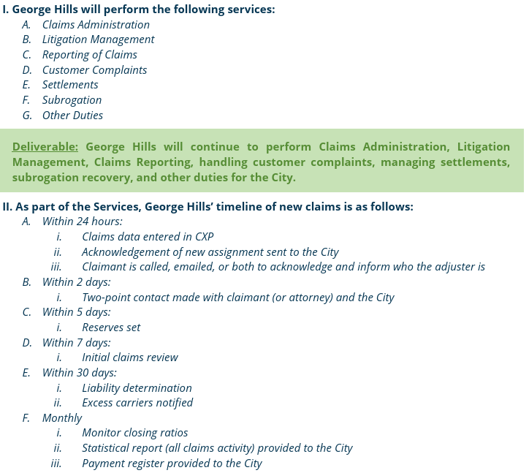
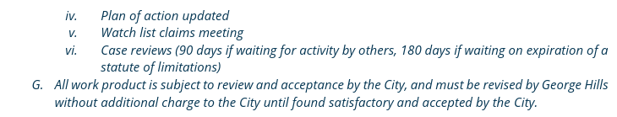

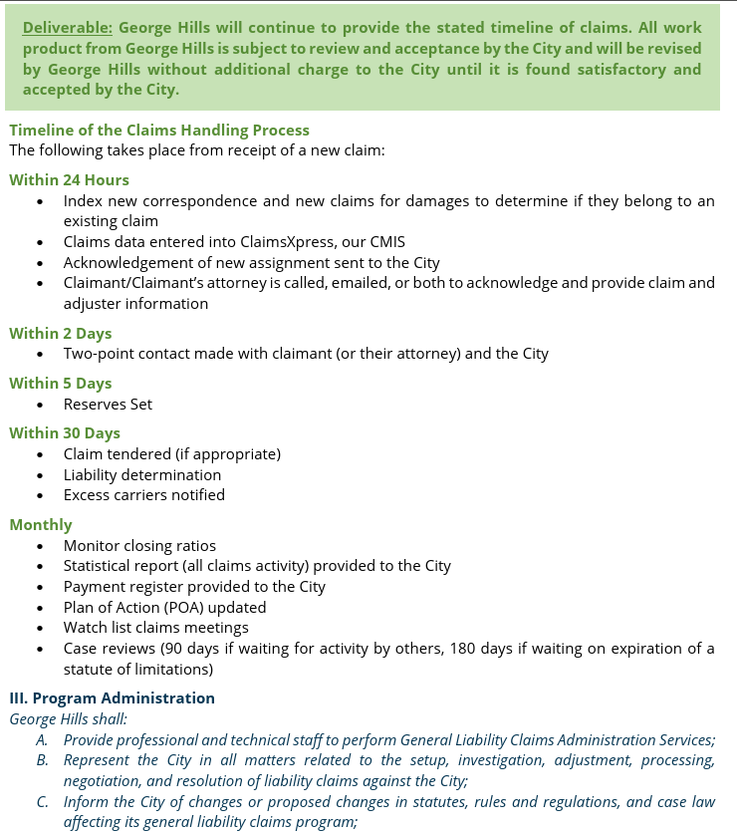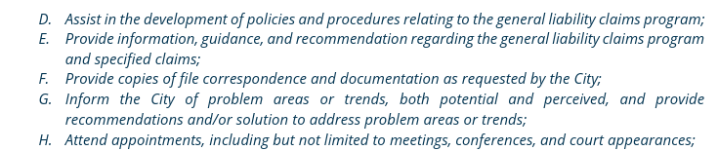

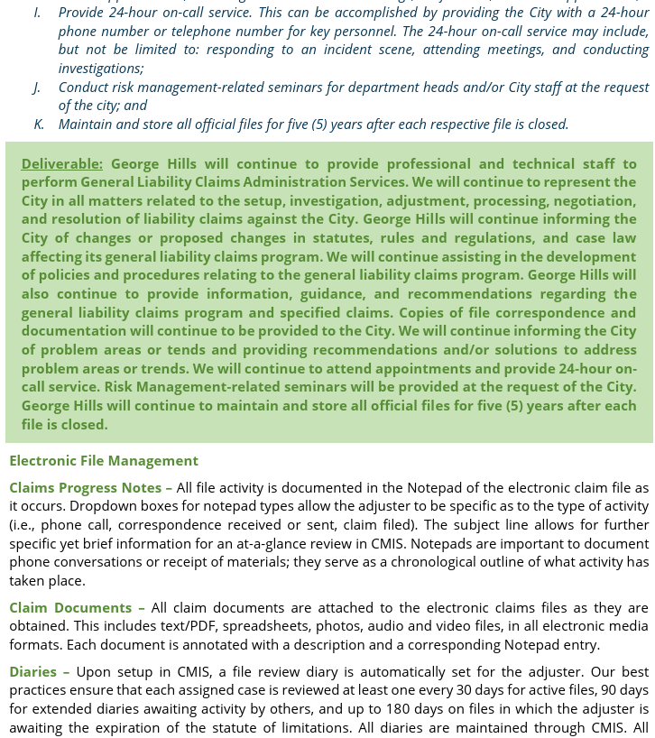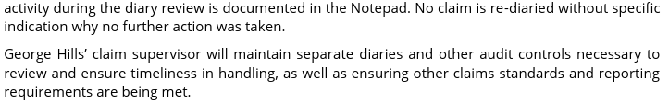
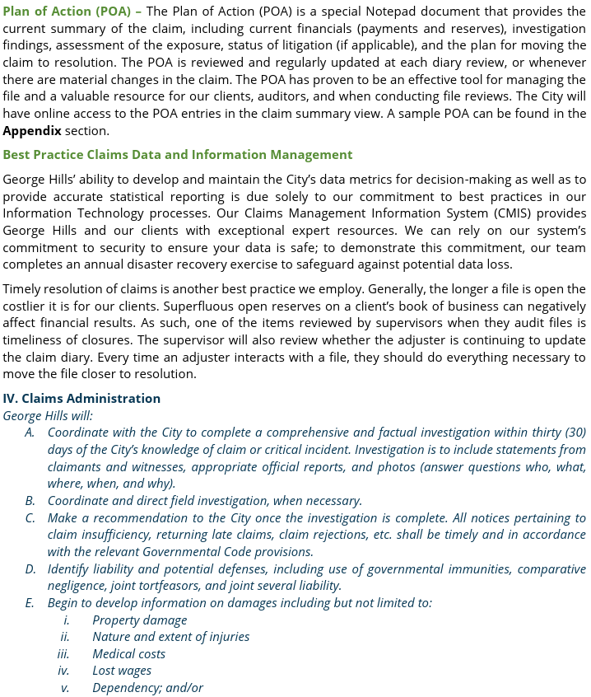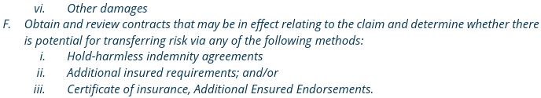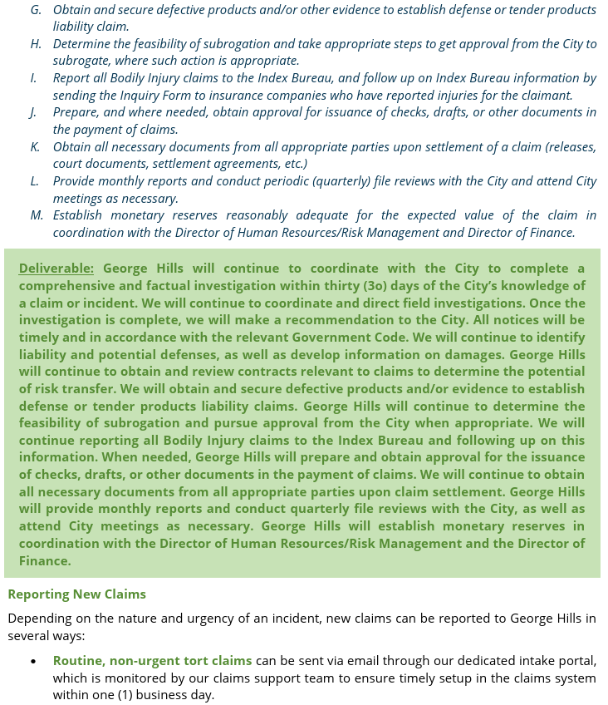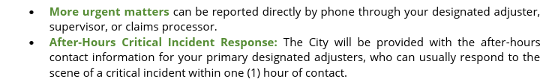
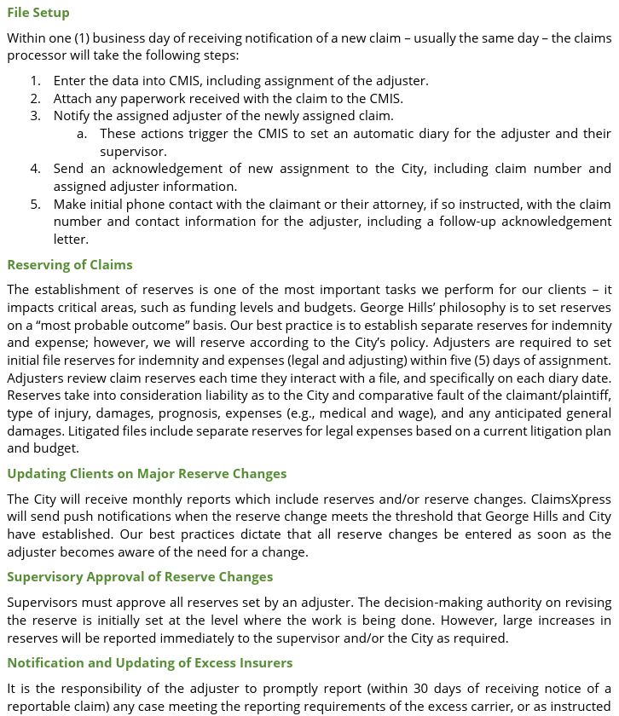

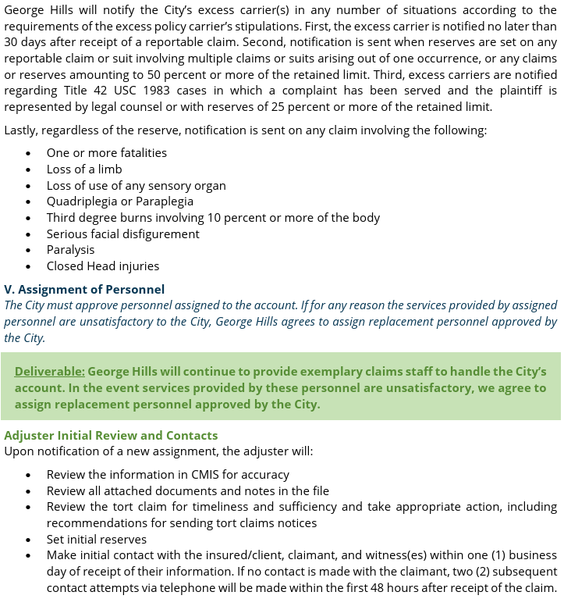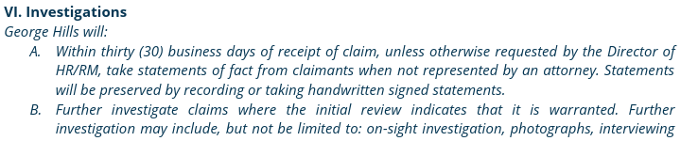

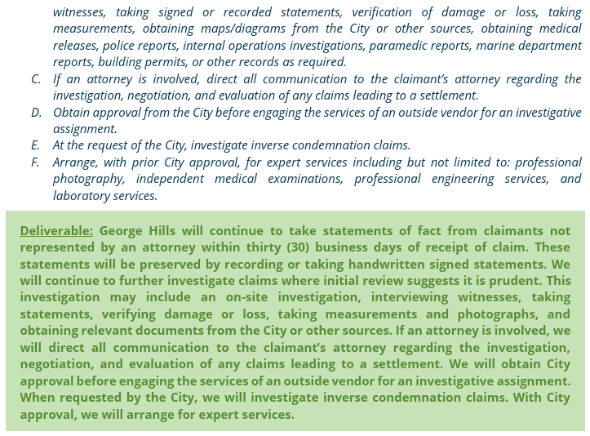
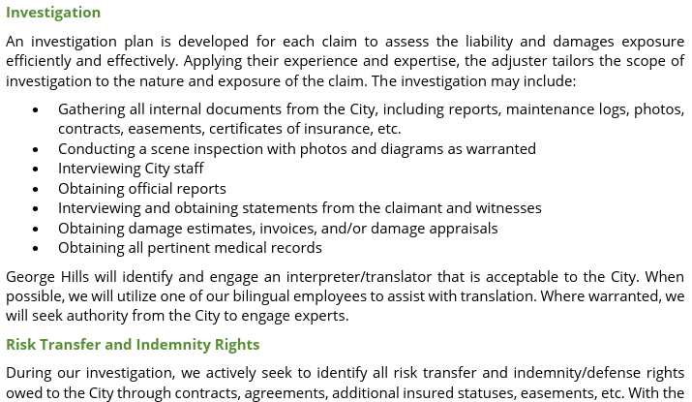
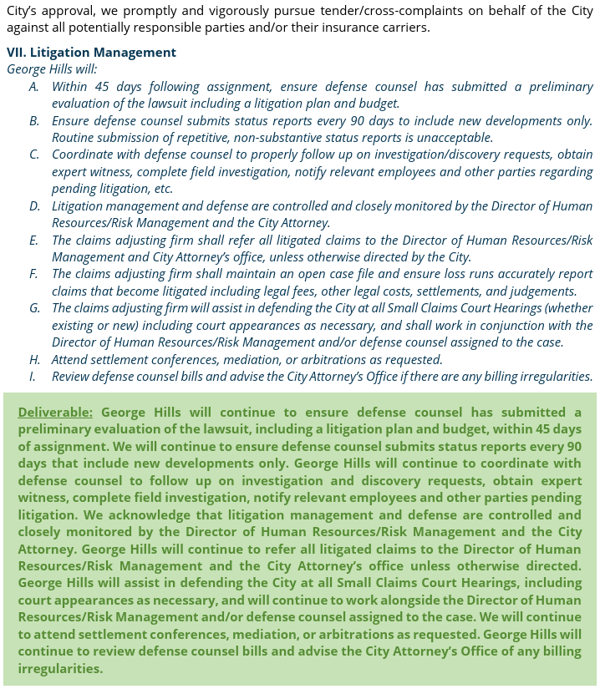
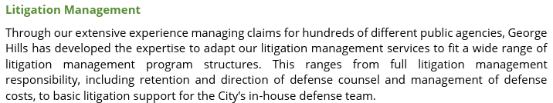
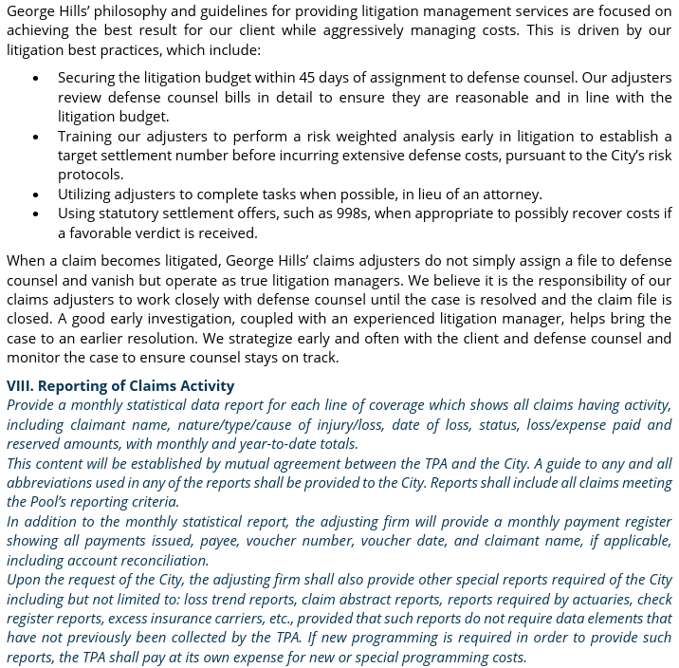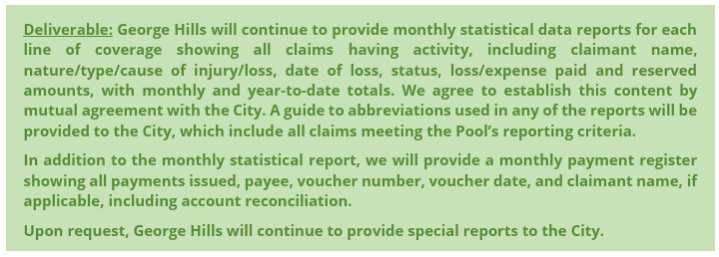
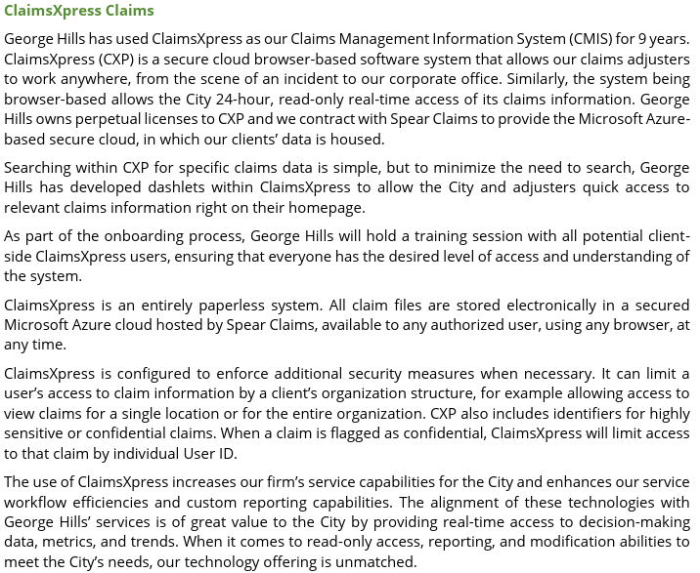
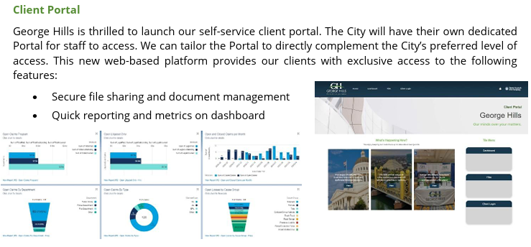

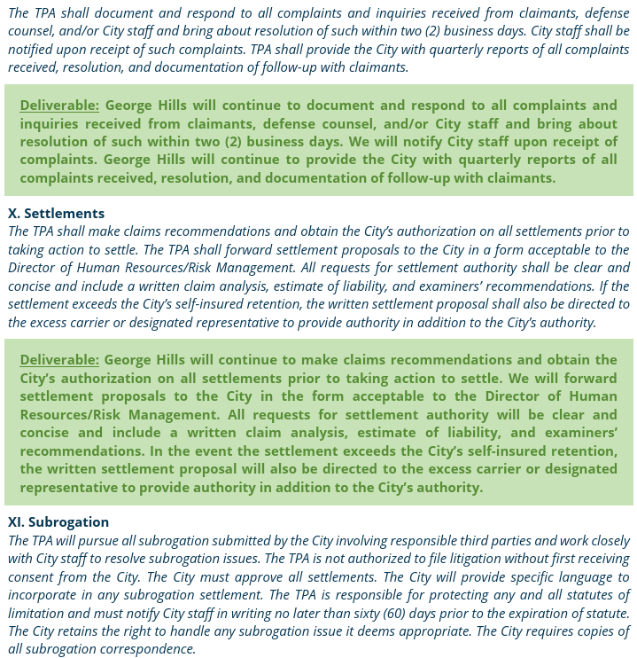
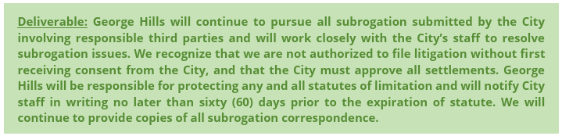

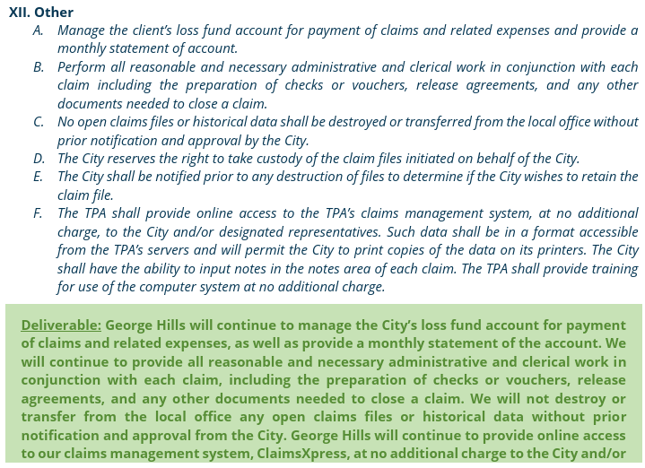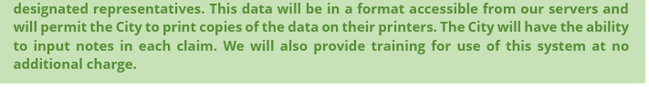

EXHIBIT “B”
“SCHEDULE OF COMPENSATION”
Subject to any limitations set forth in this Agreement, the total compensation, including reimbursement for actual expenses, shall not exceed Two Hundred Fifty-Three Thousand Five Hundred Three Dollars and Twenty-Five Cents ($253,503.25).
- Year 1: $80,500.00
- Year 2: $84,525.00
- Year 3: $88,478.25
Specifically, Consultant shall be compensated as outlined in their rate sheet included on the following pages.

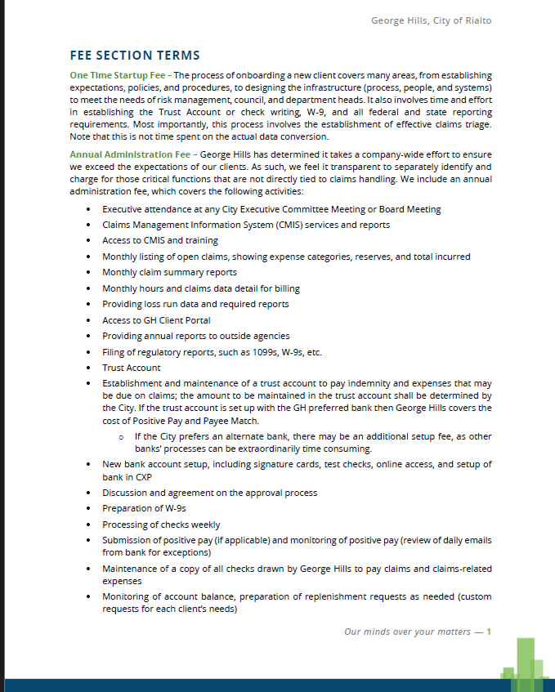

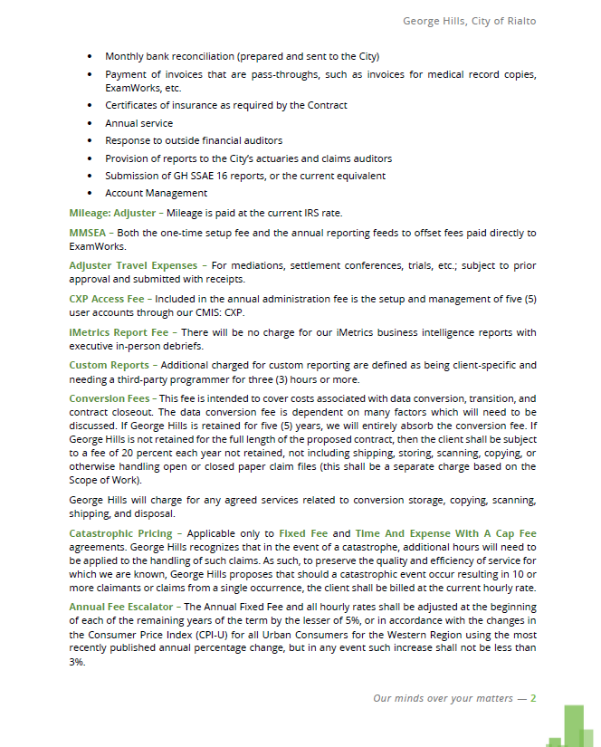

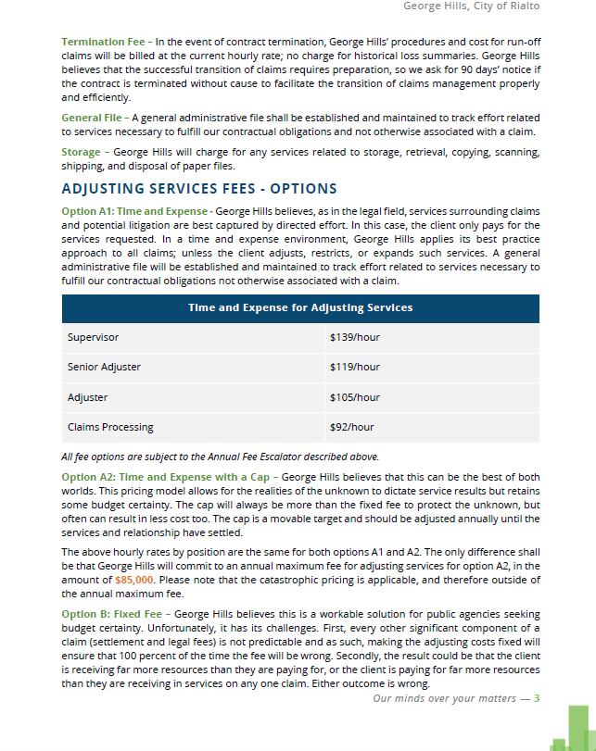

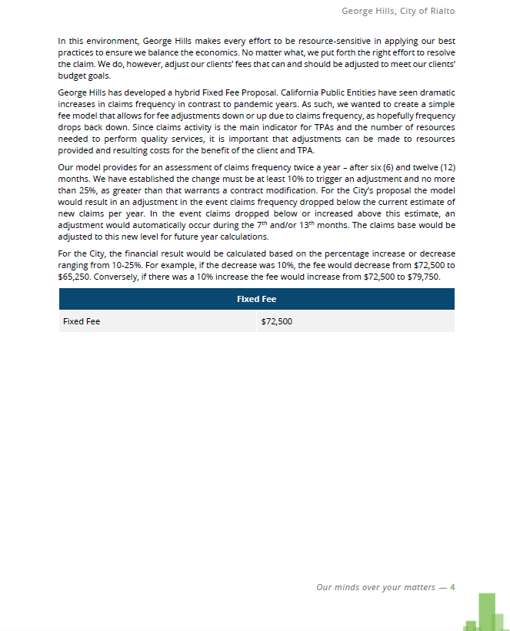

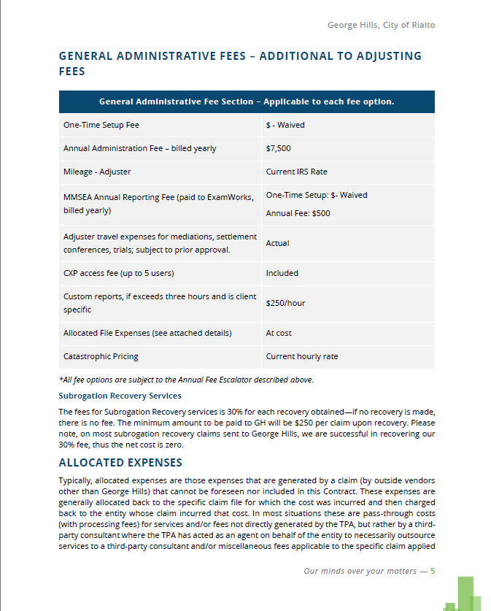

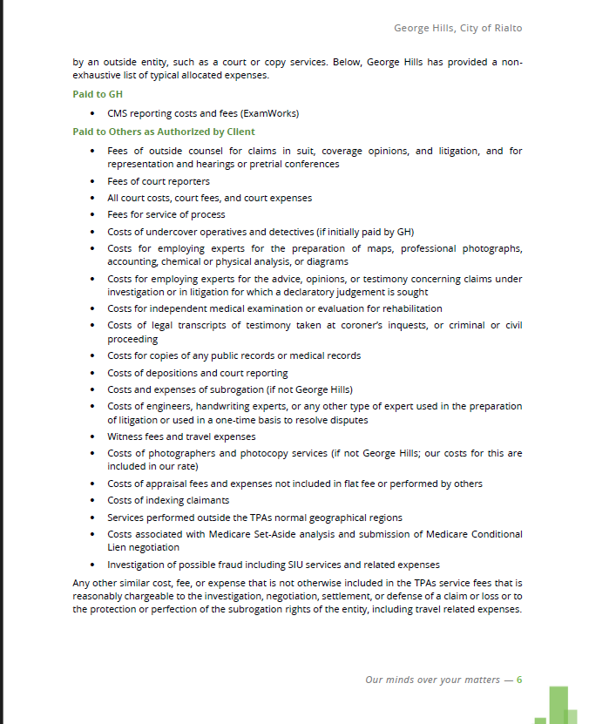

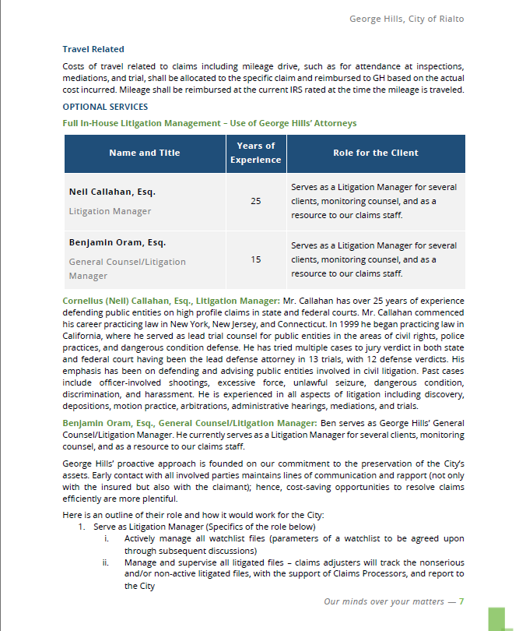

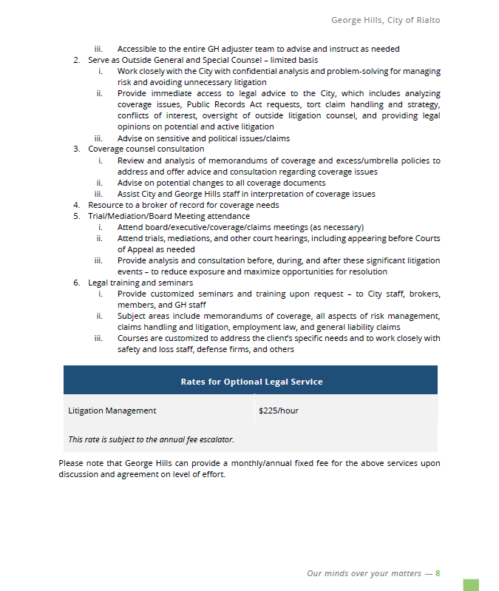

EXHIBIT “C”
“SCHEDULE OF PERFORMANCE”
Unless earlier terminated in accordance with Article 7 of this Agreement, this Agreement shall continue in full force and effect for three (3) years plus two optional one (1) year extensions based on satisfactory performance through completion of the services related to Request for Proposals No. 26-007, (the “Project”).

