

PROFESSIONAL SERVICES AGREEMENT
BETWEEN THE CITY OF RIALTO/RIALTO UTILITY AUTHORITY AND
Tree of Life Nursery

THIS SERVICES AGREEMENT (herein “Agreement”) is made and entered into this ____ day of ______________, 20__, by and between the Rialto Utility Authority, a joint powers authority (“Authority”), and Tree of Life Nursery, (“Consultant”). Authority and Consultant are sometimes individually referred to as “Party” or collectively as “Parties”.
RECITALS
A. Authority has sought, by Request for Proposals No. 24-WW0409, the performance of professional services related to plant propagation and procurement of the Rialto Habitat Nature Center, as defined and described particularly in Article 1 of this Agreement.
B. Following the submission of a proposal for the performance of the services defined and described particularly in Article 1 of this Agreement, Consultant was selected by the Authority to perform those services.
C. Pursuant to Chapter 2.48 of the Rialto Municipal Code, Authority has authority to enter into and execute this Agreement.
D. The Parties desire to formalize the selection of Consultant for the performance of those services defined and described particularly in Article 1 of this Agreement and desire that the terms of that performance be as particularly defined and described herein.
OPERATIVE PROVISIONS
NOW, THEREFORE, in consideration of the mutual promises and covenants made by the Parties and contained herein and other consideration, the value and adequacy of which are hereby acknowledged, the parties agree as follows:
ARTICLE 1. SERVICES OF CONSULTANT
1.1 Scope of Services.
In compliance with all terms and conditions of this Agreement, Consultant shall provide those professional services associated with plant propagation and procurement of the Rialto Habitat Nature Center, and as specified in the “Scope of Services” attached hereto as Exhibit “A” and incorporated herein by this reference, which services may be referred to herein as the “services” or “work” hereunder. As a material inducement for Authority to enter into this Agreement, Consultant represents and warrants that it has the qualifications, experience, and facilities necessary to properly perform the services required under this Agreement in a thorough, competent, and professional manner, it meets all local, state, and federal requirements in performing the services, and it is experienced in performing the work and services contemplated herein. Consultant shall at all times faithfully, competently, and to the best of its ability, experience, and talent, perform all services described herein. Consultant covenants that it shall follow the highest professional standards in performing the work and services required hereunder and that all materials will be of good quality, fit for the purpose intended. For purposes of this Agreement, the phrase “highest professional standards” shall mean those standards of practice recognized by one or more professional firms performing similar work under similar circumstances.
1.2 Consultant’s Proposal.
The Agreement between the Parties shall consist of the following: (1) this Agreement; (2) the Scope of Services; (3) the Authority’s Request for Proposals No. 24-WW0409; and, (4) the Consultant’s signed, original proposal submitted to the Authority (“Consultant’s Proposal”), (collectively referred to as the “Contract Documents”). The Contract Documents and Accepted Proposal shall be incorporated herein by this reference as though fully set forth herein. In the event of any inconsistency between the Scope of Services, Consultant’s Proposal, and/or this Agreement, the terms of this Agreement shall govern.
1.3 Compliance with Law.
Consultant shall keep itself informed concerning, and shall render all services hereunder in accordance with, all ordinances, resolutions, statutes, rules, and regulations of the Authority and any federal, state, or local governmental entity having jurisdiction in effect at the time service is rendered.
1.4 Licenses, Permits, Fees, and Assessments.
Consultant shall obtain, at its sole cost and expense, such licenses, permits, and approvals as may be required by law for the performance of the services required by this Agreement. Consultant shall have the sole obligation to pay for any fees, assessments, and taxes, plus applicable penalties and interest, which may be imposed by law and arise from or are necessary for the Consultant’s performance of the services required by this Agreement, and shall indemnify, defend, and hold harmless Authority, its officers, employees or agents of Authority, against any such fees, assessments, taxes penalties, or interest levied, assessed, or imposed against Authority hereunder.
1.5 Familiarity with Work.
By executing this Agreement, Consultant warrants that Consultant (i) has thoroughly investigated and considered the scope of services to be performed, (ii) has carefully considered how the services should be performed, and (iii) fully understands the facilities, difficulties, and restrictions attending performance of the services under this Agreement. If the services involve work upon any site, Consultant warrants that Consultant has or will investigate the site and is or will be fully acquainted with the conditions there existing, prior to commencement of services hereunder. If Consultant discovers any latent or unknown conditions that will materially affect the performance of the services hereunder, then Consultant shall immediately inform the Authority of such fact and shall not proceed except at Authority’s risk until written instructions are received from the Contract Officer.
1.6 Care of Work.
Consultant shall adopt reasonable methods during the life of the Agreement to furnish continuous protection to the work, and the equipment, materials, papers, documents, plans, studies, and/or other components thereof, to prevent losses or damages, and shall be responsible for all such damages to persons or property, until acceptance of the work by Authority, except such losses or damages as may be caused by Authority’s own negligence.
1.7 Prevailing Wages.
Consultant is aware of the requirements of California Labor Code Section 1720, et seq. and 1770, et seq., as well as California Code of Regulations, Title 8, Section 1600, et seq., (“Prevailing Wage Laws”), which require the payment of prevailing wage rates and the performance of other requirements on “Public Works” and “Maintenance” projects. It is the understanding of Authority and Consultant that the Prevailing Wage Laws may not apply to this Agreement because the Agreement does not involve any services subject to prevailing wage rates pursuant to the California Labor Code or regulations promulgated thereunder. However, Consultant shall defend, indemnify, and hold Authority, its elected officials, officers, employees and agents free and harmless from any claim or liability arising out of any failure or alleged failure to comply with the Prevailing Wage Laws.
1.8 Further Responsibilities of Parties.
Both Parties agree to use reasonable care and diligence to perform their respective obligations under this Agreement. Both Parties agree to act in good faith to execute all instruments, prepare all documents, and take all actions as may be reasonably necessary to carry out the purposes of this Agreement. Unless specified in this Agreement, neither Party shall be responsible for the service of the other.
1.9 Additional Services.
Authority shall have the right at any time during the performance of the services, without invalidating this Agreement, to order extra work beyond that specified in the Scope of Services or make changes by altering, adding to, or deducting from said work. No such extra work or change may be undertaken unless a written order is first given by the Contract Officer to the Consultant, describing in detail the extra work or change and the reason(s) therefor and incorporating therein any adjustment in (i) the Contract Sum for the actual cost of the extra work or change, and/or (ii) the time to perform this Agreement, which said adjustments shall be reflected in an amendment to the Agreement subject to the written approval of the Parties. Any amendment to this Agreement shall be reviewed and approved by the Executive Director. In accordance with Rialto Municipal Code section 2.48.180, increases in compensation of this Agreement may be approved by the Executive Director provided: (a) the initial Contract Sum was less than One Hundred Thousand Dollars ($100,000) and the amended Contract Sum when considering any or all amendments will not exceed One Hundred Thousand Dollars ($100,000); or (b) the agreement was approved by the Board of Directors and the increases in compensation taken either separately or cumulatively do not exceed One Hundred Thousand Dollars ($100,000). Any greater increases, taken either separately or cumulatively must be approved by the Board of Directors. Payment for additional services rendered by Consultant under this Agreement requires the submission of the actual costs of Consultant’s performance of the extra work with the invoice(s) for the extra work claim(s), as provided in Section 2.4. It is expressly understood by Consultant that the provisions of this Section shall not apply to services specifically set forth in the Scope of Services. Consultant hereby acknowledges that it accepts the risk that the services to be provided pursuant to the Scope of Services may be more costly or time consuming than Consultant anticipates and that Consultant shall not be entitled to additional compensation therefor. Authority may in its sole and absolute discretion have similar work done by other contractors.
No claim for an adjustment in the contract amount or time for performance shall be valid unless the procedures established in this Section are followed.
ARTICLE 2. COMPENSATION AND METHOD OF PAYMENT
2.1 Contract Sum.
Subject to any limitations set forth in this Agreement, Authority agrees to pay Consultant the amounts specified in the “Schedule of Compensation” attached hereto as Exhibit “B” and incorporated herein by this reference. Upon commencement of this Agreement the total compensation, including reimbursement for actual expenses, shall not exceed Ninety Four Thousand One Hundred and Seventeen dollars ($94,117) (the “Contract Sum”). The Contract Sum may also be increased for additional services pursuant to Section 1.9.
2.2 Method of Compensation.
The method of compensation may include: (i) a lump sum payment upon completion; (ii) payment in accordance with specified tasks or the percentage of completion of the services; (iii) payment for time and materials based upon the Consultant’s rates as specified in the Schedule of Compensation, provided that time estimates are provided for the performance of sub tasks, but not exceeding the Contract Sum; or (iv) such other methods as may be specified in the Schedule of Compensation.
2.3 Reimbursable Expenses.
Compensation may include reimbursement for actual and necessary expenditures for reproduction costs, telephone expenses, and travel expenses approved by the Contract Officer in advance, or actual subcontractor expenses of an approved subcontractor pursuant to Section 4.5, and only if specified in the Schedule of Compensation. The Contract Sum shall include the attendance of Consultant at all project meetings reasonably deemed necessary by the Authority. Coordination of the performance of the work with Authority is a critical component of the services. If Consultant is required to attend additional meetings to facilitate such coordination, Consultant shall not be entitled to any additional compensation for attending said meetings.
2.4 Invoices.
Each month Consultant shall furnish to Authority an original invoice for all work performed and expenses incurred during the preceding month in a form approved by City of Rialto’s Director of Finance. By submitting an invoice for payment under this Agreement, Consultant is certifying compliance with all provisions of the Agreement. The invoice shall detail charges for all necessary and actual expenses by the following categories: labor (by sub-category), travel, materials, equipment, supplies, and sub-contractor contracts. Sub-contractor charges shall also be detailed by such categories. Consultant shall not invoice Authority for any duplicate services performed by more than one person.
Authority may independently review each invoice submitted by the Consultant to determine whether the work performed, and expenses incurred are in compliance with the provisions of this Agreement. Except as to any charges for work performed or expenses incurred by Consultant which are disputed by Authority, or as provided in Section 7.3, Authority will use its best efforts to cause Consultant to be paid within thirty (30) days of receipt of Consultant’s correct and undisputed invoice; however, Consultant acknowledges and agrees that due to Authority warrant run procedures, the Authority cannot guarantee that payment will occur within this time period. In the event any charges or expenses are disputed by Authority, the original invoice shall be returned by Authority to Consultant for correction and resubmission.
2.5 No Waiver.
Review and payment by Authority to Consultant of any invoice for work performed by Consultant pursuant to this Agreement shall not be deemed a waiver of any defects in work performed by Consultant or of any rights or remedies provided herein or any applicable law.
ARTICLE 3. PERFORMANCE SCHEDULE
3.1 Time of Essence.
Time is of the essence in the performance of this Agreement.
3.2 Schedule of Performance.
Consultant shall commence the services pursuant to this Agreement upon receipt of a written notice to proceed and shall perform all services within the time period(s) established in the “Schedule of Performance” attached hereto as Exhibit “C” and incorporated herein by this reference. When requested by the Consultant, extensions to the time period(s) specified in the Schedule of Performance may be approved in writing by the Contract Officer.
3.3 Force Majeure.
The time period(s) specified in the Schedule of Performance for performance of the services rendered pursuant to this Agreement shall be extended because of any delays due to unforeseeable causes beyond the control and without the fault or negligence of the Consultant, including, but not restricted to, acts of God or of the public enemy, unusually severe weather, fires, earthquakes, floods, epidemics, quarantine restrictions, riots, strikes, freight embargoes, wars, litigation, and/or acts of any governmental agency, including the Authority, if the Consultant shall, within ten (10) days of the commencement of such delay, notify the Contract Officer in writing of the causes of the delay. The Contract Officer shall ascertain the facts and the extent of delay, and extend the time for performing the services for the period of the enforced delay when and if in the judgment of the Contract Officer such delay is justified. The Contract Officer shall extend the time for performance in accordance with the procedures set forth in Section 1.9. The Contract Officer’s determination shall be final and conclusive upon the Parties to this Agreement. In no event shall Consultant be entitled to recover damages against the Authority for any delay in the performance of this Agreement, however caused, Consultant’s sole remedy being extension of the Agreement pursuant to this Section.
3.4 Term.
Unless earlier terminated in accordance with Article 7 of this Agreement, this Agreement shall continue in full force and effect through completion of the services related to Request for Proposals No. 24-WW0409, (the “Project”), and as identified in the Schedule of Performance, Exhibit “C”.
ARTICLE 4. COORDINATION OF WORK
4.1 Representatives and Personnel of Consultant.
The following principals of Consultant (“Principals”) are hereby designated as being the principals and representatives of Consultant authorized to act in its behalf with respect to the work specified herein and make all decisions in connection therewith:

Elana Benge Contract Sales

Jeff Bohn Vice-President

It is expressly understood that the experience, knowledge, capability, and reputation of the foregoing Principals were a substantial inducement for Authority to enter into this Agreement. Therefore, the Principals shall be responsible during the term of this Agreement for directing all activities of Consultant and devoting sufficient time to personally supervise the services hereunder. All personnel of Consultant, and any authorized agents, shall at all times be under the exclusive direction and control of the Principals. For purposes of this Agreement, the Principals may not be replaced nor may their responsibilities be substantially reduced by Consultant without the express written approval of Authority. Additionally, Consultant shall utilize only competent personnel to perform services pursuant to this Agreement. Consultant shall make every reasonable effort to maintain the stability and continuity of Consultant’s staff and subcontractors, if any, assigned to perform the services required under this Agreement. Consultant shall notify Authority of any changes in Consultant’s staff and subcontractors, if any, assigned to perform the services required under this Agreement, prior to and during any such performance. In the event that Authority, in its sole discretion, at any time during the term of this Agreement, desires to reassign any staff or subcontractor of Consultant, Consultant shall, immediately upon a Reassign Notice from Authority of such desire of Authority, reassign such persons or persons.
4.2 Status of Consultant.
Consultant shall have no authority to bind Authority in any manner, or to incur any obligation, debt or liability of any kind on behalf of or against Authority, whether by contract or otherwise, unless such authority is expressly conferred under this Agreement or is otherwise expressly conferred in writing by Authority. Consultant shall not at any time or in any manner represent that Consultant or any of Consultant’s officers, employees, or agents are in any manner officials, officers, employees or agents of Authority. Neither Consultant, nor any of Consultant’s officers, employees or agents, shall obtain any rights to retirement, health care, or any other benefits which may otherwise accrue to Authority’s employees. Consultant expressly waives any claim Consultant may have to any such rights.
4.3 Contract Officer.
The Contract Officer shall be the Executive Director or other such person designated by the Executive Director. It shall be the Consultant’s responsibility to assure that the Contract Officer is kept informed of the progress of the performance of the services and the Consultant shall refer any decisions which must be made by Authority to the Contract Officer. Unless otherwise specified herein, any approval of Authority required hereunder shall mean the approval of the Contract Officer. The Contract Officer shall have authority, if specified in writing by the Executive Director, to sign all documents on behalf of the Authority required hereunder to carry out the terms of this Agreement.
4.4 Independent Contractor.
Neither the Authority nor any of its employees shall have any control over the manner, mode, or means by which Consultant, its agents or employees, perform the services required herein, except as otherwise set forth herein. Authority shall have no voice in the selection, discharge, supervision or control of Consultant’s employees, servants, representatives, or agents, or in fixing their number, compensation, or hours of service. Consultant shall perform all services required herein as an independent contractor of Authority and shall remain at all times as to Authority a wholly independent contractor with only such obligations as are consistent with that role. Consultant shall not at any time or in any manner represent that it or any of its agents or employees are agents or employees of Authority. Authority shall not in any way or for any purpose become or be deemed to be a partner of Consultant in its business or otherwise or a joint venturer or a member of any joint enterprise with Consultant.
4.5 Prohibition Against Subcontracting or Assignment.
The experience, knowledge, capability, and reputation of Consultant, its principals and employees were a substantial inducement for the Authority to enter into this Agreement. Therefore, Consultant shall not contract with any other entity to perform in whole or in part the services required hereunder without the express written approval of the Authority. In addition, neither this Agreement nor any interest herein may be transferred, assigned, conveyed, hypothecated, or encumbered voluntarily or by operation of law, whether for the benefit of creditors or otherwise, without the prior written approval of Authority. Transfers restricted hereunder shall include the transfer to any person or group of persons acting in concert of more than twenty five percent (25%) of the present ownership and/or control of Consultant, taking all transfers into account on a cumulative basis. In the event of any such unapproved transfer, including any bankruptcy proceeding, this Agreement shall be void. No approved transfer shall release the Consultant or any surety of Consultant of any liability hereunder without the express consent of Authority.
ARTICLE 5. INSURANCE, INDEMNIFICATION AND BONDS
5.1 Insurance Coverages.
The Consultant shall procure and maintain, at its sole cost and expense, in a form and content satisfactory to Authority, during the entire term of this Agreement including any extension thereof, the following policies of insurance which shall cover all elected and appointed officers, employees, and agents of Authority:
(a) Comprehensive General Liability Insurance (Occurrence Form CG0001 or equivalent). A policy of comprehensive general liability insurance written on a per occurrence basis for bodily injury, personal injury, and property damage. The policy of insurance shall be in an amount not less than $1,000,000.00 per occurrence or if a general aggregate limit is used, then the general aggregate limit shall be twice the occurrence limit.
(b) Worker’s Compensation Insurance. A policy of worker’s compensation insurance in such amount as will fully comply with the laws of the State of California and which shall indemnify, insure, and provide legal defense for both the Consultant and the Authority against any loss, claim, or damage arising from any injuries or occupational diseases occurring to any worker employed by or any persons retained by the Consultant in the course of carrying out the work or services contemplated in this Agreement.
(c) Automotive Insurance (Form CA 0001 (Ed 1/87) including “any auto” and endorsement CA 0025 or equivalent). A policy of comprehensive automobile liability insurance written on a per occurrence for bodily injury and property damage in an amount not less than $1,000,000. Said policy shall include coverage for owned, non-owned, leased, and hired cars.
(d) Professional Liability. Professional liability insurance appropriate to the Consultant’s profession. This coverage may be written on a “claims made” basis, and must include coverage for contractual liability. The professional liability insurance required by this Agreement must be endorsed to be applicable to claims based upon, arising out of, or related to services performed under this Agreement. The insurance must be maintained for at least 5 consecutive years following the completion of Consultant’s services or the termination of this Agreement. During this additional 5-year period, Consultant shall annually and upon request of the Authority submit written evidence of this continuous coverage.
(e) Additional Insurance. Policies of such other insurance, as may be required in the Special Requirements.
(f) Subcontractors. Consultant shall include all subcontractors as insureds under its policies or shall furnish separate certificates and certified endorsements for each subcontractor. All coverages for subcontractors shall be subject to all of the requirements stated herein.
5.2 General Insurance Requirements.
All of the above policies of insurance shall be primary insurance and shall name the Authority, its elected and appointed officers, employees, and agents as additional insureds, and any insurance maintained by Authority or its officers, employees, or agents shall apply in excess of, and not contribute with, Consultant’s insurance. The insurer is deemed hereof to waive all rights of subrogation and contribution it may have against the Authority, its officers, employees, and agents and their respective insurers. The insurance policy must specify that where the primary insured does not satisfy the self-insured retention, any additional insured may satisfy the self-insured retention. All of said policies of insurance shall provide that said insurance may not be amended or cancelled by the insurer or any Party hereto without providing thirty (30) days prior written notice by certified mail return receipt requested to the Authority. In the event any of said policies of insurance are cancelled, the Consultant shall, prior to the cancellation date, submit new evidence of insurance in conformance with Section 5.1 to the Contract Officer. No work or services under this Agreement shall commence until the Consultant has provided the Authority with Certificates of Insurance or appropriate insurance binders evidencing the above insurance coverages and said Certificates of Insurance or binders are approved by the Authority. Authority reserves the right to inspect complete, certified copies of all required insurance policies at any time. Any failure to comply with the reporting or other provisions of the policies including breaches or warranties shall not affect coverage provided to Authority.
Authority, its respective elected and appointed officers, directors, officials, employees, agents and volunteers are to be covered as additional insureds as respects: liability arising out of activities Consultant performs; products and completed operations of Consultant; premises owned, occupied or used by Consultant; or automobiles owned, leased, hired or borrowed by Consultant. The coverage shall contain no special limitations on the scope of protection afforded to Authority, and their respective elected and appointed officers, officials, employees or volunteers. Consultant’s insurance shall apply separately to each insured against whom claim is made or suit is brought, except with respect to the limits of the insurer’s liability.
Any deductibles or self-insured retentions must be declared to and approved by Authority. At the option of Authority, either the insurer shall reduce or eliminate such deductibles or self-insured retentions as respects Authority or its respective elected or appointed officers, officials, employees and volunteers or the Consultant shall procure a bond guaranteeing payment of losses and related investigations, claim administration, defense expenses and claims. The Consultant agrees that the requirement to provide insurance shall not be construed as limiting in any way the extent to which the Consultant may be held responsible for the payment of damages to any persons or property resulting from the Consultant’s activities or the activities of any person or persons for which the Consultant is otherwise responsible nor shall it limit the Consultant’s indemnification liabilities as provided in Section 5.3.
In the event the Consultant subcontracts any portion of the work in compliance with Section 4.5 of this Agreement, the contract between the Consultant and such subcontractor shall require the subcontractor to maintain the same policies of insurance that the Consultant is required to maintain pursuant to Section 5.1, and such certificates and endorsements shall be provided to Authority.
5.3 Indemnification.
To the full extent permitted by law, Consultant agrees to indemnify, defend, and hold harmless the Authority, its officers, employees and agents (“Indemnified Parties”) against any and all actions, either judicial, administrative, arbitration or regulatory claims, damages to persons or property, losses, costs, penalties, obligations, errors, omissions or liabilities whether actual or threatened (herein “claims or liabilities”) that may be asserted or claimed by any person, firm or entity arising out of or in connection with the negligent performance of the work, operations, or activities provided herein of Consultant, its officers, employees, agents, subcontractors, or invitees, or any individual or entity for which Consultant is legally liable (“indemnitors”), arising from Consultant’s reckless or willful misconduct, or arising from Consultant’s or indemnitors’ negligent performance of or failure to perform any term, provision, covenant, or condition of this Agreement, and in connection therewith:
(a) Consultant will defend any action or actions filed in connection with any of said claims or liabilities and will pay all costs and expenses, including legal costs and attorneys’ fees incurred in connection therewith;
(b) Consultant will promptly pay any judgment rendered against the Authority, its officers, agents, or employees for any such claims or liabilities arising out of or in connection with the negligent performance of or failure to perform such work, operations or activities of Consultant hereunder; and Consultant agrees to save and hold the Authority, its officers, agents, and employees harmless therefrom;
(c) In the event the Authority, its officers, agents or employees is made a party to any action or proceeding filed or prosecuted against Consultant for such damages or other claims arising out of or in connection with the negligent performance of or failure to perform the work, operation or activities of Consultant hereunder, Consultant agrees to pay to the Authority, its officers, agents, or employees, any and all costs and expenses incurred by the Authority, its officers, agents, or employees in such action or proceeding, including but not limited to, legal costs and attorneys’ fees.
Consultant shall incorporate similar, indemnity agreements with its subcontractors and if it fails to do so Consultant shall be fully responsible to indemnify Authority hereunder therefore, and failure of Authority to monitor compliance with these provisions shall not be a waiver hereof. This indemnification includes claims or liabilities arising from any negligent or wrongful act, error or omission, or reckless or willful misconduct of Consultant in the performance of professional services hereunder. The provisions of this Section do not apply to claims or liabilities occurring as a result of Authority’s sole negligence or willful acts or omissions, but, to the fullest extent permitted by law, shall apply to claims and liabilities resulting in part from Authority’s negligence, except that design professionals’ indemnity hereunder shall be limited to claims and liabilities arising out of the negligence, recklessness, or willful misconduct of the design professional. The indemnity obligation shall be binding on successors and assigns of Consultant and shall survive termination of this Agreement.
Notwithstanding the foregoing, to the extent that the Consultant’s services are subject to California Civil Code Section 2782.8, the above indemnity, including the cost to defend, shall be limited to the extent required by Civil Code Section 2782.8.
5.4 Sufficiency of Insurer or Surety.
Insurance required by this Agreement shall be satisfactory only if issued by companies qualified to do business in California, rated “A” or better in the most recent edition of Best Rating Guide, The Key Rating Guide or in the Federal Register, and only if they are of a financial category Class VII or better, unless such requirements are waived by the Risk Manager of the City of Rialto (“Risk Manager”) due to unique circumstances. If this Agreement continues for more than 3 years duration, or in the event the Risk Manager determines that the work or services to be performed under this Agreement creates an increased or decreased risk of loss to the Authority, the Consultant agrees that the minimum limits of the insurance policies may be changed accordingly upon receipt of written notice from the Risk Manager Consultant.
ARTICLE 6. RECORDS, REPORTS, AND RELEASE OF INFORMATION
6.1 Records.
Consultant shall keep, and require subcontractors to keep, such ledgers books of accounts, invoices, vouchers, canceled checks, reports, studies or other documents relating to the disbursements charged to Authority and services performed hereunder (the “books and records”), as shall be necessary to perform the services required by this Agreement and enable the Contract Officer to evaluate the performance of such services. Any and all such documents shall be maintained in accordance with generally accepted accounting principles and shall be complete and detailed. The Contract Officer shall have full and free access to such books and records at all times during normal business hours of Authority, including the right to inspect, copy, audit and make records and transcripts from such records. Such records shall be maintained for a period of 3 years following completion of the services hereunder, and the Authority shall have access to such records in the event any audit is required. In the event of dissolution of Consultant’s business, custody of the books and records may be given to Authority, and access shall be provided by Consultant’s successor in interest.
6.2 Reports.
Consultant shall periodically prepare and submit to the Contract Officer such reports concerning the performance of the services required by this Agreement as the Contract Officer shall require. Consultant hereby acknowledges that the Authority is greatly concerned about the cost of work and services to be performed pursuant to this Agreement. For this reason, Consultant agrees that if Consultant becomes aware of any facts, circumstances, techniques, or events that may or will materially increase or decrease the cost of the work or services contemplated herein or, if Consultant is providing design services, the cost of the project being designed, Consultant shall promptly notify the Contract Officer of said fact, circumstance, technique or event and the estimated increased or decreased cost related thereto and, if Consultant is providing design services, the estimated increased or decreased cost estimate for the project being designed.
6.3 Ownership of Documents.
All drawings, specifications, maps, designs, photographs, studies, surveys, data, notes, computer files, reports, records, documents and other materials (the “documents and materials”) prepared by Consultant, its employees, subcontractors and agents in the performance of this Agreement shall be the property of Authority and shall be delivered to Authority upon request of the Contract Officer or upon the termination of this Agreement, and Consultant shall have no claim for further employment or additional compensation as a result of the exercise by Authority of its full rights of ownership use, reuse, or assignment of the documents and materials hereunder. Any use, reuse or assignment of such completed documents for other projects and/or use of uncompleted documents without specific written authorization by the Consultant will be at the Authority’s sole risk and without liability to Consultant, and Consultant’s guarantee and warranties shall not extend to such use, reuse or assignment. Consultant may retain copies of such documents for its own use. Consultant shall have the right to use the concepts embodied therein. All subcontractors shall provide for assignment to Authority any documents or materials prepared by them, and in the event Consultant fails to secure such assignment, Consultant shall indemnify Authority for all damages resulting therefrom.
6.4 Confidentiality and Release of Information.
(a) All information gained, or work product produced by Consultant in performance of this Agreement shall be considered confidential, unless such information is in the public domain or already known to Consultant. Consultant shall not release or disclose any such information or work product to persons or entities other than Authority without prior written authorization from the Contract Officer.
(b) Consultant, its officers, employees, agents or subcontractors, shall not, without prior written authorization from the Contract Officer or unless requested by the Authority Counsel, voluntarily provide documents, declarations, letters of support, testimony at depositions, response to interrogatories or other information concerning the work performed under this Agreement. Response to a subpoena or court order shall not be considered “voluntary” provided Consultant gives Authority notice of such court order or subpoena.
(c) If Consultant, or any officer, employee, agent or subcontractor of Consultant, provides any information or work product in violation of this Agreement, then Authority shall have the right to reimbursement and indemnity from Consultant for any damages, costs and fees, including attorney’s fees, caused by or incurred as a result of Consultant’s conduct.
(d) Consultant shall promptly notify Authority should Consultant, its officers, employees, agents, or subcontractors be served with any summons, complaint, subpoena, notice of deposition, request for documents, interrogatories, request for admissions or other discovery request, court order or subpoena from any party regarding this Agreement and the work performed there under. Authority retains the right, but has no obligation, to represent Consultant or be present at any deposition, hearing or similar proceeding. Consultant agrees to cooperate fully with Authority and to provide Authority with the opportunity to review any response to discovery requests provided by Consultant. However, this right to review any such response does not imply or mean the right by Authority to control, direct, or rewrite said response.
ARTICLE 7. ENFORCEMENT OF AGREEMENT AND TERMINATION
7.1 California Law.
This Agreement shall be interpreted, construed, and governed both as to validity and to performance of the Parties in accordance with the laws of the State of California. Legal actions concerning any dispute, claim, or matter arising out of or in relation to this Agreement shall be instituted in the Superior Court of the County of San Bernardino, State of California, or any other appropriate court in such county, and Consultant covenants and agrees to submit to the personal jurisdiction of such court in the event of such action. In the event of litigation in a U.S. District Court, venue shall lie exclusively in the Central District of California, Eastern Division.
7.2 Disputes; Default.
In the event that Consultant is in default under the terms of this Agreement, the Authority shall not have any obligation or duty to continue compensating Consultant for any work performed after the date of default. Instead, the Authority may give notice to Consultant of the default and the reasons for the default. The notice shall include the timeframe in which Consultant may cure the default. This timeframe is presumptively thirty (30) days, but may be extended, though not reduced, if circumstances warrant. During the period of time that Consultant is in default, the Authority shall hold all invoices and shall proceed with payment on the invoices only when the default is cured. In the alternative, the Authority may, in its sole discretion, elect to pay some or all of the outstanding invoices during the period of default. If Consultant does not cure the default, the Authority may take necessary steps to terminate this Agreement under this Article. Any failure on the part of the Authority to give notice of the Consultant’s default shall not be deemed to result in a waiver of the Authority’s legal rights or any rights arising out of any provision of this Agreement.
7.3 Retention of Funds.
Consultant hereby authorizes Authority to deduct from any amount payable to Consultant (whether or not arising out of this Agreement) (i) any amounts the payment of which may be in dispute hereunder or which are necessary to compensate Authority for any losses, costs, liabilities, or damages suffered by Authority, and (ii) all amounts for which Authority may be liable to third parties, by reason of Consultant’s acts or omissions in performing or failing to perform Consultant’s obligation under this Agreement. In the event that any claim is made by a third party, the amount or validity of which is disputed by Consultant, or any indebtedness shall exist which shall appear to be the basis for a claim of lien, Authority may withhold from any payment due, without liability for interest because of such withholding, an amount sufficient to cover such claim. The failure of Authority to exercise such right to deduct or to withhold shall not, however, affect the obligations of the Consultant to insure, indemnify, and protect Authority as elsewhere provided herein.
7.4 Waiver.
Waiver by any Party to this Agreement of any term, condition, or covenant of this Agreement shall not constitute a waiver of any other term, condition, or covenant. Waiver by any Party of any breach of the provisions of this Agreement shall not constitute a waiver of any other provision or a waiver of any subsequent breach or violation of any provision of this Agreement. Acceptance by Authority of any work or services by Consultant shall not constitute a waiver of any of the provisions of this Agreement. No delay or omission in the exercise of any right or remedy by a non-defaulting Party on any default shall impair such right or remedy or be construed as a waiver. Any waiver by either Party of any default must be in writing and shall not be a waiver of any other default concerning the same or any other provision of this Agreement.
7.5 Rights and Remedies are Cumulative.
Except with respect to rights and remedies expressly declared to be exclusive in this Agreement, the rights and remedies of the Parties are cumulative and the exercise by either Party of one or more of such rights or remedies shall not preclude the exercise by it, at the same or different times, of any other rights or remedies for the same default or any other default by the other Party.
7.6 Legal Action.
In addition to any other rights or remedies, either Party may take legal action, in law or in equity, to cure, correct, or remedy any default, to recover damages for any default, to compel specific performance of this Agreement, to obtain declaratory or injunctive relief, or to obtain any other remedy consistent with the purposes of this Agreement.
7.7 Termination Prior to Expiration of Term.
This Section shall govern any termination of this Contract except as specifically provided in the following Section for termination for cause. Authority reserves the right to terminate this Contract at any time, with or without cause, upon thirty (30) days’ written notice to Consultant, except that where termination is due to the fault of the Consultant, the period of notice may be such shorter time as may be determined by the Contract Officer. Upon receipt of any notice of termination, Consultant shall immediately cease all services hereunder except such as may be specifically approved by the Contract Officer. Consultant shall be entitled to compensation for all services rendered prior to the effective date of the notice of termination and for any services authorized by the Contract Officer thereafter in accordance with the Schedule of Compensation or such as may be approved by the Contract Officer, except as provided in Section 7.3. In the event of termination without cause pursuant to this Section, the Authority need not provide the Consultant with the opportunity to cure pursuant to Section 7.2.
7.8 Termination for Default of Consultant.
If termination is due to the failure of the Consultant to fulfill its obligations under this Agreement, Authority may, after compliance with the provisions of Section 7.2, take over the work and prosecute the same to completion by contract or otherwise, and the Consultant shall be liable to the extent that the total cost for completion of the services required hereunder exceeds the compensation herein stipulated (provided that the Authority shall use reasonable efforts to mitigate such damages), and Authority may withhold any payments to the Consultant for the purpose of set-off or partial payment of the amounts owed the Authority as previously stated.
ARTICLE 8. AUTHORITY OFFICERS AND EMPLOYEES: NON-DISCRIMINATION
8.1 Non-liability of Authority Officers and Employees.
No officer or employee of the Authority shall be personally liable to the Consultant, or any successor in interest, in the event of any default or breach by the Authority or for any amount which may become due to the Consultant or to its successor, or for breach of any obligation of the terms of this Agreement.
8.2 Conflict of Interest.
Consultant covenants that neither it, nor any officer or principal of its firm, has or shall acquire any interest, directly or indirectly, which would conflict in any manner with the interests of Authority, or which would in any way hinder Consultant’s performance of services under this Agreement. Consultant further covenants that in the performance of this Agreement, no person having any such interest shall be employed by it as an officer, employee, agent or subcontractor without the express written consent of the Contract Officer. Consultant agrees to at all times avoid conflicts of interest or the appearance of any conflicts of interest with the interests of Authority in the performance of this Agreement.
No officer or employee of the Authority shall have any financial interest, direct or indirect, in this Agreement nor shall any such officer or employee participate in any decision relating to the Agreement which effects his financial interest or the financial interest of any corporation, partnership or association in which he is, directly or indirectly, interested, in violation of any State statute or regulation. The Consultant warrants that it has not paid or given and will not pay or give any third party any money or other consideration for obtaining this Agreement.
Additionally, pursuant to Rialto Municipal Code section 2.48.145, Consultant represents that it has disclosed whether it or its officers or employees is related to any officer or employee of the Authority by blood or marriage within the third degree which would subject such officer or employee to the prohibition of California Government Sections 87100 et. seq., Fair Political Practices Commission Regulation Section 18702, or Government Code Section 1090. To this end, by approving this Agreement, Consultant attests under penalty of perjury, personally and on behalf of Consultant, as well its officers, representatives, that it/they have no relationship, as described above, or financial interests, as such term is defined in California Government Section 87100 et. seq., Fair Political Practices Commission Regulation Section 18702, or Government Code Section 1090, with any City of Rialto elected or appointed official or employee, except as specifically disclosed to the Authority in writing.
8.3 Covenant Against Discrimination.
Consultant covenants that, by and for itself, its heirs, executors, assigns, and all persons claiming under or through them, there shall be no discrimination against or segregation of any person or group of persons on account of race, color, creed, religion, sex, gender, sexual orientation, gender identity, marital status, national origin, ancestry, or other protected class in the performance of this Agreement. Consultant shall take affirmative action to ensure that applicants are employed and that employees are treated during employment without regard to their race, color, creed, religion, sex, sexual orientation, gender, gender identity, marital status, national origin, ancestry, or other protected class.
8.4 Unauthorized Aliens.
Consultant hereby promises and agrees to comply with all of the provisions of the Federal Immigration and Nationality Act, 8 U.S.C.A. §§ 1101, et seq., as amended, and in connection therewith, shall not employ unauthorized aliens as defined therein. Should Consultant so employ such unauthorized aliens for the performance of work and/or services covered by this Agreement, and should any liability or sanctions be imposed against Authority for such use of unauthorized aliens, Consultant hereby agrees to and shall reimburse Authority for the cost of all such liabilities or sanctions imposed, together with any and all costs, including attorney’s fees, incurred by Authority.
ARTICLE 9. MISCELLANEOUS PROVISIONS
9.1 Facilities and Equipment.
Except as otherwise provided, Consultant shall, at its own cost and expense, provide all facilities and equipment necessary to perform the services required by this Agreement. Authority shall make available to Consultant only physical facilities such as desks, filing cabinets, and conference space (“Facilities”), as may be reasonably necessary for Consultant’s use while consulting with Authority employees and reviewing records and the information in possession of Authority. The location, quality, and time of furnishing of Facilities shall be in the sole discretion of Authority. In no event shall Authority be required to furnish any facilities that may involve incurring any direct expense, including but not limited to computer, long distance telephone, network data, internet, or other communication charges, vehicles, and reproduction facilities.
9.2 Payment of Taxes.
Consultant is solely responsible for the payment of employment taxes incurred under this Agreement and any federal and state taxes.
9.3 Notices.
All notices or other communications required or permitted hereunder shall be in writing, and shall be personally delivered, sent by pre-paid First Class U.S. Mail, registered or certified mail, postage prepaid, return receipt requested, or delivered or sent by facsimile with attached evidence of completed transmission, and shall be deemed received upon the earlier of (i) the date of delivery to the address of the person to receive such notice if delivered personally or by messenger or overnight courier; (ii) three (3) business days after the date of posting by the United States Post Office if by mail; or (iii) when sent if given by facsimile. Any notice, request, demand, direction, or other communication sent by facsimile must be confirmed within forty-eight (48) hours by letter mailed or delivered. Other forms of electronic transmission such as e-mails, text messages, instant messages are not acceptable manners of notice required hereunder. Notices or other communications shall be addressed as follows:
If to Authority: City of Rialto/Rialto Utility Authority
150 S. Palm Ave.
Rialto, CA 92376
Attn: Executive Director
Tel: (909) 820-2525
Fax: (909) 820-2527

With copy to: Burke, Williams & Sorensen, LLP
1770 Iowa Avenue, Suite 240
Riverside, CA 92507
Attn: Eric S. Vail, City Attorney/Authority Counsel
Tel: (951) 788-0100
Fax: (951) 788-5785

If to Consultant: Tree of Life Nursery
33201 Ortega Hwy
San Juan Capistrano, CA 92675
Elana Benge
(949) 728-0685
Either Party may change its address by notifying the other Party of the change of address in writing.
9.4 Interpretation.
The terms of this Agreement shall be construed in accordance with the meaning of the language used and shall not be construed for or against either Party by reason of the authorship of this Agreement or any other rule of construction which might otherwise apply.
9.5 Counterparts.
This Agreement may be executed in counterparts, each of which shall be deemed to be an original, and such counterparts shall constitute one and the same instrument.
9.6 Integration; Amendment.
This Agreement including the attachments hereto is the entire, complete and exclusive expression of the understanding of the Parties. It is understood that there are no oral agreements between the Parties hereto affecting this Agreement and this Agreement supersedes and cancels any and all previous negotiations, arrangements, agreements and understandings, if any, between the Parties, and none shall be used to interpret this Agreement. No amendment to or modification of this Agreement shall be valid unless made in writing and approved by the Consultant and by the Authority. The Parties agree that this requirement for written modifications cannot be waived and that any attempted waiver shall be void.
9.7 Severability.
In the event that any one or more of the phrases, sentences, clauses, paragraphs, or sections contained in this Agreement shall be declared invalid or unenforceable by a valid judgment or decree of a court of competent jurisdiction, such invalidity or unenforceability shall not affect any of the remaining phrases, sentences, clauses, paragraphs, or sections of this Agreement which are hereby declared as severable and shall be interpreted to carry out the intent of the Parties hereunder unless the invalid provision is so material that its invalidity deprives either Party of the basic benefit of their bargain or renders this Agreement meaningless.
9.8 Corporate Authority.
The persons executing this Agreement on behalf of the Parties hereto warrant that (i) such Party is duly organized and existing, (ii) they are duly authorized to execute and deliver this Agreement on behalf of said Party, (iii) by so executing this Agreement, such Party is formally bound to the provisions of this Agreement, and (iv) the entering into this Agreement does not violate any provision of any other Agreement to which said Party is bound. This Agreement shall be binding upon the heirs, executors, administrators, successors and assigns of the Parties.
9.9 Conflicting Terms
Except as otherwise stated herein, if the terms of this Agreement conflict with the terms of any Exhibit hereto, or with the terms of any document incorporated by reference into this Agreement, the terms of this Agreement shall control.
[SIGNATURES ON FOLLOWING PAGE]

IN WITNESS WHEREOF, the parties hereto have executed and entered into this Agreement on the date first written above.
AUTHORITY: |  |  | CONSULTANT:
RIALTO UTILITY AUTHORITY, a joint powers authority |  |  | Tree of Life
By: |  |  | By:
 | David N. Carmany, Executive Director |  |  | Signature
ATTEST:
 |  |  |  | Jeff Bohn
By:
 | Barbara A. McGee, Board Secretary |  |  | Part-Owner/Partner/Vice-President
 |  |  |  | Title
APPROVED AS TO FORM:
 |  |  | By:
Burke, Williams & Sorensen, LLP |  |  |  | Signature
By:
 | Eric S. Vail, Authority Counsel |  |  | Name
 |  |  |  | Title
 |  |  | **Two signatures are required if a corporation**

EXHIBIT “A“
SCOPE OF SERVICES

- Understanding of the City's Request for Qualifications needs

i. Tree of Life Nursery is offering a proposal to grow California native plant material for Rialto Habitat Nature Center. These plants would be grown from seeds and/or cuttings collected within 75 miles of Rialto.

Please note that all plants are being offered on our "Cost Proposal" to be grown in 1 gallon pots, instead of tree bands and tree pots.

One item on your list, Verbena lilacina 'De la Mina', is more of an ornamental plant and doesn't quite match the other habitat type plants. We also grow Verbena lasiostachys in case you want that instead.

Please note that in order to have crops ready for installation between January and April 2025, we'd need to have a confirmed order with a deposit by April 30, 2024.

ii. Tree of Life Nursery has extensive experience producing large quantities of California native plants, utilizing seeds and/or cuttings and proper transplanting times, corresponding with the plants and seasonal needs. Communication will be provided primarily electronically and by telephone. Updates on plant progress will be provided via email.

iii. Tree of Life Nursery will grow plants, as specified, and deliver full truck loads(2500 - 3000 1 gallon plants) with delivery fees specified in "Cost Proposal."

- Project Manager Qualifications

i. Elana Benge, Contract Sales will be the Project Manager, operating under our Head Grower, Jeff Bohn.

ii. Elana Benge has successfully completed over 100 contract grow projects, being involved in all phases of production, from procuring propagules to the final delivery. Jeff Bohn has completed over 1000 projects.

iii. Elana Benge has been employed by Tree of Life Nursery for 15 years and Jeff Bohn has been part-owner/partner/Vice-President for over 40 years.

iv. Tree of Life Nursery is adequately staffed to grow these plants for you.

C. Firm's Qualifications

The information requested here has been provided in Attachment "A" - Small
Business Concerns Information.

No sub-consultants will be utilized.

D. Firm's Resources

i. Tree of Life Nursery is equipped to provide the plants, as noted on this proposal. A 25% deposit would be required to initiate production and an additional 25% after 2 months.
Should City of Rialto increase their demand for services, the specifics of such an increase would dictate the increased cost and time required.

ii. Please see organizational chart below and our Equal Employment Opportunity Handbook.
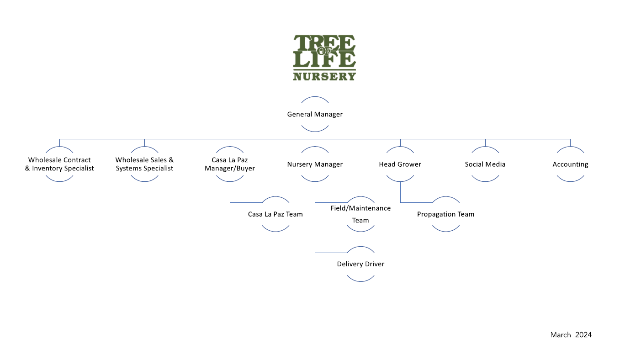
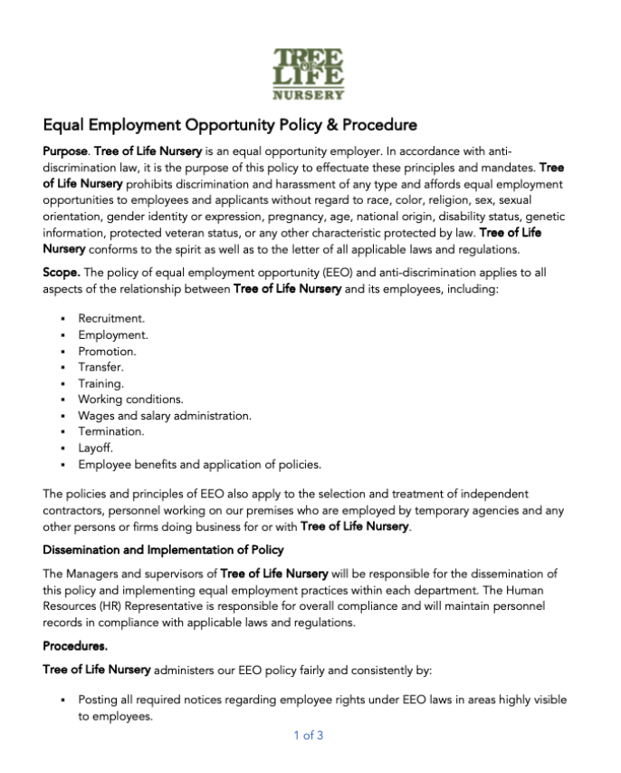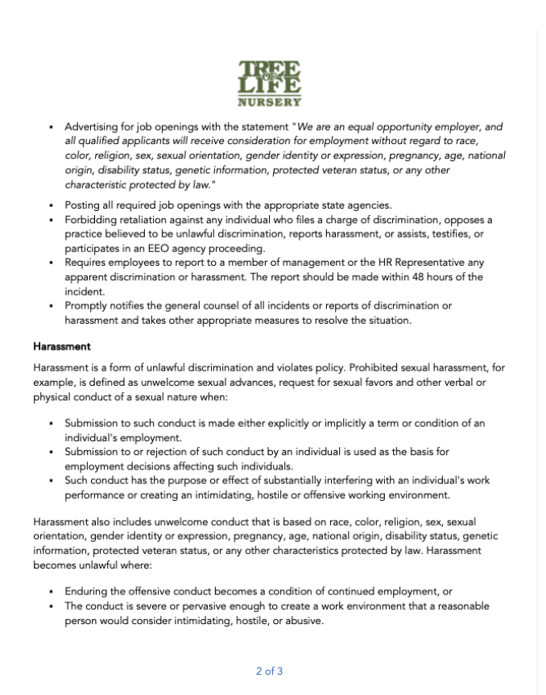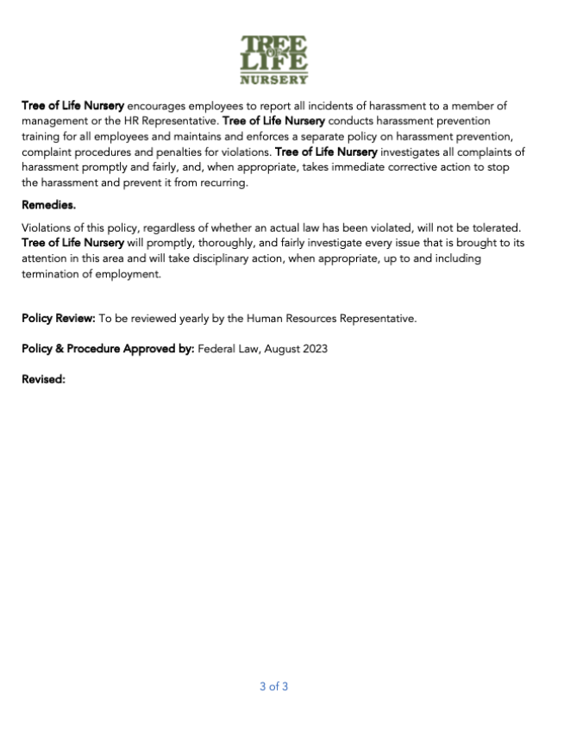
Additional Background Information

Tree of Life Nursery was established in 1976 and is one of the largest native plant suppliers
in California. The 40-acre nursery produces a high quality line of California natives on the historic Rancho Mission Viejo in San Juan Capistrano. More than 500 species and varieties of native plants are grown in various container sizes. Tree of Life provides plants for landscaping and ecological restoration at the wholesale level. In addition, natives are made available to the general public through Casa ‘La Paz’ where plants and books are on display for retail sales. The nursery website, www.CaliforniaNaivePlants.com provides information on the use of native plants in the garden. The Tree of Life Nursery catalog, entitled “Plants of El Camino Real,” is used as a planning tool for horticultural professionals and garden enthusiasts working with native plants.

Work with Rare & Endangered Plant Species
Since 1980, tree of Life Nursery has worked at various times with rare, threatened and endangered species under jurisdiction of federal, state, and local agencies. Projects include the recovery of 14 rare and 4 threatened species on San Clemente Island (USFWS and U.S. Navy), propagation and recovery of San Diego Willowy Mint (State of California and Caltrans), multithemed Dudley (County of Orange), and storage, increase and production of thread-leaved brodiaea in San Diego County. The nursery’s reputation for working with rare species under various MOU’s is based on their careful record keeping, professional handling, state-of-the-art facilities, and horticultural expertise.

EXHIBIT “B”
“SCHEDULE OF COMPENSATION”

A 25% deposit would be required to initiate production and an additional 25% after 2 months. Should City of Rialto increase their demand for services, the specifics of such an increase would dictate the increased cost and time required.

EXHIBIT “C”
“SCHEDULE OF PERFORMANCE”
Tree of Life Nursery is equipped to provide the plants, as noted on this proposal.

