ORDINANCE NO. 1709
AN ORDINANCE OF THE CITY COUNCIL OF THE CITY OF RIALTO, CALIFORNIA, AMENDING TITLE 18 (ZONING) OF THE RIALTO MUNICIPAL CODE TO MODIFY CHAPTER 18.116 ESTABLISHING A HOUSING OPPORTUNITY DISTRICT TO ACCOMMODATE HOUSING AND MODIFYING PERMITTED LAND USES AND RESIDENTIAL DENSITIES IN ACCORDANCE WITH THE HOUSING ELEMENT REZONE PROGRAM IMPLEMENTATION PROJECT

WHEREAS, there is a shortage of affordable housing in the City of Rialto (“City”) as documented in the 2021-2029 (6th Cycle) General Plan Housing Element; and
WHEREAS, the 2021-2029 (6th Cycle) General Plan Housing Element is a mandatory element of the City’s General Plan and the City’s main housing policy and planning document that identifies housing needs and constraints, sets forth goals, policies and programs that address these needs and constraints, and plans for projected housing needs for all income levels based on the City’s assigned Regional Housing Needs Allocation (RHNA); and
WHEREAS, California Government Code Section 65580(d) states that all cities have a responsibility to use the powers vested in them to facilitate the improvement and development of housing and to make adequate provisions for the housing needs of all economic segments of the community; and
WHEREAS, the Housing Element includes a Sites Inventory, which identifies suitable sites throughout the City that can adequately accommodate the required capacity set forth by the City’s RHNA which for the 2021-2029 (6th Cycle) planning period is 8,272 housing units; and
WHEREAS, consistent with State Law, Housing Goal #2 is to “Promote and encourage housing development that adequately meets the needs of all socioeconomic segments of the community and region”; and
WHEREAS, in order to implement Housing Element Goal #2, Housing Program 2B, referred to as the Rezone Program, calls for the City to rezone to provide adequate sites to accommodate RHNA; and
WHEREAS, the City’s Rezone Program includes a residential overlay affecting 315 parcels totaling approximately 323 acres; and
WHEREAS, the City’s Rezone Program includes a provision to permit at least 20 units per acre on sites identified in a prior housing element; and
WHEREAS, pursuant to the California Environmental Quality Act (CEQA), Initial Study/Mitigated Negative Declaration (IS/MND) was prepared for this Project in compliance with CEQA and the local environmental review guidelines; and
WHEREAS, pursuant to Government Code Sections 65350-65362, the Planning Commission held a public hearing for a proposed amendment to the zoning code and forwarded a recommendation to the City Council for action; and
WHEREAS, on January 21, 2026, the Planning Commission of the City of Rialto conducted a duly noticed public hearing, as required by law, on ZCA No. 25-0002; heard public testimony; discussed ZCA No. 25-0002; and closed the public hearing; and
WHEREAS, the Planning Commission voted 6-0 to recommend the City Council approve the GPA No. 25-0001; and
WHEREAS, pursuant to Government Code Section 65350-65362, on February 24, 2026, the City Council of the City of Rialto conducted a duly noticed public hearing, as required by law, on ZCA No. 25-0002, heard testimony, at which time it received input from staff and the city attorney; received public testimony; discussed the proposed ZCA No. 25-0002; and closed the public hearing; and

WHEREAS, the final adoption of the IS/MND and approval of the draft Zoning Code Amendment shall be considered by the City Council as the final approval authority, after evaluation of the environmental document; and
WHEREAS, all legal prerequisites to the adoption of this Resolution have occurred.
NOW, THEREFORE, the City Council of the City of Rialto, California, does hereby ordain as follows:
SECTION 1. The City Council hereby specifically finds that facts set forth in the recitals above of this Ordinance are true and correct and are incorporated herein.
SECTION 2. Pursuant to the California Environmental Quality Act (CEQA), an Initial Study/Mitigated Negative Declaration (IS/MND) was prepared for the draft 2021-2029 Housing Element Update in compliance with CEQA and the local environmental review guidelines;
SECTION 3. The Rialto Municipal Code shall be amended to revise the following code section in the manner shown, with underlined text representing added language. All unmarked text shall remain unmodified and in full force and effect. The Rialto Municipal code shall be amended to read as follows:
“Chapter 18.116 RESIDENTIAL OVERLAY HOUSING OPPORTUNITY DISTRICT

18.116.010 Purpose.
The intent of the residential overlay is to allow for attractive high density residential development in appropriate areas of the city while allowing existing development to remain and retain the development potential of the underlying zoning. All underlying uses, legally permitted, may remain and the underlying zoning shall remain intact. The residential overlay is an additional layer of permitted uses that can be utilized. Property owners will retain full discretion to use the residential overlay, if they choose, to pursue development of residential units. The residential overlay does not impose any obligation on property owners to convert or change the use of their commercial or other non-residential uses. There is no mechanism proposed by the rezone program to mandate or impose an obligation on existing property owners to redevelop their properties for residential uses.

The Housing Opportunity District (HOD) implements policies and programs addressed in the City’s Housing Element. By facilitating the development of a HOD project of residential-only or residential with commercial uses, on select parcels the HOD encourages:

- The implementation of goals and policies of the general plan;
- A diversity of single- and/or multifamily housing types in a residential-only or mixed-use configuration to increase housing choice and affordability;
- A compatible mix of uses with an emphasis on residential and supporting limited uses, that include commercial uses and those uses supported by surrounding uses and development patterns.

The purpose of the residential overlay is to accomplish the following objectives:
A. To provide an overlay zone which will implement the goals and policies of the General Plan;
B. To provide additional housing options for people, including but not limited to, students, young professionals and older people, who want to live near their workplace and/or near retail and other non-residential uses;
C. To ensure compatibility of residential projects with surrounding uses and development patterns;
D. To create additional opportunities, but not impose any obligation, for development beyond those uses allowed in the underlying zoning district; and
E. To protect underlying land uses and the established character of existing neighborhoods.

18.116.020 Application Applicability.
The regulations in this chapter apply only to residential and/or mixed-use development located within the HOD. All mixed-use development standards shall conform to the regulations of the underlying zone, except as identified in this Chapter. The HOD applies in certain portions of the city as shown in the maps provided herein.

18.116.040 Permitted uses.
Uses permitted in the Housing Opportunity District Residential Overlay are as follows:
- Multiple family dwellings, consisting of four or less units;
- Multiple family dwelling developments consisting of five or more units are permitted subject to the issuance of a conditional development permit by the City Planning Commission.
- Development projects consisting of 100 percent residential within areas having an underlying zone of commercial, mixed-use, or residential.
- A mix of residential development and commercial development—no maximum percentage of residential, a maximum of 50 percent commercial of the total floor area—when the property is located in an area with an underlying zone of commercial or mixed-use.
- Development projects consisting of any number of units, in which twenty percent or more of the residential units are affordable to lower-income households are permitted by-right and subject to the provisions of Government Code Section 65583.2 subdivisions (h) and (i).

18.116.050 Regulations–Adoption by reference.
The regulations of the R-4 High Density Multiple Family Zone, outlined in Chapter 18.24 of this title, apply to residential structures in the Housing Opportunity District Residential Overlay zone, except as otherwise provided in this chapter.

18.116.060 Regulations–Exceptions.
The exceptions to the R-4 High Density Multiple Family Zone regulations, as set forth in this section, are applicable to residential structures in the Residential Overlay Housing Opportunity District.
- Maximum density.
  - 35 dwelling units per acre for properties identified in:
    - 18.116.020(A) located near Baseline Road and Riverside Avenue,
    - 18.116.020(B) located in the Foothill Boulevard Specific Plan area, and
    - 18.116.020(C) located in Gateway Specific Plan area.
  - 40 dwelling units per acre for properties identified in:
    - 18.116.020(D) located near North Riverside Avenue and Easton Street and
    - 18.116.020(E) located within the Central Area Specific Plan.
- Minimum residential density of 20 du/ac shall apply to all sites identified on Table 1.
- B. Maximum residential density is 35-40 du/ac in areas with an underlying residential zone and 50 du/ac in areas with an underlying commercial zone, as identified on Table1.
- Maximum building coverage is seventy 70 percent of the lot area for all sites identified on Table 1.
- Building height limit, five stories or sixty 60 feet.”

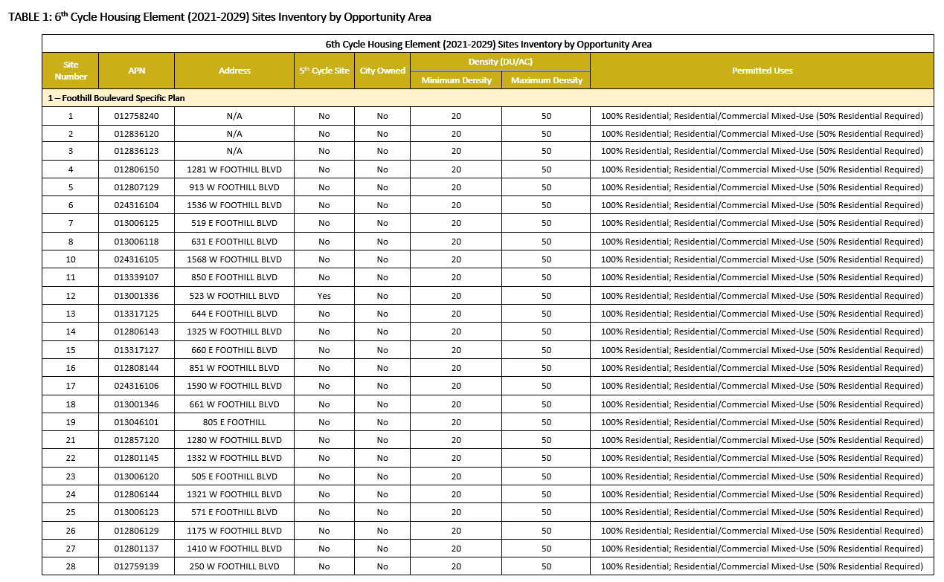
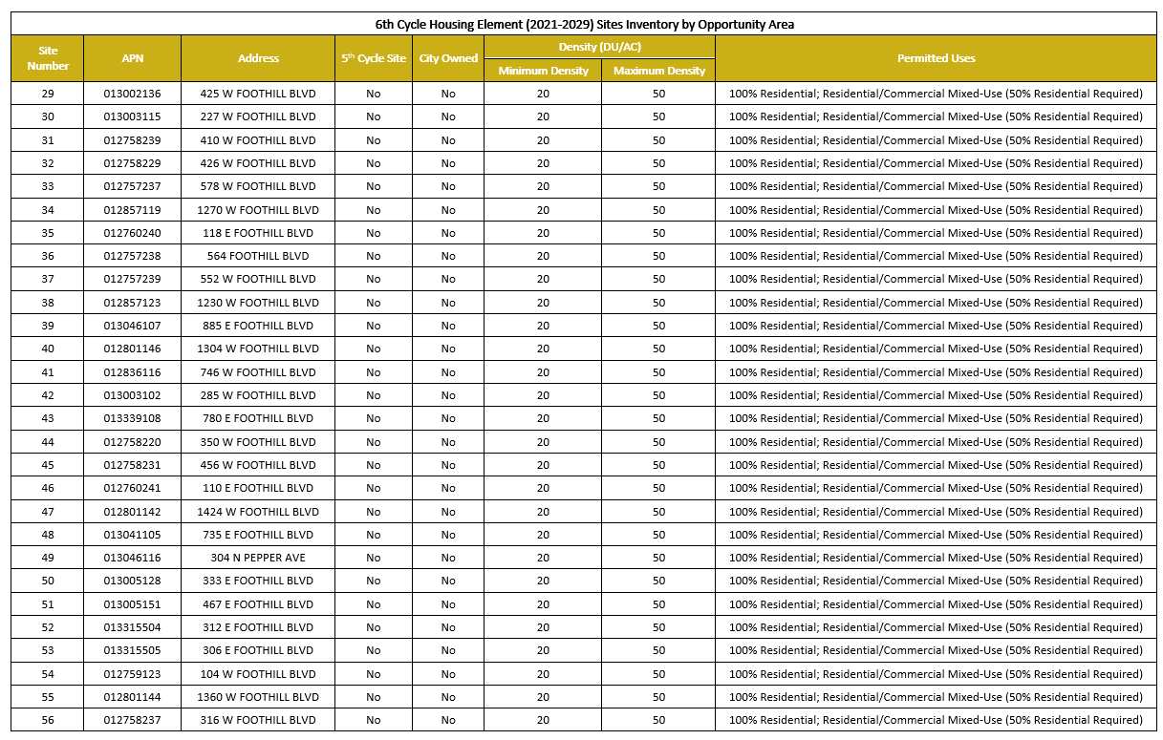

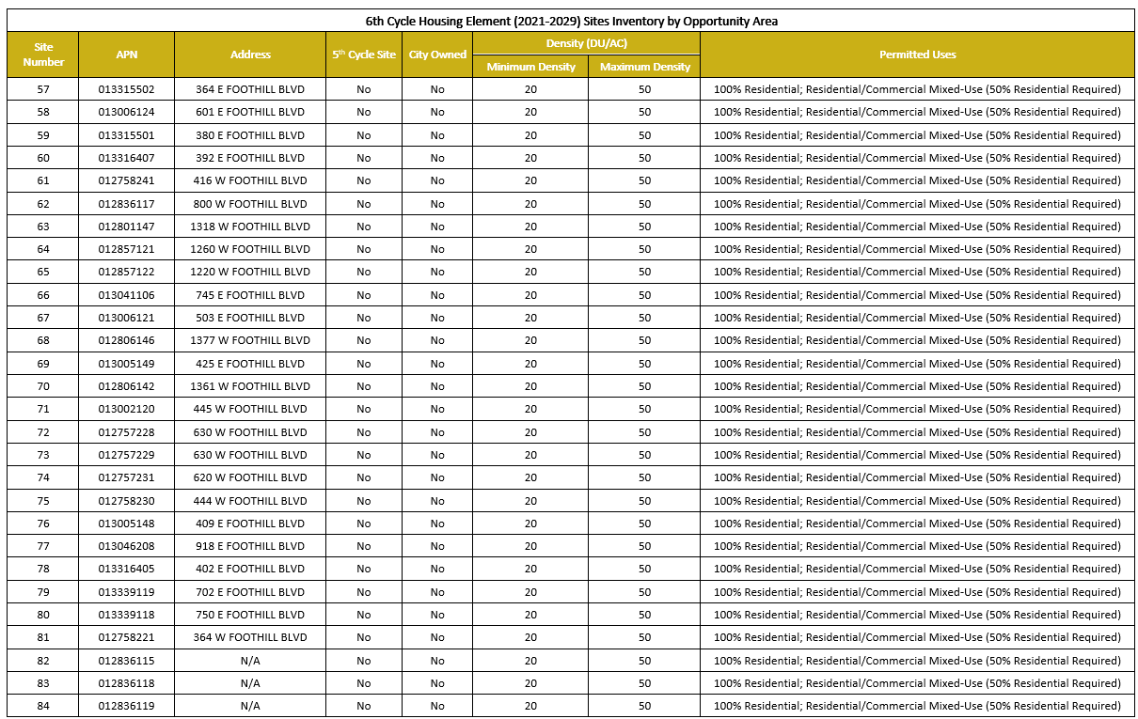

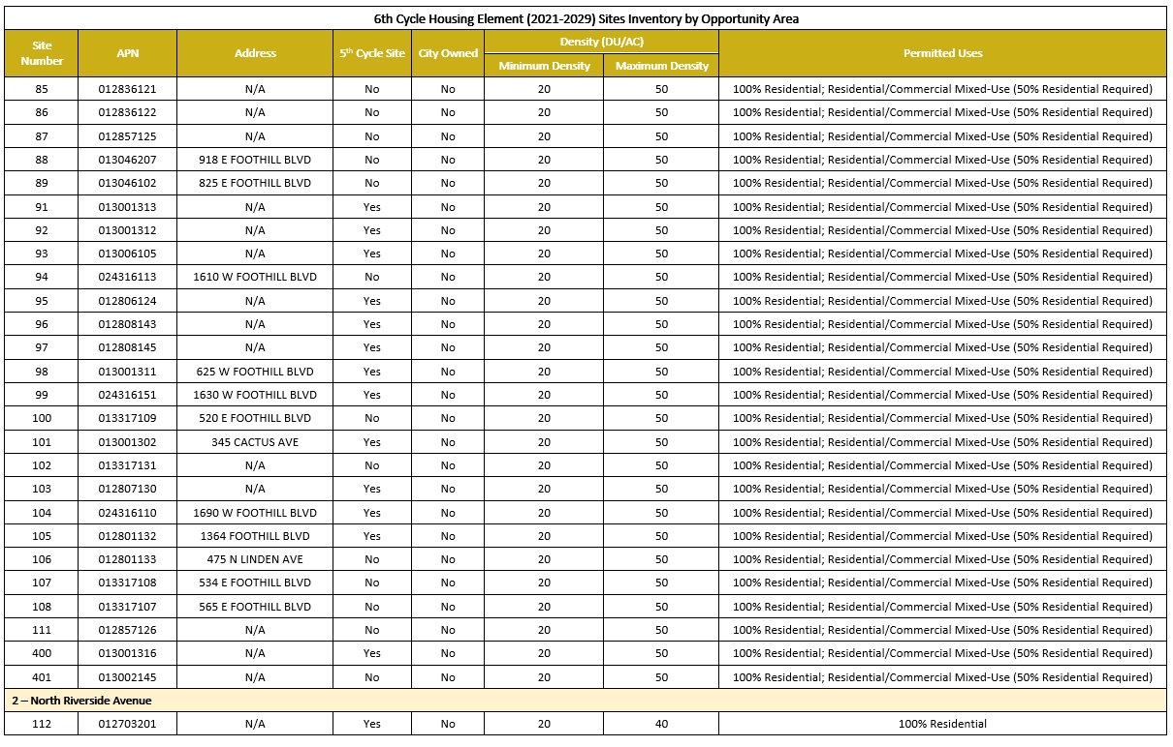

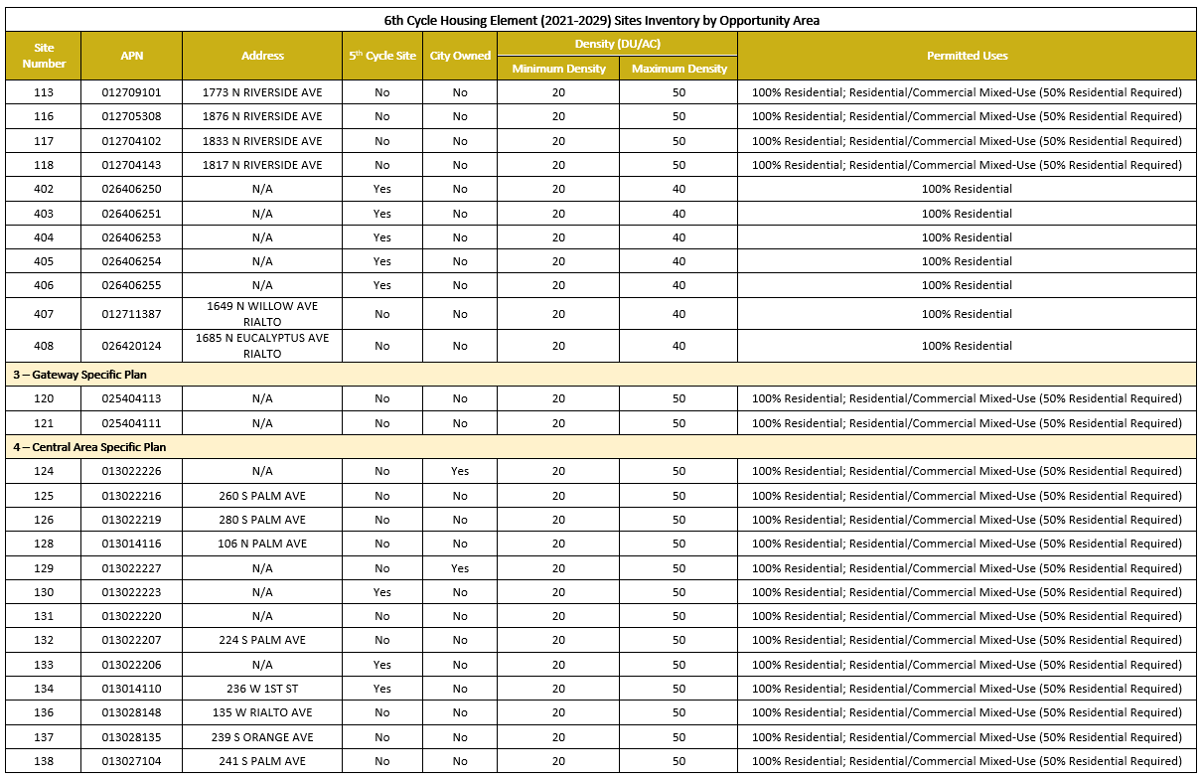

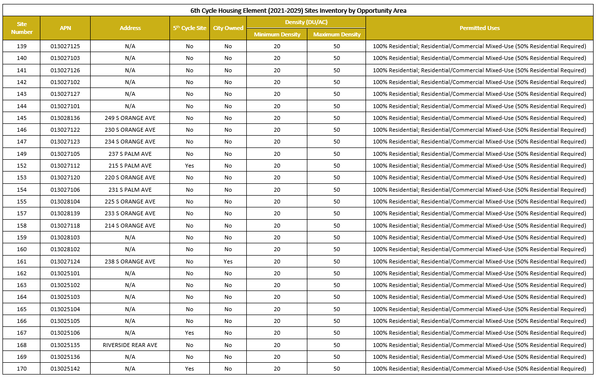

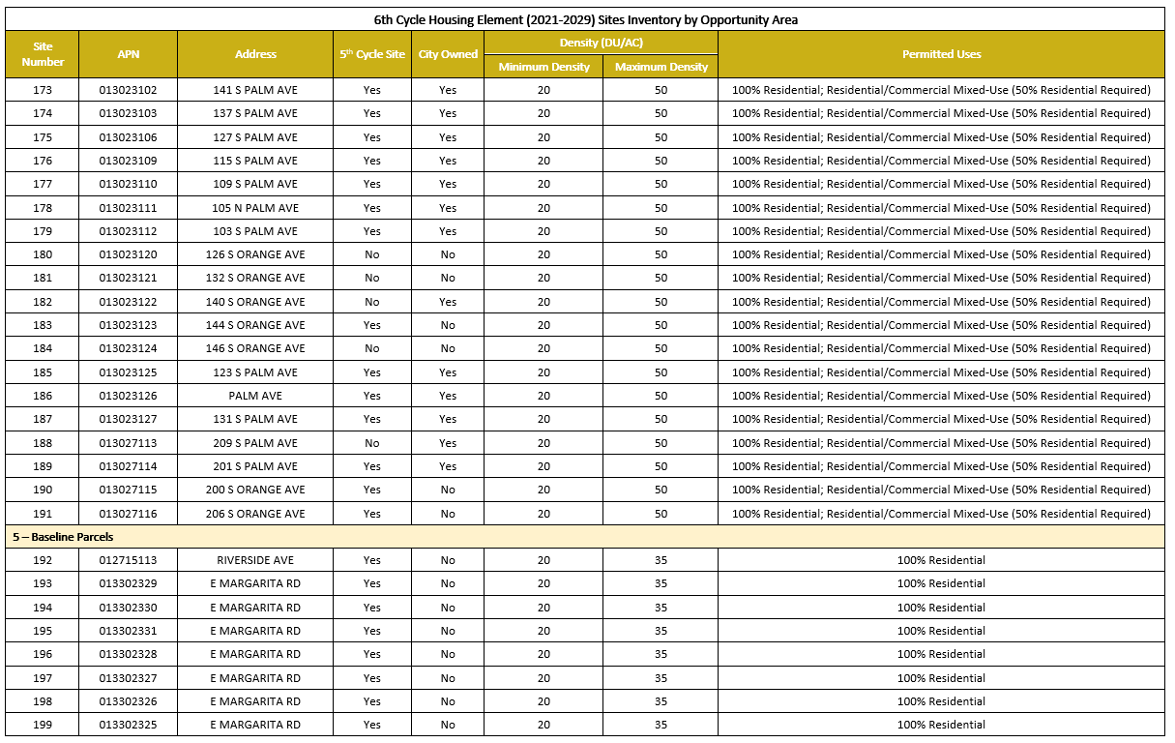

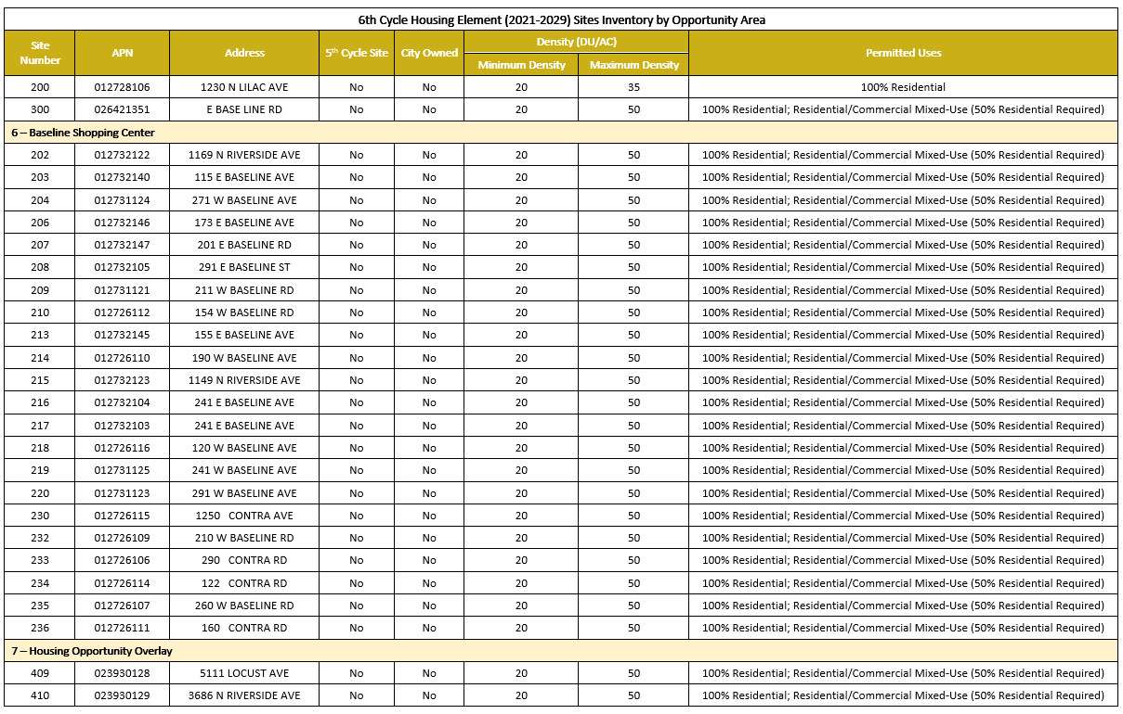

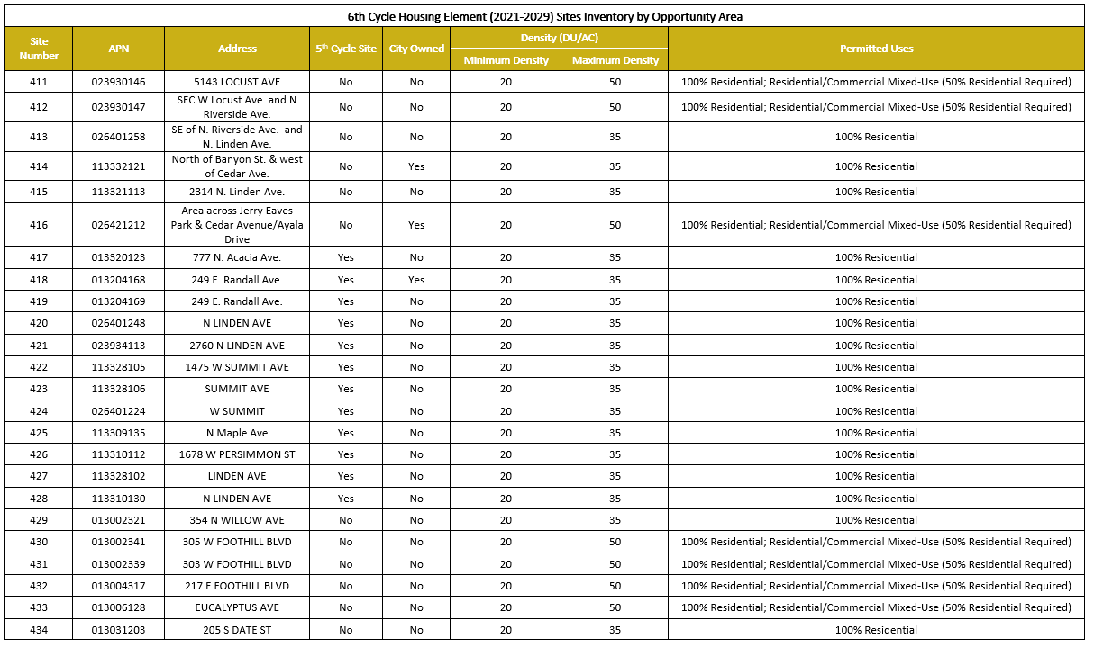

Map 1: Overview of all Housing Opportunity District Sites
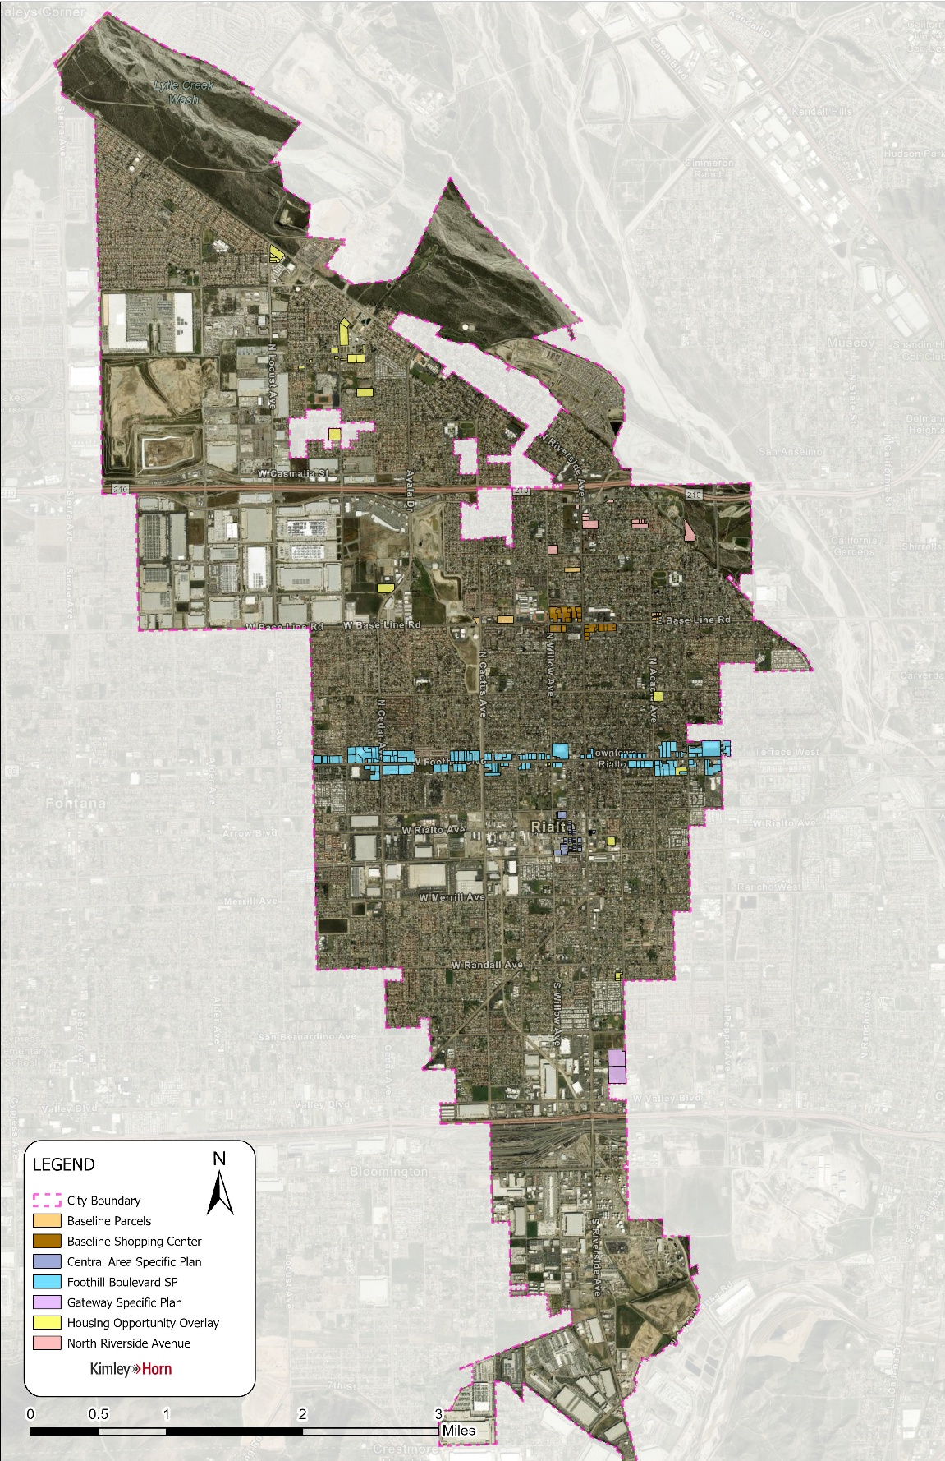
Map 2: Baseline Road HOD Sites
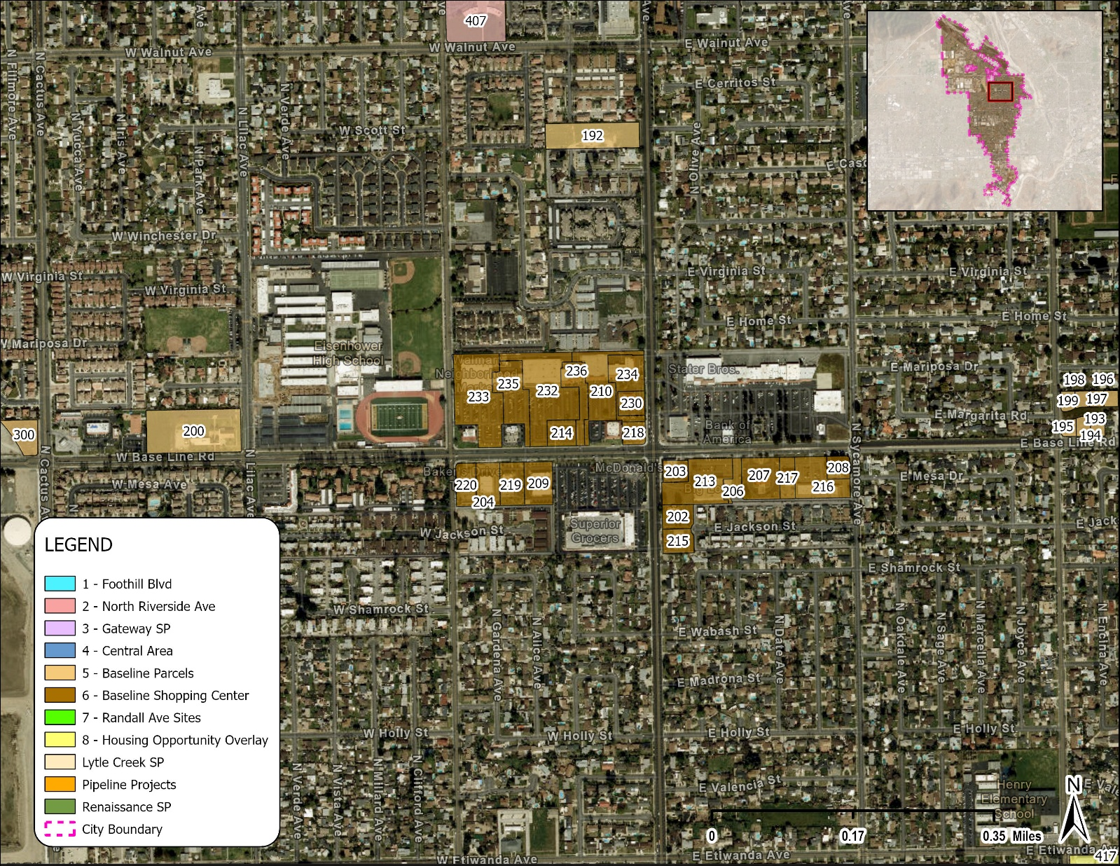
Map 3: Central Area HOD Sites
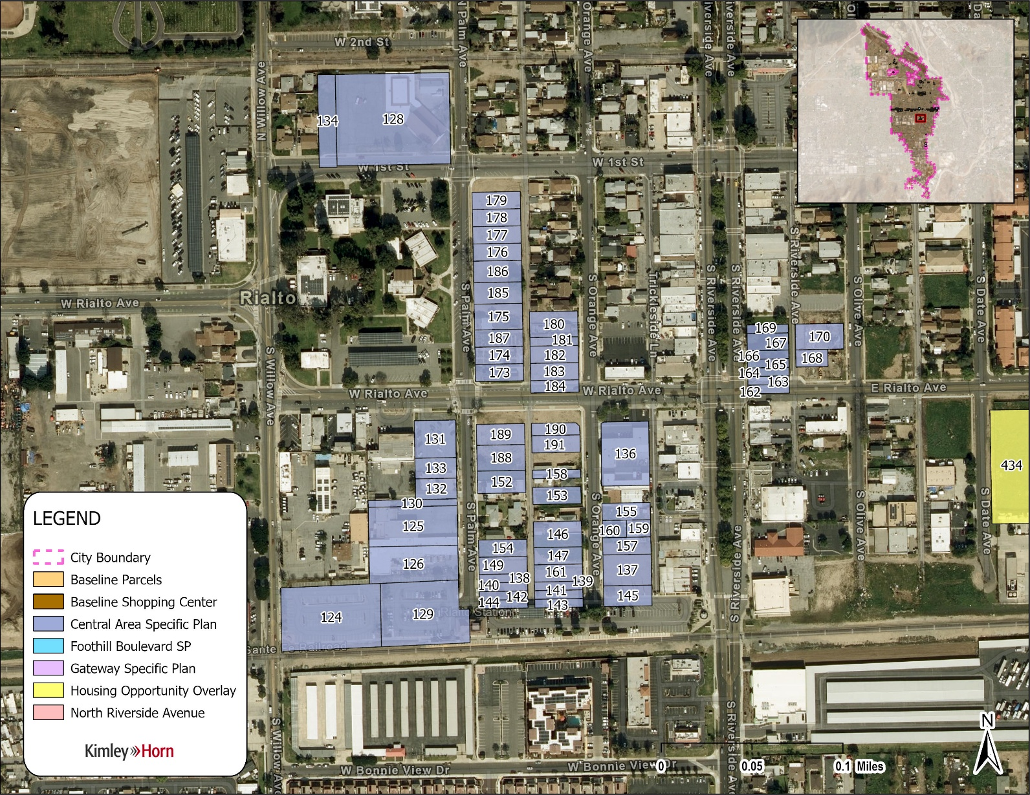

Map 4: Foothill Boulevard HOD Sites
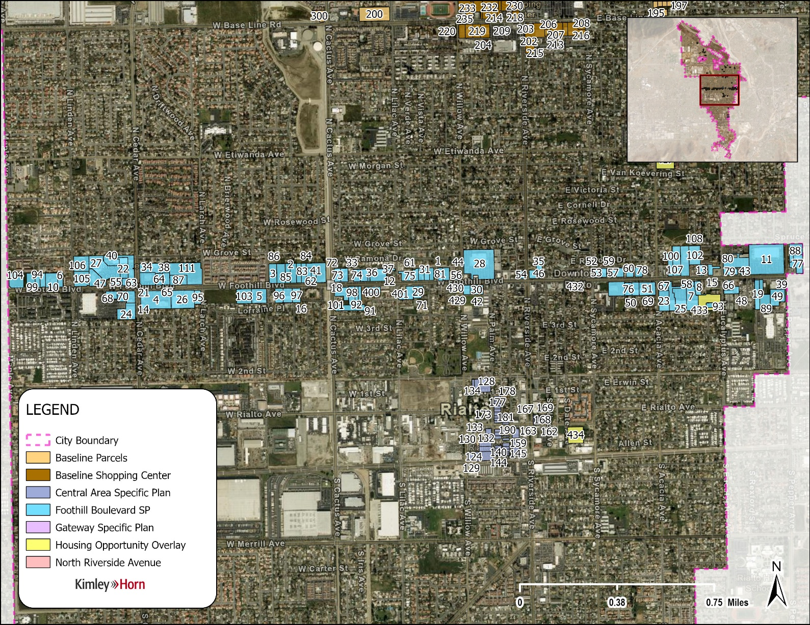

Map 5: Housing Opportunity Overlay HOD Sites
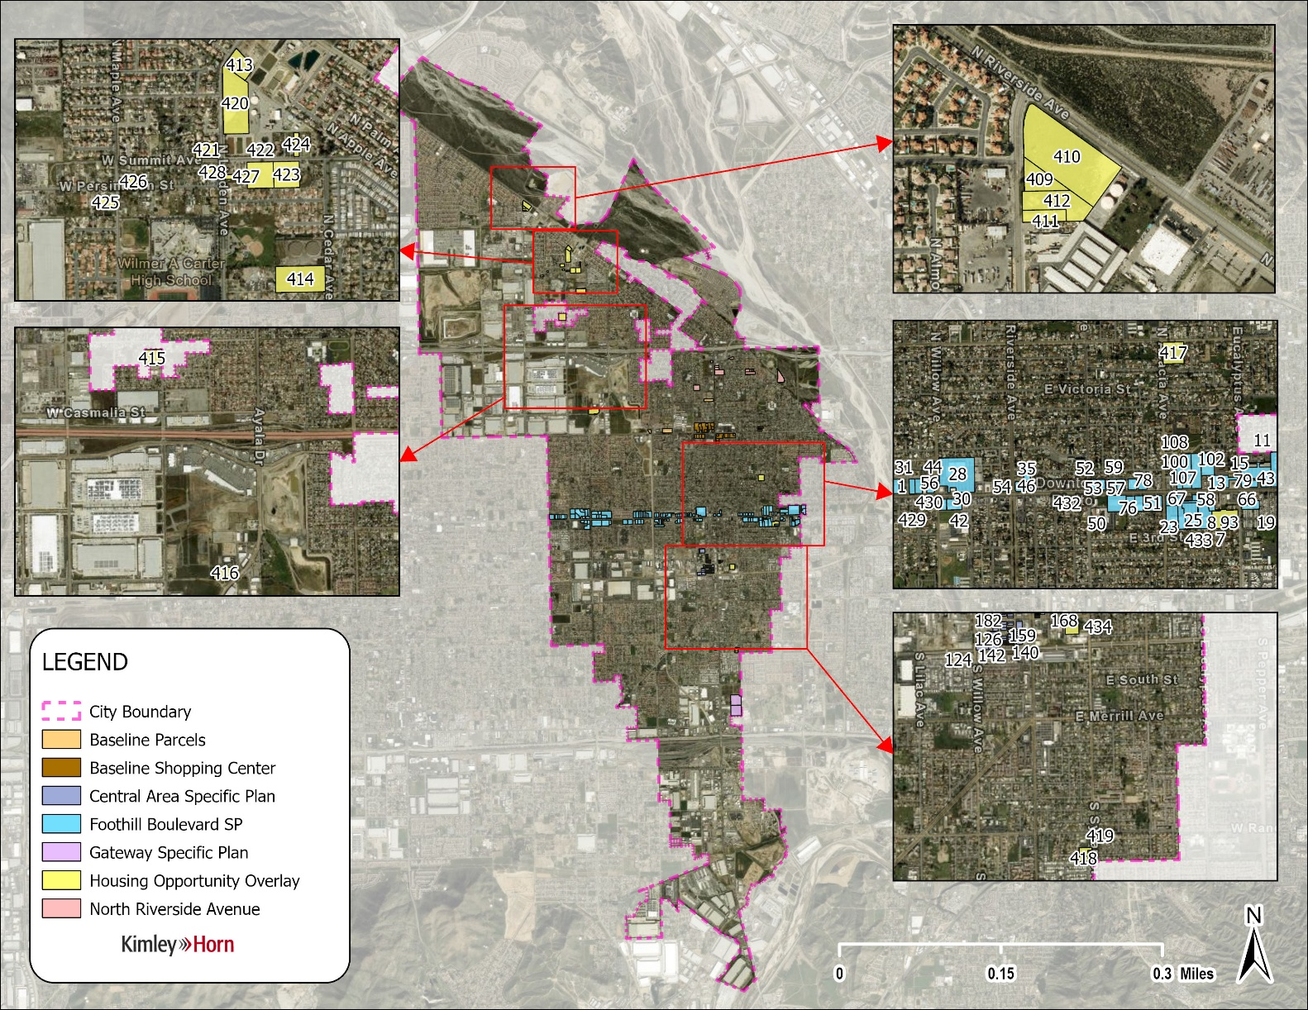

Map 6: Gateway Specific Plan HOD Sites
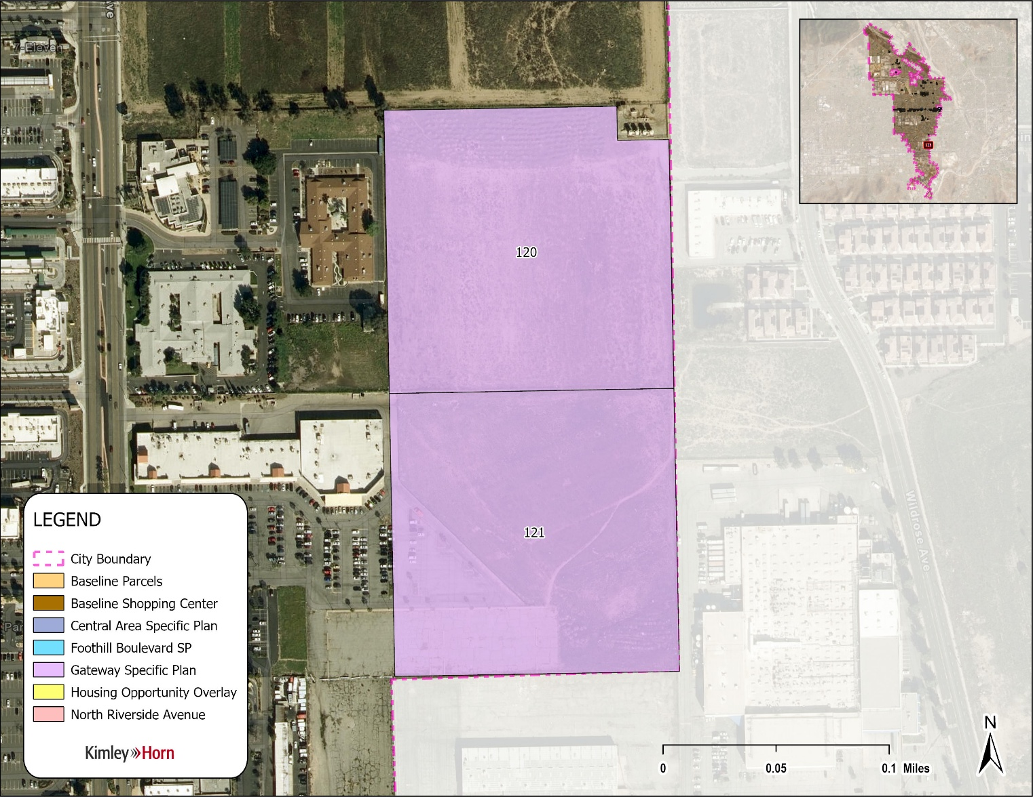

Map 7: North Riverside Avenue HOD Sites
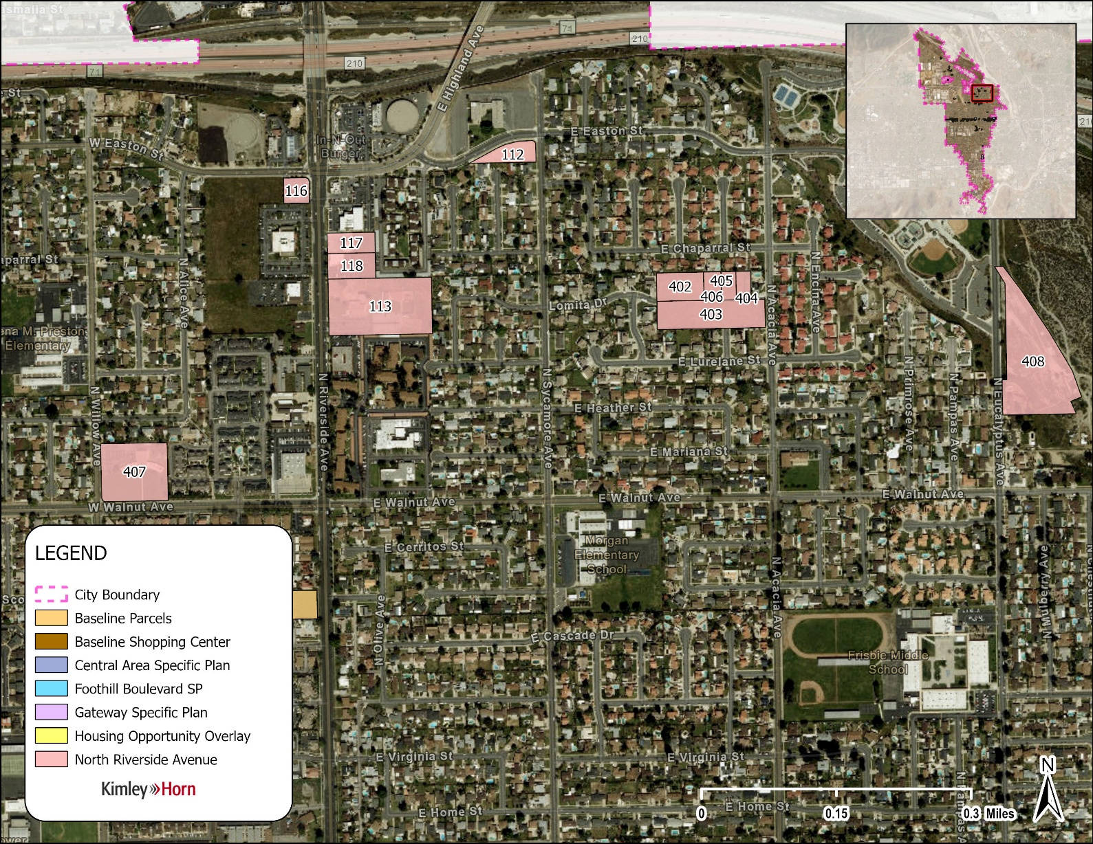
SECTION 4. Consistent with State Law, including Government Code section 65863, the capacity for residential development on Sites 114, 115, 119 of the Housing Element Sites Inventory shall be accommodated on alternate sites within 180 days of the adoption of this Ordinance.
SECTION 5. The City Council hereby directs staff to prepare, execute, and file with the San Bernardino County Clerk of the Board of Supervisors a Notice of Determination within five (5) working days of the adoption of the Ordinance.
SECTION 6. If any provision of this Ordinance is held invalid, such invalidity shall not affect the remaining provisions of this Ordinance, which shall remain in effect absent the provision held to be invalid and, to this end, the provisions of this Ordinance are declared to be severable.
SECTION 7. The Mayor shall sign this Ordinance and the City Clerk shall certify as to the adoption of this Ordinance and shall cause a copy thereof to be published within fifteen (15) days of the adoption and shall post a certified copy of this Ordinance, including the vote for and against the same, in the Office of the City Clerk, in accordance with Government Code Section 36933.

PASSED, APPROVED AND ADOPTED this day of ____, 2026.

_________________________________
JOE BACA, MAYOR

ATTEST:

__________________________________
BARBARA A. MCGEE, CITY CLERK

APPROVED AS TO FORM:

__________________________________
ERIC S. VAIL, CITY ATTORNEY

STATE OF CALIFORNIA )
COUNTY OF SAN BERNARDINO ) ss
CITY OF RIALTO )

I, BARBARA MCGEE, City Clerk of the City of Rialto, do hereby certify that the foregoing Resolution No. _________ was duly passed and adopted at a regular meeting of the City Council of the City of Rialto held on the day of _____, 2026.
Upon motion of Councilmember _______________, seconded by Councilmember ___________________, the foregoing Resolution No. _________ was duly passed and adopted.
Vote on the motion:
AYES:
NOES:
ABSENT:
IN WITNESS WHEREOF, I have hereunto set my hand and the Official Seal of the City of Rialto this ______ day of __________________, 2026.

________________________________
BARBARA MCGEE, CITY CLERK

