RESOLUTION NO. 23-XX

A RESOLUTION OF THE CITY COUNCIL OF THE CITY OF RIALTO, CALIFORNIA, APPROVING SPECIFIC PLAN AMENDMENT NO. 2022-0008 TO ESTABLISH A RESIDENTIAL OVERLAY IN THE GATEWAY SPECIFIC PLAN TO ACCOMMODATE HOUSING IN ACCORDANCE WITH THE HOUSING ELEMENT REZONE PROGRAM IMPLEMENTATION PROJECT.

WHEREAS, on March 8, 2022, the City Council adopted the 2021-2029 (6th Cycle) General Plan Housing Element, a mandatory element of the City’s General Plan and the City’s main housing policy and planning document that identifies housing needs and constraints, sets forth goals, policies and programs that address these needs and constraints, and plans for projected housing needs for all income levels based on the City’s assigned Regional Housing Needs Allocation (RHNA); and
WHEREAS, the 2021-2029 (6th Cycle) General Plan Housing Element identified a shortage of affordable housing within the City of Rialto (“City”); and
WHEREAS, California Government Code Section 65580(d) states that all cities have a responsibility to use the powers vested in them to facilitate the improvement and development of housing and to make adequate provisions for the housing needs of all economic segments of the community; and
WHEREAS, the Housing Element includes a Sites Inventory, which identifies suitable sites throughout the City that can adequately accommodate the required capacity set forth by the City’s RHNA for the 2021-2029 (6th Cycle) planning period totaling 8,272 housing units; and
WHEREAS, consistent with State Law, Housing Goal #2 is to “Promote and encourage housing development that adequately meets the needs of all socioeconomic segments of the community and region”; and
WHEREAS, in order to implement Housing Element Goal #2, Housing Program 2B, referred to as the Rezone Program, the City will need to rezone parcels to provide adequate sites to accommodate RHNA; and
WHEREAS, the City’s Rezone Program includes a residential overlay in the Gateway Specific Plan over approximately twenty (20) acres and permitting residential development at a maximum density of fifty (50) dwelling units per acre; and
WHEREAS, on January 11, 2023, the Planning Commission of the City of Rialto conducted a duly noticed public hearing, as required by law; heard public testimony; discussed Specific Plan Amendment (SPA) No. 2022-0008; and closed the public hearing; and
WHERAS, the Planning Commission voted 5-0 to recommend the City Council approve the amendment to the Gateway Specific Plan; and
WHEREAS, on February 14, 2023, the City Council of the City of Rialto conducted a duly noticed public hearing, as required by law; heard public testimony; discussed SPA No. 2022-0008; and closed the public hearing; and
WHEREAS, all legal prerequisites to the adoption of this Resolution have occurred.
NOW, THEREFORE, the City Council of the City of Rialto, California, does hereby resolve as follows:
SECTION 1. The City Council hereby specifically finds that all of the facts set forth in the recitals above of this Resolution are true and correct and incorporated herein.
SECTION 2. In conjunction with the Project, the City has prepared an addendum to the previously adopted Mitigated Negative Declaration for the 2021-2029 (6th Cycle) General Plan Housing Element (“MND 6th Cycle Housing Element”) under the California Environmental Quality Act (“CEQA”) because the proposed Specific Plan Amendment will not result in any change with respect to the circumstances or require major revisions to the previously approved MND 6th Cycle Housing Element.
SECTION 3. The City Council hereby amends the Gateway Specific Plan to add the following sections in the manner shown, with underlined text representing added language and stricken text representing removed language.
“4.2 Goals and Policies of the Specific Plan
….
Economic Development
- Actively promote the Gateway as a location for retail uses, office/research and development parks and freeway oriented commercial uses.
- Use the authority of the Redevelopment Agency to acquire and assemble land where necessary.
- Provide assistance and advice for businesses interested in locating in the Gateway.
4.3 Land use Plan
The land use plan for the Gateway proposes a mix of retail, freeway commercial, office park, and industrial park and residential uses. The distribution of these uses is based on their relationship to the street system, to each other and to adjoining development.
….
Industrial and Commercial Parks – 91.24 acres
The area of land west of the flood channel and fronting on Valley Boulevard in the western portion of the Gateway area has been designated for industrial and commercial parks. Dr. Gobar’s market study showed that the demand was highest for industrial uses. Clearly not all industrial activities
are appropriate for the Gateway, particularly heavy manufacturing and plants generating noise, dust and fumes. The recommended strategy must be to direct these heavy industrial uses to the Agua Mansa district and allow light industrial and warehousing uses to locate in the Gateway. The Gateway industrial uses must be “good neighbors’” for the proposed upscale retail, office, and freeway commercial uses and for the existing residential areas adjoining the area.
Residential Overlay – 20.00 acres
The area west of the Senior Center has been designated Industrial and the area west of Gateway Plaza has been designated Retail. While retail and industrial uses are suitable for the area and may be developed, property owners may choose to develop residential due to the residential overlay. Residential uses are in demand and generate local demand for the nearby retail uses.
….
4.9 Proposed Zoning
4.9.1 Introduction
The Specific Plan will also be implemented through the zoning ordinance. The City’s present zoning categories were reviewed for possible application at the Gateway. After considerable analysis and discussions with City staff it was decided that new zoning categories be established for the Gateway. This decision was based on the conclusion that the existing zoning categories did not fully accommodate the upscale environment proposed for the Gateway in terms of the types of land uses permitted, setbacks, bulk, height, landscape and other items. The one exception to this is the recently adopted Off-Street Parking Ordinance, Section 18.58, which is appropriate for the Gateway and is included by reference in the new Gateway zoning categories.
The new zoning categories area as follows:
O-P Office Park
R-C Retail Commercial
F-C Freeway Commercial
I-P Industrial Park
R-O Residential Overlay

….
4.9.2. Residential Overlay
The provisions of Rialto Municipal Code Chapter 18.116 – Residential Overlay, as those provisions and regulations may be amended from time to time, are made a part of this Specific Plan by reference with the same force and effect as if the provisions therein were specifically and fully set out herein. The residential overlay applies in the areas appearing in Figure 4.13 below.

4.13 Residential Overlay

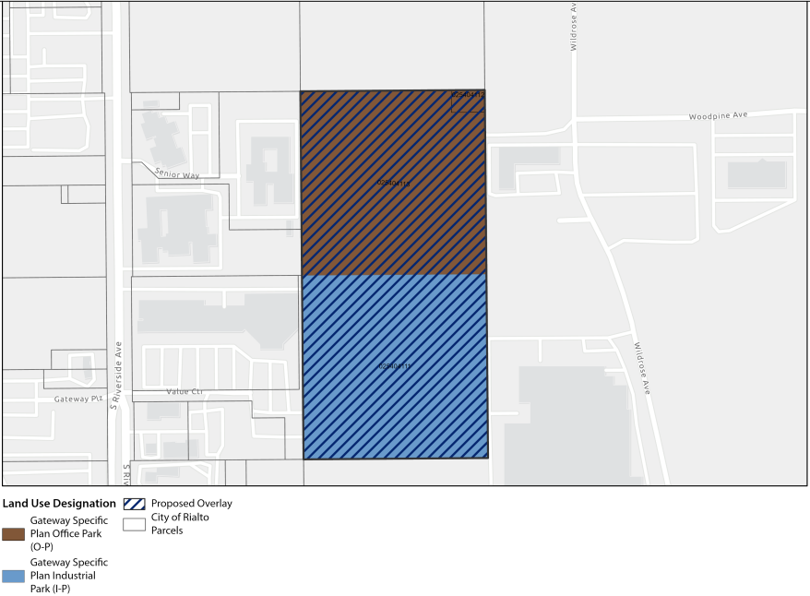

SECTION 4. The Mayor shall sign the passage and adoption of this Resolution and thereupon the same shall take effect and be in force.

PASSED, APPROVED AND ADOPTED this 14th day of February, 2023.

_________________________________
DEBORAH ROBERTSON, MAYOR
ATTEST:

__________________________________
BARBARA MCGEE, CITY CLERK

APPROVED AS TO FORM:

__________________________________
ERIC S. VAIL, CITY ATTORNEY
State of California )
County of San Bernardino )
City of Rialto )

I, Barbara McGee, City Clerk of the City of Rialto, do hereby certify that the foregoing Ordinance was introduced and first read on the ___ day of __________ 2023, and had its second reading at the regular meeting of the Rialto City Council on the ___ day of _____________, 2023, and was passed by the following vote:

AYES:

NOES:

ABSTAIN:

ABSENT:

_________________________________
Barbara McGee, City Clerk

