EXTRATERRITORIAL WASTEWATER SERVICE
AGREEMENT BETWEEN THE CITY OF RIALTO AND BLOOMINGTON HILLS, LLC
This EXTRATERRITORIAL WASTEWATER SERVICE AGREEMENT (“Agreement”) is made and entered into this 26th day of April 2022, between Bloomington Hills, LLC, Property Owner (“Owner”) and the City of Rialto, a California municipal corporation (“City”) (each a “Party” and collectively the “Parties”).
RECITALS
WHEREAS, the City, through its concessionaire Rialto Water Services, and sewer system operator Veolia, provides wastewater conveyance, treatment, and disposal services for wastewater (“Sewer Services”) to properties within the City’s jurisdiction and spheres of influence, and has adequate pipelines, facilities, and infrastructure for said Sewer Services; and
WHEREAS, the Owner has requested the City to provide Sewer Services to a property located within the City’s sphere-of-influence, but outside of the City’s existing corporate boundaries, and which is associated with Assessor’s Parcel Numbers 0257-101-09-0000, located at 11279 Cedar Avenue, Bloomington, CA as identified on Exhibit “A” and shown on Exhibit “B”, attached hereto and made a part hereof (the “Property”); and
WHEREAS, other wastewater collection systems are unavailable, and Owner desires to connect the Property to the City’s wastewater collection system for the general health safety and welfare; and
WHEREAS, City owns and operates wastewater collection mains and any other related and/or additional facilities used for the conveyance, treatment or disposal of wastewater originating in the City and areas located outside the corporate boundaries of the City approved by the City for extraterritorial wastewater service (the “Service Area”), and any extensions, expansions or replacements of any of the above being hereinafter referred to as the “City’s Disposal System”; and
WHEREAS, City has defined and established by City Council resolution a policy and administrative guidelines to provide Sewer Services outside of the City’s corporate boundaries, and has agreed to provide Sewer Services to the Property through the City’s Disposal System on the terms and conditions contained herein; and
WHEREAS, California Government Code Section 56375(p) permits a city to provide new or extended services by agreement outside its jurisdictional boundaries but within its sphere of influence in anticipation of a later change of organization only if the city first request and receives approval from the Local Agency Formation Commission for San Bernardino County (“LAFCO”); and
WHEREAS, City and Owner desire to memorialize their arrangement for the City’s provision of Sewer Services to the Owner through this Agreement.
AGREEMENT
NOW, THEREFORE, in consideration of the foregoing and subject to the terms and conditions contained herein, the Parties hereto hereby agree as follows:
ARTICLE I. CONDITION PRECEDENT

Section 1.01 Recitals Incorporated. The recitals set forth above are true and correct and are hereby incorporated into and made a part of this Agreement.

Section 1.02 Condition Precedent. The effectiveness of this Agreement is expressly conditioned upon approval by LAFCO authorizing the City to provide new or extended Sewer Services to the Property. The Effective Date of this Agreement shall be the date of such approval by LAFCO.

ARTICLE II. RIGHTS AND OBLIGATIONS

Section 2.01 Delivery and Receipt of Wastewater. At all times, except as may be restricted by unforeseen emergencies, Owner shall have the right to deliver to the City’s Disposal System normal strength domestic wastewater, and City shall have the obligation to receive all such wastewater into the City’s Disposal System and to convey, treat and dispose of such wastewater.

Section 2.02 Disposal of Service Area Wastewater; Ownership and Reclamation of Effluent. The cost of constructing, expanding, extending, maintaining and operating the City’s Disposal System and of conveying, treating and disposing of the Service Area wastewater (including without limitation and effluent of by-product thereof) after delivery of such Service Area wastewater to the City’s Disposal System shall be the responsibility solely of the City, and Owner shall have no responsibility for, and shall not be liable to the City or any third party for, any costs or other expenses incurred by the City in connection with or related thereto, other than design and construction costs to connect to the City’s Disposal System set forth in Section 2.05 and payment of the Wastewater User Fees set forth in Article III, provided Owner complies with all aspects of the City’s Municipal Code, ordinances and policies, incorporated herein by reference, as they relate to wastewater discharge applicable to the Property.

Section 2.03 Ownership of Service Area Wastewater. It is the intention and agreement of the Parties that the City shall have total ownership and control of all Service Area wastewater delivered to the City’s Disposal System. Owner warrants that Owner shall comply with all aspects of the City’s Municipal Code, ordinances, and policies as they relate to wastewater discharge applicable to the Property.

Section 2.04 Connection Points. Owner is authorized one (1) connection point to the City’s Disposal System. Such connection point shall be located at a point mutually acceptable to the Owner, City Engineer, and the Building Official. Construction of laterals and connection points shall be in conformance with the specifications and details set forth in the City’s Utility Design Standards, Building Safety Codes and other applicable laws and regulations, as may apply.

Section 2.05 Design and Construction of Connection Points. Owner agrees, at its sole expense and without reimbursement from the City, to design and construct the sewer lines, laterals and connection points needed for the Owner to connect to the City’s Disposal System. City and the Owner also agree the design and construction necessary to connect to the City’s Disposal System is subject to the appropriate City approvals, including but not limited to plan check(s) and inspections.

Section 2.06 Inspection. City shall have the right to inspect and examine sewer lines, laterals, connection points and any other facilities related to the Owner’s connection to the City’s Disposal System at any time, including during construction and operation of any portion of the Sewer System within the Service Area.

Section 2.07 Maintenance and Repairs. Maintenance, repairs, and replacement of the laterals including the connection point within the right-of-way shall be the responsibility solely of the Owner. All construction work, maintenance and repairs shall be performed under permit from, inspected, and approved by the City. Should Owner fail to operate, maintain, repair, and replace the lateral including the connection point as needed for proper operation of the City’s Disposal System, the City shall have the right, but not the obligation to stop providing Sewer Services.

ARTICLE III. WASTEWATER USER FEES

Section 3.01 Initial Special Service Availability Payment. In consideration of the City’s agreements contained herein, Owner shall, promptly upon the Effective Date of this Agreement, pay to City a service connection fee for treatment, collections, and related fees in the amount of $101,648.39 in accordance with the adopted fee schedule, Resolution 6069, approved by the Rialto City Council/Rialto Utility Authority on December 27, 2011. Any additional fees related to plan check(s), inspection or not named in this Agreement shall be the responsibility of the Owner.

Section 3.02 Monthly Wastewater User Fees. After the Effective Date, Owner shall pay to the City for the provision of Sewer Services a wastewater fee calculated at a rate equal to one point three (1.3) times the rate then charged by the City to properties located within the incorporated boundaries of the City, in accordance with the rates established pursuant to Chapter 12.08.200 of the City’s Municipal Code, or as may be amended from time to time.

Section 3.03 Delinquent Sewer Service Fees. Owner shall pay to the City delinquent fees as established in the City’s Municipal Code, ordinances, or policies. Any sewer charges that are unpaid by the specified due date shall be a debt in favor of the City, which may use any legal means to collect any delinquent sewer charges, including, but not limited to, placing liens on the Property of any such persons, and collecting such delinquent fees, penalties, and interest due and owning on the property tax roll.

ARTICLE IV. MONITORING OF SERVICE AREA WASTEWATER

Section 4.01 Pre-Treatment Program; Quality Specifications and Standards. Pretreatment of wastewater from the Service Area may not be required under this Agreement, provided the Owner complies with all aspects of the City’s Municipal Code, ordinances, and policies as they relate to wastewater discharge applicable to the Property. City shall have the right to monitor or restrict the discharge of wastewater to the City’s Disposal System if City suspects or discovers the Owner has discharged prohibited substances, as described in the City’s Municipal Code, into the City’s Collection System, or violated other provisions of said Municipal Code. City may, at its option, allow discharge to resume with the Owner’s installation, and proper maintenance of, an approved pretreatment device or system.

ARTICLE V. TERM

Section 5.01 Effective Date; Term. This Agreement shall become effective as first written above in Section 1.02. The Agreement shall continue in perpetuity, or until terminated pursuant to Section 5.02, or such time as the Property is annexed into the corporate boundaries of City. At such time, the Owner shall have such rights, privileges, and duties, including fees and rates, as all other City citizens for the then current wastewater disposal classification.

Section 5.02 Termination. Either Party may terminate this Agreement upon thirty (30) days prior written notice to the other Party.

ARTICLE VI. MISCELLANEOUS

Section 6.01 Indemnification. Owner hereto agrees to indemnify, defend, save, and hold harmless the City and its officers, agents and employees from and against all liability, claims, damages, losses and expense of any nature whatsoever, including but not limited to bodily injury, death, personal injury, property damages and attorney’s fees, arising directly or indirectly from any acts or omissions of such indemnified party or its officers, agents or employees in connection with this Agreement.

Section 6.02 Successors and Assigns. The agreements contained in this Agreement shall be binding upon and shall inure to the benefit of the heirs, successors, and assigns of the parties hereto. Owner may not assign its rights and/or obligations under this Agreement without the prior written consent of the City, which consent shall not be unreasonably withheld. Any such consent by City shall not, in any way, relieve Owner of its obligations and responsibilities under this Agreement.

Section 6.03 Notices. All notices or other communications required or permitted hereunder shall be in writing, and shall be personally delivered, sent by pre-paid First Class U.S. Mail, registered or certified mail, postage prepaid, return receipt requested, or delivered or sent by facsimile with attached evidence of completed transmission, and shall be deemed received upon the earlier of (i) the date of delivery to the address of the person to receive such notice if delivered personally or by messenger or overnight courier; (ii) three (3) business days after the date of posting by the United States Post Office if by mail; or (iii) when sent if given by facsimile. Any notice, request, demand, direction, or other communication sent by facsimile must be confirmed within forty-eight (48) hours by letter mailed or delivered. Other forms of electronic transmission such as e-mails, text messages, instant messages are not acceptable manners of notice required hereunder. Notices or other communications shall be addressed as follows:
If to City: City of Rialto
150 South Palm Avenue
Rialto, CA 92376
Attn: City Manager
Tel: (909) 820-2528
Fax: (909) 820-2527

With copy to: Burke, Williams & Sorensen, LLP
1770 Iowa Avenue, Suite 240
Riverside, CA 92507-2479
Attn: Eric Vail, City Attorney
Tel: (951) 788-0100
Fax: Not Available

If to Owner: Bloomington Hills, LLC
3940 E. Callaway Drive
Ontario, CA 9176
Tel: 909-702-3044
Fax: Not Available

With copy to: N/A

Either Party may change its address by notifying the other Party of the change of address in writing.
Section 6.04 Costs and Expense of Enforcement. Should litigation be necessary to enforce any term or provision of this Agreement, the prevailing party shall be entitled to collect all litigation costs and attorney’s fees incurred by the prevailing party.

Section 6.05 Amendment. No amendment or waiver of any provisions of this Agreement or consent to any departure from its terms shall be effective unless the same shall be in writing and signed by the parties hereto.

Section 6.06 Severability. The provisions of this Agreement are severable. The invalidity or unenforceability of any provision of this Agreement will not affect the validity of the remainder hereof.

Section 6.07 Execution in Counterparts. This Agreement may be executed in counterparts, all of which taken together shall constitute an original hereof.

Section 6.08 Time of Essence. Time is of the essence in the fulfillment by the parties hereto of their obligations under this Agreement.

Section 6.09 Governing Law. This Agreement shall be governed by and construed in accordance with the laws of the State of California and any legal action must be brought in a court of competent jurisdiction in San Bernardino County.

[SIGNATURES ON NEXT PAGE]

IN WITNESS WHEREOF, City and Owner have caused this Agreement to be executed the day and year first above written.

CITY:
CITY OF RIALTO,
a Municipal Corporation
By:
Marcus Fuller, City Manager
ATTEST:
By:
Barbara A. McGee, City Clerk
APPROVED AS TO FORM:
Burke, Williams & Sorensen, LLP
By:
Eric Vail, City Attorney
Owner:
Bloomington Hills, LLC
By:
Harjit Singh,
President
EXHIBIT “A”
LEGAL DESCRIPTION

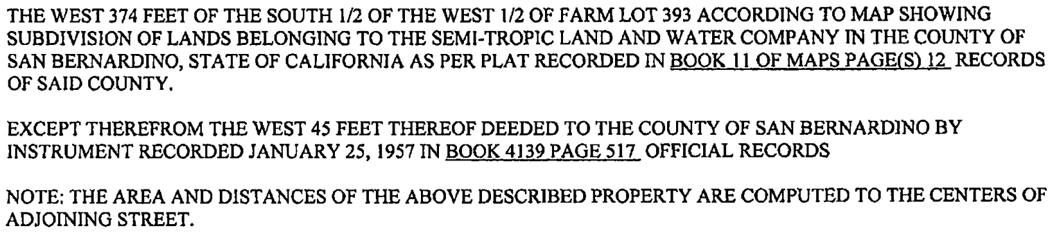

EXHIBIT “B”

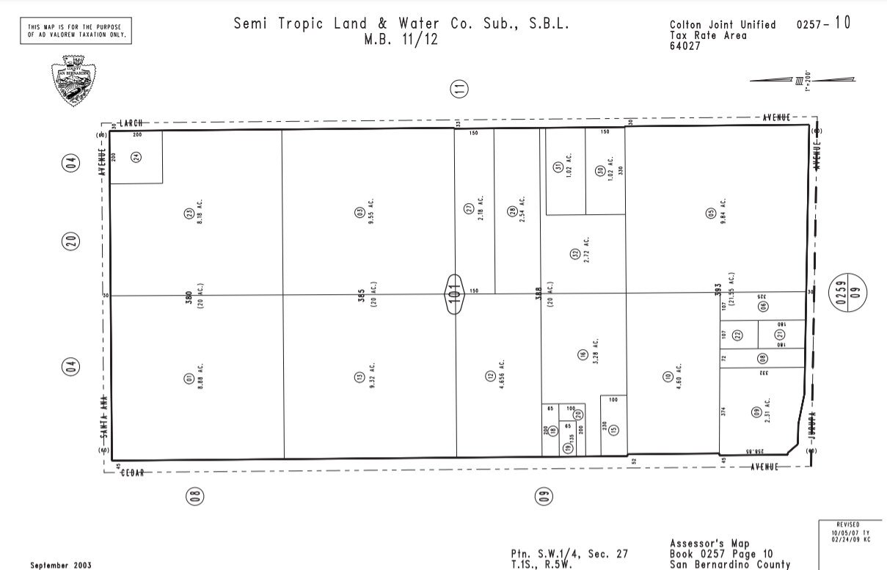
Subject Property

