PLANNING COMMISSION STAFF REPORT
Agenda Date: November 14, 2023
SUBJECT
Conditional Use Permit Amendment and Architectural & Site Approval to consider a modification of the original Main Street Use Permit (U-2008-01) for the addition of a second floor within Shop 1 (TD Ameritrade). (Application No.: M-2022-003; ASA-2023-009; Applicant: Main Street Cupertino Retail Property, LLC; Location: 19409 Stevens Creek Blvd. (APNs: 316-20-112)
RECOMMENDED ACTIONS
That the Planning Commission adopt the proposed draft resolutions (Attachment 1 & 2) to:
- Adopt the Third Addendum to an EIR and approve the Conditional Use Permit Amendment (M-2022-003); and
- Approve the Architectural and Site Approval Permit (ASA-2023-009).

DISCUSSION:

Project Data:
General Plan Land Use Designation | Commercial/Office/Residential
Special Planning Area | Heart of the City Specific Plan (East Stevens Creek Boulevard)/South Vallco Master Plan
Zoning Designation | P(CG, OP, ML, Res)
Net/gross lot area | 18.7 acres
 | Allowed/Required | Existing | Proposed
Height of Structures | Up to 45 feet (Up to 60 feet with ground floor retail) | Top of Parapet – 28 feet. | No Change
Height of Structures | Up to 45 feet (Up to 60 feet with ground floor retail) | Top of Roof – 17 feet, 4 inches |  | 25 feet, 4 inches
Setbacks
Front | 35 feet from the face of curb (min.) | 35 feet from the face of curb. No Change from existing |  | No Change
Slope Line | 1:1 line from the face of curb of Stevens Creek Boulevard | Meets the standard. |  | No Change
Project Consistency with
General Plan: | Yes
Zoning: | Yes

Background:
On September 4, 2012, City Council adopted Resolution No. 12-098(M) (Attachment 2) approving a Modification (M-2012-03), Second Addendum to the Final Certified 2009 Environmental Impact Report (EA-2012-05), and modified Tentative Map (TM-2012-04) to a previously approved Master Use Permit (U-2008-01 and M-2011-09), Architectural and Site Approval (ASA-2011-24), and Tentative Map (TM-2011-04) for the Main Street Cupertino mixed use project consisting of 130,500 square feet of retail, a 180-room hotel, a five-level parking garage with two levels of underground parking, 260,000 square feet of office, a 120-unit market-rate live/work rental loft residential development with a 9,146-square-foot retail condominium unit and shared parking plan. 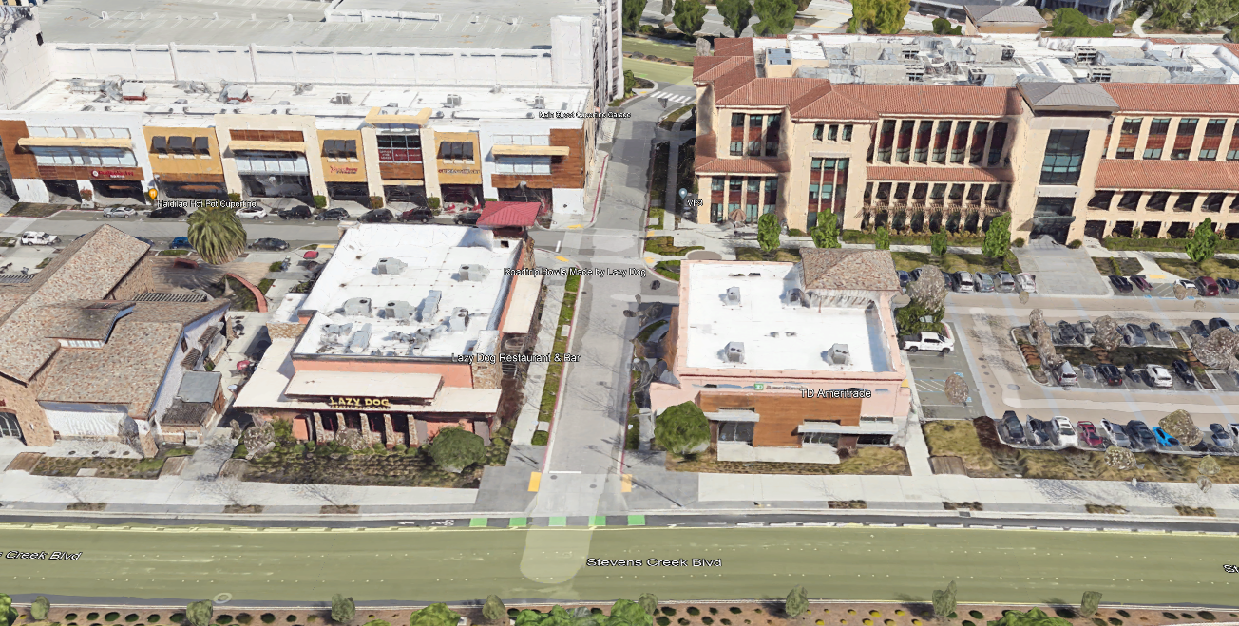
Stevens Creek Blvd.
Figure 1 Location of Shop 1 (TD Ameritrade) within Main Street Cupertino.
The 18.7-acre Main Street project is located at the northwest corner of the Stevens Creek Boulevard and Tantau Avenue intersection. The site is bounded by Stevens Creek Boulevard to the south, Tantau Avenue to the east, Vallco Parkway to the north, and the Metropolitan mixed-use development to the west. Main Street incorporates 12 separate commercial/retail buildings labeled as Pads 1-3, Shops 1-8, Major Retail, and Flex 1-2. The two office buildings along the eastern portion of Main Street are currently occupied by Apple. Please refer to Figure 1 for an approximate location.
The proposed project is within Shop 1, which is located at the secondary, easterly entry to Main Street Cupertino, along Stevens Creek Boulevard. It serves as a transitional building between the office buildings and the large retail plaza to the west. Since its completion in 2016, the building has been occupied solely by TD Ameritrade, a commercial office tenant serving the public.
Application Request
Michael Rohde, representing Main Street Cupertino Aggregator LLC, requests a Conditional Use Permit Amendment (U-2008-01) and an Architectural and Site Approval Permit to allow a 5,585 square foot second-floor addition within Shop 1 (TD Ameritrade) and for minor façade modifications. If the addition is approved, the total square footage for the building would increase from 5,930 square feet to 11,515 square feet.

Analysis:
General Plan Compliance
The proposed use is consistent with the General Plan Land Use Designation of Commercial/Office/Residential. The City’s General Plan uses a development allocation system when evaluating development projects and allows the City flexibility in developing project- and site-specific mitigation measures when reviewing projects. The City of Cupertino’s General Plan: Community Vision 2015 – 2040 (General Plan) establishes heights and setbacks for development on sites within each of the Special Areas through its Community Form Diagram (Chapter 3, Figure LU-1). Shop 1 is in the Heart of the City Special Area (South Vallco Park), which has a height limit of 45 feet (a height limit up to 60 feet is allowable if ground-floor retail uses are included) and a 1:1 slope line setback from the curb line of Stevens Creek Boulevard.
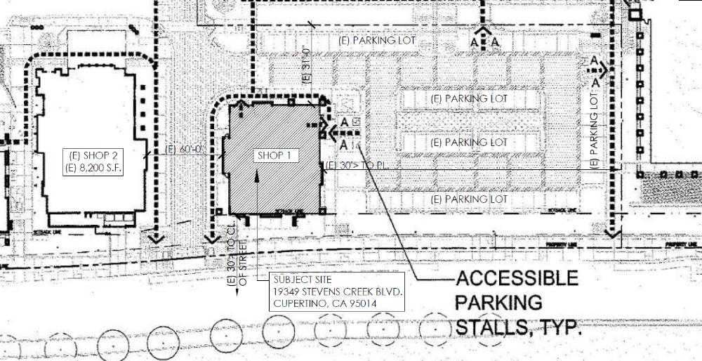
Figure 2 Site plan of Shop 1.

The applicant proposes this development within the existing building envelope, which would raise the height of the roof by eight feet, from 17 feet, 4 inches to 25 feet, 4 inches. The surrounding roof parapet height will remain 28 feet, screening the increased roof height from view. The existing tower and facade heights will also remain unchanged.
Staff has evaluated the project’s consistency with the General Plan and concludes that it conforms with the General Plan Land Use designation for the site. An Addendum to the Main Street project EIR has also been prepared, indicating that the proposed building addition will not result in any environmental impacts (Attachment 5). Additionally, the proposed project supports several of the City’s other General Plan goals including:

- Policy LU-1.3: Land Use in All City-wide Mixed-Use Districts - Encourage land uses that support the activity and character of mixed-use districts and economic goals.
The development is located within an existing structure (Shop 1) in the Commercial/Office/Residential General Plan Land Use district (Main Street Cupertino). The building was designed to be compatible with the neighboring office buildings, and transition to the adjacent retail uses within the development. TD Ameritrade is a Commercial Office use that is permitted in the General Commercial (CG) zoning district.

- Policy LU-13.6: Building Form - Buildings should be high-quality, with pedestrian-oriented and active uses along the street.
The building as currently developed will only have minor façade changes to allow required fenestration for the added second story. As currently designed, the building provides pedestrian access paths on all sides. These changes are complementary to the existing structure and will be required to follow the City’s Bird Safe Ordinance.

- Strategy LU-18.2.1: Uses - Encourage a mix of retail, commercial, office, residential and hotel uses. Provide active retail uses on the ground floor facing the street or outdoor pedestrian corridor with connections to adjacent development. Office sites to the north of Vallco Parkway are encouraged to provide retail uses. However, if retail is not provided, office sites should provide entries and active uses along the street frontage.
Main Street Cupertino is an existing mixed-use (Office/Retail/Residential/Hotel) development along Stevens Creek Boulevard and along the southside of Vallco Parkway. The proposed second floor addition reinforces the existing commercial office use that fronts along Stevens Creek Boulevard.

Should the proposed project be approved, 5,585 square feet will be allocated from the Heart of the City Special Area commercial allocation. The remaining balance in the Heart of the City allocation will be reduced to 784,685 square feet.
 | Heart of City Commercial (s.f.)
Current Allocation Available | 790,270
Added square footage | 5,585
Remaining Allocation Balance | 784,685
Figure 3 Allocation chart relative to this development consistent with Table LU-1: Citywide Development Allocation Between 2014-2040 of the General Plan.

Cupertino Municipal Code Findings
The Cupertino Municipal Code includes ‘findings’ for approval of the various permits necessary to approve the proposed project. These provide a framework for making decisions and facilitating an orderly analysis of the review of a project. Listed below are the findings for the three permits sought by the applicant that the City must make when rendering a decision on this project.
A. Use Permit (CMC 19.156.040)
- The proposed development and/or use, at the proposed location, will not be detrimental or injurious to property or improvements in the vicinity, and will not be detrimental to the public health, safety, general welfare, or convenience;

The project is consistent with the General Plan and Zoning Ordinance and has been designed to be compatible with the existing building and adjoining land uses. Additionally, all mitigation measures that are within the responsibility and jurisdiction of the City have been adopted and will be made conditions of approval to mitigate potential impacts to a less than significant level. Therefore, the project will not be detrimental or injurious to properties or improvements in the vicinity, and will not be detrimental to the public health, safety, general welfare, or convenience.
- The proposed development and/or use will be located and conducted in a manner in accord with the Cupertino Comprehensive General Plan, underlying zoning regulations, and the purpose of this title and complies with the California Environmental Quality Act (CEQA).
The General Plan land use designation for the property is Commercial/Office/Residential. The proposed addition is consistent with the General Plan in terms of use, height, slope line setback, as well as allocation for commercial. Further, the development fits within many of land use strategies and policies for the South Vallco Park portion of the Heart of the City Special Area, such as consistent mix of uses as well as activation of Stevens Creek Boulevard. The proposed addition with the existing development has met the applicable development standards of the Heart of the City Specific Plan including outdoor open space and setbacks. The project has been approved with a Third Addendum to its EIR.
B. Architectural and Site Approval Permit (CMC 19.168.030)
- The proposed development, at the proposed location, will not be detrimental or injurious to property or improvements in the vicinity, and will not be detrimental to the public health, safety, general welfare, or convenience;
The project is within an existing building that is consistent with the land use designations in the General Plan and Zoning Ordinance and has been designed to be compatible with and respectful of adjoining land uses, including but not limited to setbacks from Stevens Creek Boulevard and the adjacent buildings within Main Street Cupertino. All added fenestrations will be condition to follow the City’s Bird Safe Ordinance. Further, the City’s environmental consultant David J. Powers completed an Addendum to the developments EIR that did not identify any further impacts. Therefore, the project will not be detrimental or injurious to properties or improvements in the vicinity, and will not be detrimental to the public health, safety, general welfare, or convenience.
- The proposed development is consistent with the purposes of this chapter, the General Plan, any specific plan, zoning ordinances, applicable planned development permit, conditional use permits, variances, subdivision maps or other entitlements which regulate the subject property including, but not limited to, adherence to the following specific criteria:
  - Abrupt changes in building scale should be avoided. A gradual transition related to height and bulk should be achieved between new and existing buildings.
The proposed project is within an existing structure (Shop 1). Shop 1 was designed to be complementary with the other buildings within Main Street Cupertino. The addition of the second floor will raise the roof height 8-feet, none of which will be visible by the public as it will be behind and lower than the existing parapet.
  - In order to preserve design harmony between new and existing buildings and in order to preserve and enhance property values, the materials, textures and colors of new buildings should harmonize with adjacent development by being consistent or compatible with design and color schemes, and with the future character of the neighborhood and purposes of the zone in which they are situated. The location, height and materials of walls, fencing, hedges and screen planting should harmonize with adjacent development. Unsightly storage areas, utility installations and unsightly elements of parking lots should be concealed. The planting of ground cover or various types of pavements should be used to prevent dust and erosion, and the unnecessary destruction of existing healthy trees should be avoided. Lighting for development should be adequate to meet safety requirements as specified by the engineering and building departments, and provide shielding to prevent spill- over light to adjoining property owners.
The design quality of the development is consistent with the high-quality standards encouraged by City Staff. The existing building meets the design qualities of a Modern design development. The architectural style is consistent throughout the development. Further, the planting plan is consistent with the intent of the Heart of the City Specific Plan guidelines. Unsightly uses, such as roof top equipment installation, are conditioned to be screened on top of the roof. The final lighting for the development will be reviewed as part of the review of the project construction documents to ensure that they meet safety requirements while avoiding spill-over light to adjacent properties. The windows will have to follow the City’s Bird Safe Ordinance as well.
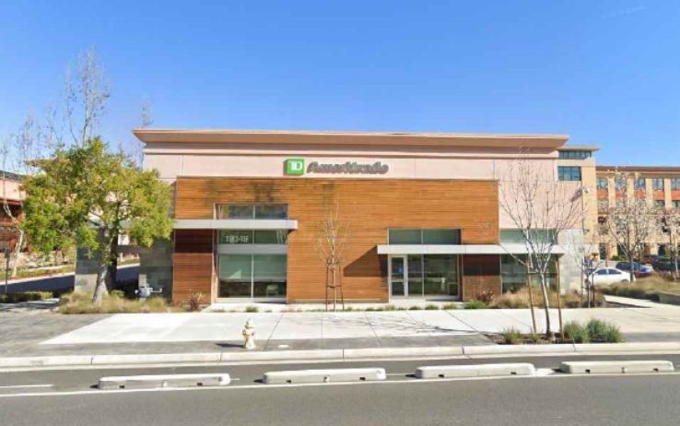
  - The number, location, color, size, height, lighting and landscaping of outdoor advertising signs and structures shall minimize traffic hazards and shall positively affect the general appearance of the neighborhood and harmonize with adjacent development.
Figure 4 Current view of Shop 1 of the southern facade, from Stevens Creek Boulevard.
Signage approval is not included in this application. Any new signage will have to conform to the existing master sign program for Main Street Cupertino.
  - With respect to new projects within existing residential neighborhoods, new development should be designed to protect residents from noise, traffic, light and visually intrusive effects by use of buffering, setbacks, landscaping, walls and other appropriate design measures.
The project is within an existing building (Shop 1). The additional square footage needed for the second floor will not add any further impacts that require mitigation. Further, the addition does not extend beyond the existing building footprint.
Conditional Use Permit Amendment
City Council on September 4, 2012, adopted Resolution No. 12-098(M) (Attachment 3) approving a Modification (M-2012-03) to a previously approved Master Use Permit (U-2008-01 and M-2011-09). The Heart of the City Special Area commercial allocation for this development was 130,500 square feet. If the 5,585 square foot second floor is approved for this project, it would amend the allocation to 136,085 square feet.
Architectural Design
The main building entries for Shop 1 are located on the north and east façades, forming a relationship to the Office 1 and Office 2 buildings. Both the south and west facades have large storefront areas which would visually engage passers-by on Stevens Creek Boulevard.
The design of Shops 1 is reflective of and complementary to the design of Shops 6 at the primary entrance of Main Street. It has the same clean, modern design with overlapping wall planes of horizontal tongue & groove wood siding and stucco. Window canopies are metal framing with pre-finished metal panel cladding. Exterior walls terminate at a pre-finished aluminum cap flashing. The storefront system is clear anodized aluminum with large panels of clear glazing. 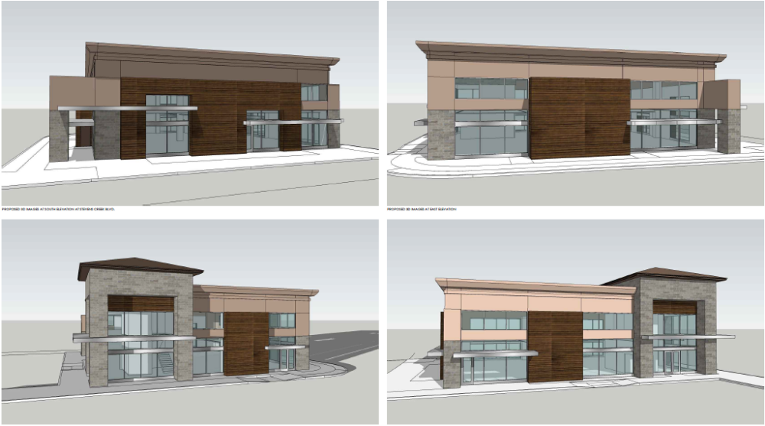
Figure 5 Rendering of the proposed modifications to the existing Shop 1 (TD Ameritrade) building.
As Figure 5 demonstrates, the façade improvements for the added second floor will be limited to the increased fenestration on all four sides. This will allow light into the second-floor office space, as well as complementing the existing glazing on the first floor. The windows will have to follow the City’s Bird Safe Ordinance. No other major changes are proposed.
Parking Analysis
Main Street Cupertino parking demand and supply are regulated by a shared parking analysis. The on-site supply of parking available to the public is 1,242 spaces. Fehr & Peers was retained by the City to analyze the parking impact of the addition.
Peak parking demand occurs at 8 PM on weekdays due to the heavy retail and restaurant uses. Since the peak demand hour is outside of TD Ameritrade’s hours of operation, the added space at TD Ameritrade does not change weekday peak parking demand. The peak parking demand is estimated at 909 spaces during on weekdays. Therefore, the additional bank space from TD Ameritrade can be accommodated within the current parking supply and will not increase parking demand beyond what is currently available.
Other Department/Agency Review
The City’s Building Division, Public Works Department, Environmental Services Division, Cupertino Sanitary District and the Santa Clara County Fire Department have reviewed the project and have included sufficient proposed conditions of approval to ensure compliance.
Environmental Review
On September 4, 2012, the City of Cupertino adopted a Second Addendum to an Environmental Impact Report (2009 Final EIR), State Clearinghouse (SCH) Number 2008082058, and approved the Main Street Project). As described earlier in this staff report, the project has been modified since the original 2012 approval (i.e., 5,585 square feet more commercial, etc.).
The City and its consultant, David J. Powers, conducted a CEQA analysis of changes to the project to determine the appropriate level of environmental review. Under CEQA Guidelines sections 15162 and 15164, an addendum to an EIR should be prepared where there are: (1) no substantial changes to the project requiring major revisions to the EIR because of new or substantially increased significant environmental effects of the project; (2) no substantial changes in circumstances requiring major revisions to the EIR because of new or substantially increased significant environmental effects of the project; and (3) no new, previously unknown or unknowable, information of substantial importance showing: (a) new or substantially more severe significant efforts than were discussed or shown in the EIR; (b) that previously infeasible mitigation measures/alternatives are now feasible and would substantially reduce significant efforts; or (c) that considerably different mitigation measures than analyzed in the EIR would substantially reduce significant effects.
David J. Powers analysis determined that proposed changes to the project meet the criteria for an addendum. The addendum reviews each topic in the CEQA Environmental Checklist and concludes that neither the modifications to the project nor new circumstance or information will result in an environmental impact that is new or more severe than the impacts studied in the Initial Study and EIR. Please refer to Attachment5, Third Addendum to the Final Environmental Impact Report for the Main Street Cupertino Project (SCH# 2008082058). .
Based on the information provided in this Addendum, construction and operation of the modified project would not result in any new impacts or increase the severity of previously identified significant impacts analyzed in the Adopted EIR.

Other Department/Agency Review
The City’s Public Works Department, Building Division, Environmental Programs Division, and the Santa Clara County Fire Department have no objections to the project. Their comments have been incorporated as conditions of approval in the draft resolution.
PUBLIC NOTICING AND COMMUNITY OUTREACH
The following table is a brief summary of the noticing for this project:
Notice of Public Hearing | Agenda
- Site Signage (at least 10 days prior to hearing)  - Legal ad placed in newspaper  (at least 10 days prior to hearing)  - 127 notices mailed to property owners 300 feet from the cemetery (at least 10 days prior to the hearing) | - Posted on the City's official notice bulletin board (five days prior to hearing)  - Posted on the City of Cupertino’s Web site (five days prior to hearing)
As of the date of this staff report, one public comment has been received for this application. See Attachment 6.
NEXT STEPS
Should the project be approved, the Planning Commission’s decision on this project is final unless an appeal is filed within 14 calendar days of the date of the decision. All approvals granted by the Planning Commission shall go into effect after 14 days.
Upon project approval, the applicant will be able to submit building permit drawings to enable construction to commence. These approvals expire on November 14, 2025, at which time the applicant may apply for a one-year extension.
Prepared by: Gian Paolo Martire, Senior Planner
Reviewed by: Luke Connolly, Assistant Director of Community Development
Approved by: Benjamin Fu, Director of Community Development
ATTACHMENTS
- Draft Resolution for M-2022-003
- Draft Resolution for ASA-2023-009
- Plan Set
- City Council Resolution No. 12-098
- Third Addendum to the Final Environmental Impact Report for the Main Street Cupertino Project (SCH# 2008082058)
- Public Comment

General Plan Figure LU-2 Community Form Diagram under the South Vallco Park subarea within the Heart of the City Special Area
Fehr & Peers also conducted a parking study on the conversion of retail space, including Target, to restaurant space above what had been conditioned and approved subsequently in 2015. This study does not include the expansion of TD Ameritrade. The parking study provided to staff will be updated if future restaurant tenants apply for permits.

