

DATE: | November 7, 2023
TO: | Mayor and Council Members
FROM: | Rachel Molina, City Manager
BY: | Casey Brooksher, Assistant City Manager
SUBJECT: | Discussion on Alternative Funding Sources

RECOMMENDED ACTION

It is recommended that the City Council receive and file this staff report, which provides information about potential funding sources to address the needs of the community, and provide direction to staff.

BACKGROUND

During the October 17, 2023, City Council Meeting, Council Member Gregg requested for staff to bring forth a report to discuss revenue enhancements that would require a vote of the residents during the November 2024 elections; such revenue enhancements are tax measures. The following is the staff report originally presented to the City Council at the September 19, 2023 City Council Meeting for the purpose of discussing potential revenue measures to improve public infrastructure and public safety, per the request of Mayor Pro Tem Bird. This report discusses several different tax measures and their respective potential revenue impacts. As shown, the most impactful revenue enhancement, should it be approved by the voters, is an increase to sales tax; whereas, the least impactful is an increase to the transient occupancy tax rate, from a revenue generation standpoint.

In general, the City primarily receives General Fund revenue from two main sources: Charges for Services and Taxes. Charges for Services, such as building permits, are assessed to cover the City’s costs for providing a service. In the case of building permits, the City assess a fee to cover the cost of reviewing project design submittals to ensure compliance with building codes and for providing inspections.

General Fund tax revenue is primarily comprised of four sources:

Sales Tax is the largest General Fund revenue. The sales tax rate in the City is 7.75% on all taxable goods sold within City limits. The following is a breakdown of the sales tax rate: 6%-State of California, 1%-Local (Hesperia), 0.25%-Local Transportation (State assessed), and 0.50%-Countywide Measure I (transportation/road).

Property Taxes are governed by the 1978 voter approved Proposition 13. This dictates that the maximum amount of any ad valorem tax on real property shall not exceed one percent (1%) of the assessed value. The City of Hesperia receives approximately 1.59% of the 1% ad valorem. For this tax type to grow, continued development must occur in the City. For every $100 million growth of assessed valuation, the City would see a net annual property tax revenue growth of $15,900 ($100 million assessed valuation x 1% ad valorem tax x 1.59% Hesperia share).

Vehicle License Fee revenue is based on the growth of the City’s assessed valuation. This annual amount is determined and remitted by the State.

Transient Occupancy Tax is a 10% room tax assessed by the local hotel/motel establishments for stays under 30 days (short-term rentals).

In total, taxes of all types comprise 65% of the General Fund revenue budget, which is detailed in the following table and chart:
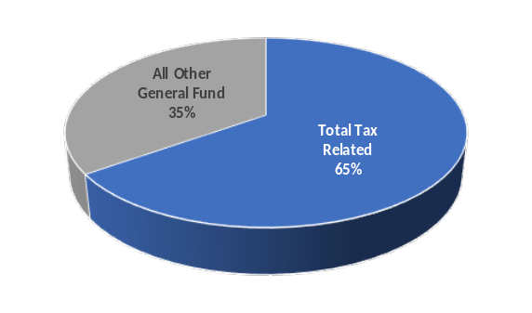
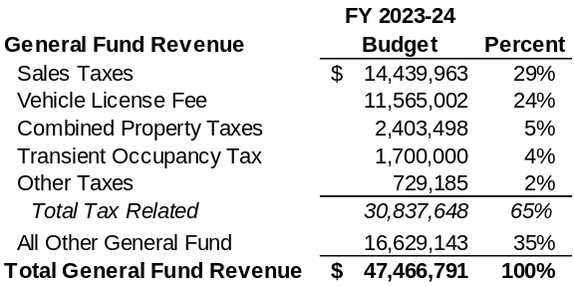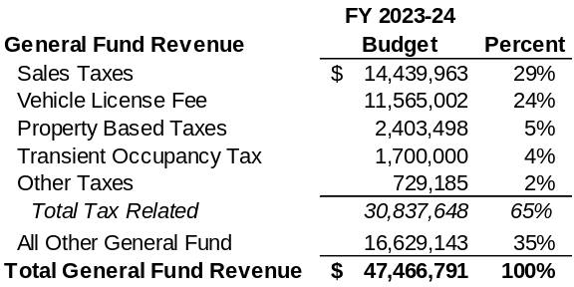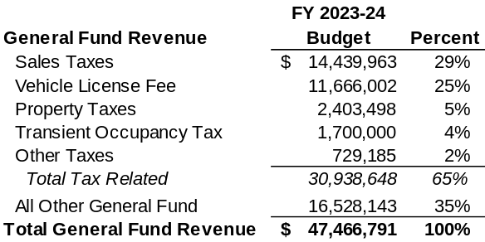

ISSUES/ANALYSIS

Should the City Council consider potential tax increases as an option to increase funding for government services, such as roadway enhancements and law enforcement, there are several options that may be considered.

Taxing Options
- Sales Tax
Sales tax is assessed when tangible goods are sold within the City limits. The tax is collected from any person making a purchase, regardless of whether or not the person is a resident of the City.

By a vote of the residents, the one percent (1%) local share can be increased. A determination would need to be made as to whether the sales tax increase would be a general or special tax. A general tax generates revenues that can be used for any purpose determined by the City Council and requires a simple majority vote (50% + 1). A special tax must be spent on uses specified in the ballot measure and requires a 2/3 (66.6%) vote.

Additionally, should a sales tax increase be explored, a decision could be made to have a citywide increased tax rate or a targeted tax rate. For example, a targeted tax rate that could be applied to certain areas in corridors such as the freeway and Bear Valley Road.

Data from the California Department of Tax and Fee Administration indicates that there are 1,788 different jurisdictions, which includes cities, towns, and unincorporated areas that receive sales taxes. The following details the statistics of sales tax rates:
- 22% or 384 jurisdictions have the state minimum rate of 7.25%
- 35% or 641 jurisdictions have a rate exceeding the minimum rate, but less than 8%
- 43% or 763 jurisdictions have rates exceeding 8%
Locally within San Bernardino County, 15 cities and towns have the County minimum rate of 7.75%. The following cities* have a sales tax rate of 8.75%, which increased the local share from 1% to 2%: Barstow, Colton, Ontario, Redlands, San Bernardino, Victorville, and Yucca Valley. The City of Montclair has a sales tax rate of 9.00%.
*Source: California Department of Tax and Fee Administration (CDTFA)

The following tables show the potential revenue increase that could be achieved, should the voters approve a sales tax increase. The first table details the impacts of a citywide sales tax increase of 1% and 0.5%, which would bring the total sales tax rate to 8.75% (equal to the City of Victorville) and 8.25%, respectively. The second table reflects the projected outcome from a targeted sales tax of the same rates, at the freeway and Bear Valley Road corridors.
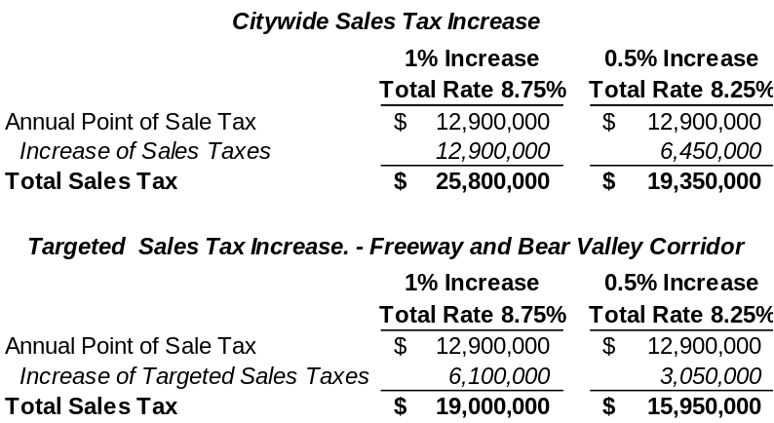
- Utility User Tax
The voters could elect to raise revenue through a Utility User Tax ballot initiative which is placed on water/sewer bills. The voting requirements are the same as a sales tax; with a general tax requiring a simple majority vote (50% + 1) and a special tax (spent on uses specified purpose) requiring a 2/3 (66.6%) vote.

For every one percent (1%) of utility user tax, the General Fund could potentially yield approximately $300,000. The following table demonstrates the potential increase should a utility user tax be levied.
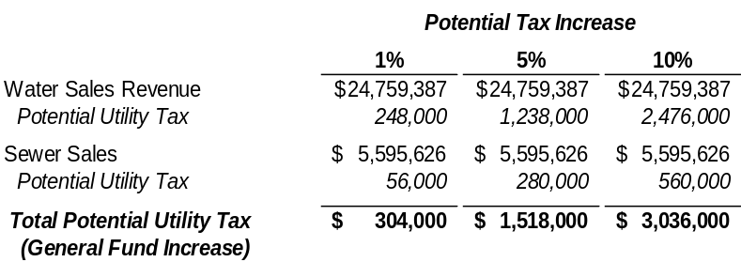

As mentioned, a utility user tax is assessed to the rate payers, whereas a sales tax is assessed to anyone making a purchase of tangible goods. This means that such a tax would be spread amongst the 28,000 accounts within the Water District. The following demonstrates the potential impact to the average rate payer bill for water only, along with water and sewer combined:
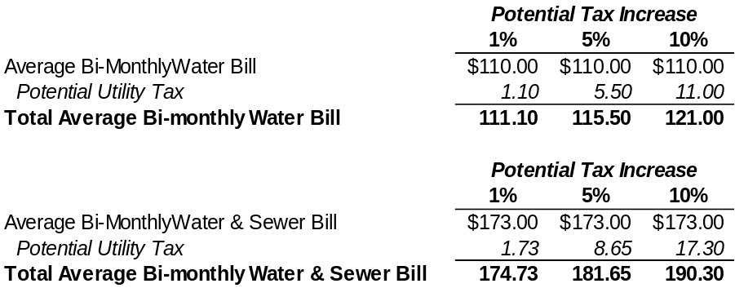

- Transient Occupancy Tax (TOT)
TOT is only paid by individuals staying in the various motels and hotels within the City. As with sales and utility user tax, a voter approved ballot measure would need to be approved to increase the transient occupancy tax (TOT). In California, the average TOT rate ranges from 10% to 12%. Currently, the Hesperia rate is 10%, which yields approximately $1.7 million annually of General Fund revenue. Should the voters approve an increase, the General Fund would gain approximate $170,000 for each additional percentage increase. For example, should the rate be increased to 11%, the General Fund revenue could potentially increase from $1.7 million to approximately $1.9 million; furthermore, a 12% TOT tax rate would increase General Fund revenue by $340,000 to $2.04 million.

Should consideration be given to increasing taxes, it is recommended that the City engage an outreach consultant. A consultant can assist with engaging the community on the potential increases ahead of the November 2024 election. This engagement will inform the community on the City’s existing budget and revenue as well as it will gather community input on priorities of the residents and help to gauge whether there is community support for a revenue measure. Through the community outreach, a determination can be made on the following key issues:
- Type of Tax
If a tax will be considered, a decision will need to be made on the type of tax (sales tax, utility user tax, or transient occupancy tax). Additionally, a determination will need to be made regarding the ballot measure’s indication of a general or special tax.
  - General tax can be used for any purpose determined by the Council and requires a majority (50% + 1) vote.
  - Special tax must be spent on uses specified in the ballot measure and requires a 2/3 (66.6%) vote.
- Amount of Increase
As demonstrated, there are potential options to the amount of tax. Through the outreach / community engagement process, the City is able receive information on citizen support of the amount (percentage) of taxes to be potentially levied. The following is a recap of identified potential tax increases:
  - Sales Taxes – Annual Increased Revenue
    - 1% Citywide - $12,900,000
    - 0.5% Citywide - $6,450,000
    - 1% Freeway & Bear Valley Corridor - $6,100,000
    - 0.5% Freeway & Bear Valley Corridor - $3,050,000
  - Utility User Tax – Approximately $300,000 in revenue for every 1% levied
  - Transient Occupancy Tax - Approximately $170,000 revenue for every 1% levied
    - Note – Hesperia current rate is 10% and state average is in between 10% and 12%.
Based upon the information presented above, to help meet important community needs, staff is seeking direction from the City Council on whether to move forward with a public outreach consultant to proceed with community engagement on potential tax increases. Staff would then report back to the City Council the results of the public engagement. At that time, the City Council may elect to place an initiative on the November 2024 ballot.

FISCAL IMPACT

Should the City Council choose to proceed with a public engagement consultant, the City will seek qualified/experienced consultants. It is estimated that such a consultant could cost between $50,000 to $100,000 depending on the number of outreach meetings, as wells as the detail of the public outreach.

Following the City’s purchasing ordinance, if costs exceed $50,000, a staff report will be presented to the City Council for approval. Furthermore, as this was not included in the Fiscal Year
2023-24 Operating Budget, a budget amendment would be presented to the City Council during the quarterly budget review.

ALTERNATIVE(S)

- Provide alternative direction to staff.

ATTACHMENT(S)

None

