Agenda Item #________
For Council Meeting of: April 21,2026

CITY OF SANTA ROSA
CITY COUNCIL

TO: MAYOR AND CITY COUNCIL
FROM: LORI ANN FARRELL, INTERIM CITY MANAGER
SCOTT WAGNER, CHIEF FINANCIAL OFFICER, FINANCE DEPARTMENT
SUBJECT: GENERAL FUND BUDGET STATUS AND UPDATE

AGENDA ACTION: STUDY SESSION

RECOMMENDATION

The Finance Department recommends that the City Council hold a Study Session regarding the Fiscal Year 2026-27 General Fund budget development process, actions taken to date, and the overall strategy in the upcoming fiscal year to address the City’s ongoing structural deficit. This item is presented for the Council’s information and no action is required. This item has no impact on current fiscal year budget.

EXECUTIVE SUMMARY

As previously reported, the Fiscal Year (FY) 2026-27 General Fund base budget for the fiscal year starting July 1, 2026, is currently projecting an estimated $17.5 million deficit. Projected General Fund expenditures and transfers, totaling $243.0 million for FY 2026-27, are expected to outpace General Fund revenue growth of $225.5 million. While the estimated General Fund base budget does not contain any significant enhancements, it does reflect fixed cost and contractually obligated increases, including: 1) A higher CalPERS’ annually required payment; 2) Increased public safety overtime funding to accurately align the budget with historic expenditures; and, 3) Previously negotiated cost-of-living adjustments to align employee compensation with comparable agencies in the region to better recruit and maintain a high quality workforce, among other items.

Further, the projected deficit includes the cost of certain positions previously supported by County and Federal grants whose funding will expire by June 30, 2026. While the City is not required to absorb these costs into the General Fund, the fiscal impact of these positions is currently reflected in the deficit calculation to indicate the potential cost to the City of continuing these positions without Federal or County funding.

City Council will review the City Manager’s Proposed Budget for FY 2026-27 in greater detail at the Study Sessions scheduled on May 5th and May 6th. Following this process, staff will present a budget for formal adoption on June 16, 2026.

GOAL

This item relates to Council Goal #1 - Achieve and Maintain Budgeting Excellence and Fiscal Stability through proactively managing pension liabilities.

BACKGROUND/PRIOR COUNCIL REVIEW

On June 18, 2024, FY 2024-25 budget was initially approved with a General Fund deficit of $13.3 million. The City has been impacted by a structural deficit caused by increased costs outpacing revenue growth. This structural deficit was projected to increase to $30.3 million by FY 2027-28 without intervention, making the deficit unsustainable in the short term.

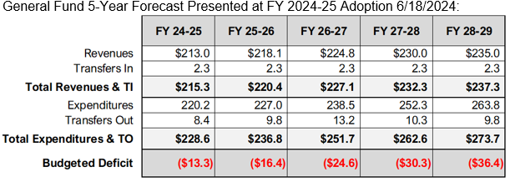

On August 6, 2024 the City Council introduced an ordinance to amend Chapter 3-28 of the Santa Rosa City Code to increase the Transient Occupancy Tax (TOT), paid by guests at hotels, motels, and other lodging establishments by two percent (2%), and approved a resolution ordering the submission of a ballot measure to seek voter approval of this ordinance at the November 5, 2024, General Municipal Election.

On August 6, 2024 the City Council introduced an ordinance to amend Chapter 6-04 of the City Code, entitled “General Business Tax” to increase the large business maximum tax to $10,000 annually, adjust business tax rates, and tax Short-Term Rental businesses, and approved a resolution ordering the submission of a ballot measure to seek voter approval of that ordinance at the November 5, 2024, General Municipal Election.

On November 5, 2024 voters passed ballot Measure EE to increase general business taxes and FF to increase the City’s TOT. The increased revenue from these changes resulted in actual collections exceeding the budgeted amount at adoption by $3.3 million for general business tax and $400,000 for the TOT.

On January 28, 2025, the City Council took mid-year actions to address the imbalance of the FY 2025-26 budget deficit of $13.3 million. Actions included reducing 13 full-time equivalent (FTE) positions that had ongoing budgetary savings of $4.0 million. Council additionally allocated $10.6 million in one-time funds from previously assigned projects to shore up the City’s reserves.

Prior to the FY 2025-26 budget development process, staff contracted with a firm, Alvarez & Marsal (A&M), to provide an independent validation of the City Long-Range Financial Forecast for the General Fund, and to evaluate the City’s annual budget process to provide insights into opportunities for improvement. A&M’s review found that the City’s General Fund financial model is a best practice and is more advanced than those used in other jurisdictions they have studied. Overall, the forecast methodology is sound; however, A&M noted that revenue forecasting should better align with actuals, notably that sales tax estimates should more closely align with actual sales tax revenue.

On June 17, 2025, the City Council approved $11.4 million in further budget reductions, which included eliminating 41 FTEs. Following these reductions, the Council adopted the FY 2025–26 budget with a remaining General Fund deficit of $8.4 million.

General Fund 5-Year Forecast after changes made during FY 2025-26 Adoption 6/17/2025:
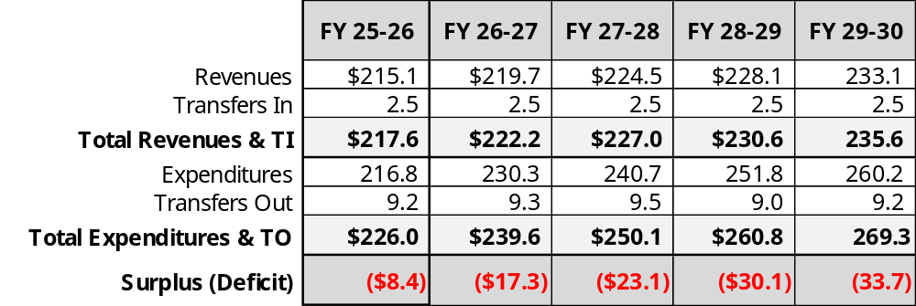

In short, the City has engaged in a multi-year strategy over the last two fiscal years to address the General Fund’s structural deficit, implementing $15.2 million in ongoing reductions, eliminating 54 FTE positions, and utilizing $10.2 million in one-time project funding to shore up reserves.
ANALYSIS

FY 2026-27 Deficit Reduction Strategy: A Two-Year Approach
The Fiscal Year 2026-27 General Fund base budget projects a $17.5 million deficit. This deficit is structural in nature, driven by expenditure growth (7.7%) outpacing revenue growth (3.6%). Projections indicate this structural deficit will continue to grow, with an additional $8 million increase expected in FY 2027-28 if no corrective action is taken.
While total revenues are projected to increase by $7.8 million to $222.9 million, expenditures are projected to increase by $16.7 million to a total of $233.6 million.
FY 2026-27 Base Budget General Fund Long Range Financial Forecast:
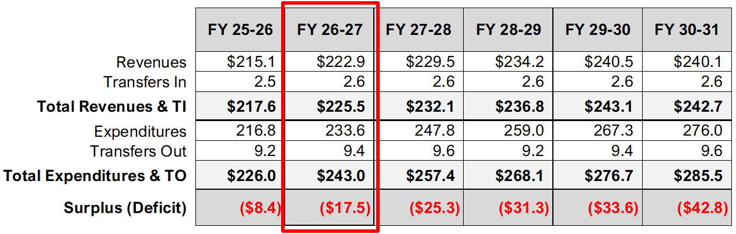
Two Year Strategy (FY 2026-2028)
Staff is recommending a two-year strategy to address the total deficit of $17.5 million. In Year One it is recommended to take a multi-pronged approach to address the deficit through: 1) partial use of reserves to avoid draconian cuts that negatively impact services; 2) eliminating/defunding vacant positions; 3) lowering pension costs through a new innovative pension cost smoothing strategy (aka Fresh Start Plus 115 Trust); and, 4) utilizing short term lease financing for major fleet and equipment purchases (i.e. valued over $250k) consistent with the useful life of the apparatus.
This multi-pronged approach results in the need for fewer reductions to departments and core public services. However, it does require that additional measures are taken in Year Two to address the remaining structural deficit, unless there is additional General Fund revenue to offset those costs. As such, Year One will include:
- Departmental Reductions (FY 2026-27 or Year 1): Departments were asked to develop 1% and 3% reduction plans, including the elimination or defunding of certain vacant positions, and other targeted cuts resulting in over $4.0 million in savings.
- Capital Lease Strategy: Shifting future major apparatus purchases to a lease financing program will smooth out payments and generate $1.0 million in ongoing budget savings.
- Use of Reserves: The strategy utilizes $8.0 million in reserves, matching the adopted deficit amount from FY 2025-26.
- Pension Savings: The City will present a Study Session to City Council also on April 21st on an innovative program combining the Fresh Start initiative and the usage of the Pension Stability 115 trust to lower pension costs by $3.8 million.

Year Two Plan (FY 2027-28):
Department Reductions (FY 2027-28 or Year 2) - Departments were also asked to develop 8% reduction plans to address the ongoing structural deficit in Year 2 if there is no additional General Fund revenue in FY 2027-28 to fully fund all General Fund costs. These impacts will be reviewed in further detail during the Budget Study Sessions scheduled for May 5th and May 6th.
While the City Manager’s formal Proposed Budget for the fiscal year beginning July 1, 2026, that will be presented to the City Council for adoption on June 16, 2026, will not include anticipated Year Two departmental cuts, it is imperative that there is a transparent and thorough discussion of the potential impacts to core public services if additional General Fund revenue is not generated to address these out-year shortfalls.
FISCAL IMPACT

This Study Session has no direct impact on budgets as no formal action is to be taken.

ENVIRONMENTAL IMPACT

The recommended action does not constitute a project under the California Environmental Quality Act (CEQA) pursuant to CEQA Guidelines Section 15378(b)(5), as it involves an organizational or administrative activity of government that will not result in a direct or reasonably foreseeable indirect physical change in the environment. In the alternative, the recommended action is exempt from CEQA pursuant to CEQA Guidelines section 15061(b)(3) because it can be seen with certainty that there is no possibility that the recommended action may have a significant effect on the environment.

BOARD/COMMISSION/COMMITTEE REVIEW AND RECOMMENDATIONS

This Study Session was previously considered by the Long-Term Financial Planning and Audit Subcommittee on April 9, 2026, and recommended for City Council Review.

NOTIFICATION

Not applicable.
ATTACHMENTS

- Presentation

PRESENTER(S)

Scott Wagner, Chief Financial Officer, Finance Department

