ATTACHMENT 1

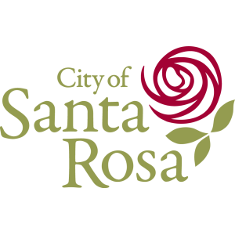
City of Santa Rosa
City Council Priority Setting Workshop
Held February 24, 2022
March 2022

Table of Contents
Workshop Report 1
Workshop Overview 1
Opening Comments 3
Ice-breaker Exercise 4
Review Accomplishments 5
Reflect on the City’s Mission, Vision and Values 7
Establish Goals and Strategies 11
Discuss Working Together to Achieve Results 15
Wrap up and Next Steps 17
Attachment – Workshop Evaluation 19

Workshop Report
The City of Santa Rosa held a City Council workshop on Thursday, February 24, 2022 from 8:30 a.m. to 5 p.m. at the Utilities Field Operation Building. The workshop provided an opportunity for Councilmembers to set intentions for the organization’s focus of time and limited resources for the upcoming year. This report contains a summary of the results of the goal setting session.
Nancy Hetrick, Vice President for Management Partners, facilitated the workshop. Ashley Garcia, Principal Management Analyst, assisted and served as recorder.

Workshop Overview

Objectives
- Affirm the City’s mission, vision, and values
- Establish strategic goals and direction for FY 2022-23
- Define expectations and methods for regular updates on Council priorities.

Participants
City Council
- Mayor Chris Rogers
- Vice Mayor Eddie Alvarez
- Councilmember John Sawyer
- Councilmember Dianna MacDonald
- Councilmember Victoria Fleming
- Councilmember Tom Schwedhelm
- Councilmember Natalie Rogers
Staff
- City Manager Maraskeshia Smith
- Assistant City Manager/Operations and Transportation Jason Nutt
- Interim Assistant City Manager/Community Development and Engagement Director Clare Hartman
- Chief Financial Officer Alan Alton
- City Attorney Sue Gallagher
- City Clerk Stephanie Williams
- Police Chief Ray Navarro
- Police Captain John Cregan
- Fire Chief Scott Westrope
- Director of Human Resources Amy Reeve
- Director of Water Jennifer Burke
- Director of Housing and Community Services Megan Basinger
- Interim Chief Information Officer and Director of Information Technology Brian Tickner
- Communications Coordinator Elise Miller

Agenda
- Welcome and call to order by the Mayor
- Public comment
- City Manager’s remarks
- Review financial outlook and accomplishments
- Reflect on the City’s mission, vision, and values
- Establish goals and strategies
- Discuss working together to achieve results
- Wrap up and next steps

Workshop Ground Rules
At the start of the workshop, Nancy suggested the following ground rules to help the group have a successful workshop.

- Listen to understand each other’s point of view
- Assume good intent
- Speak up if we need course correction
- Seek consensus
- Stay focused

Bike Rack. Nancy explained that if items were brought up that could not receive immediate attention, they would be added to a “bike rack.” The following items were added.
- Create a visual list to help Council acknowledge non-priority requests,
- Discuss the role of Council-appointed committees and commissions,
- Operationalize values and goals for accountability (measurable),
- Take action on the Council’s declaration of racism as a public health crisis,
- Consider a manufactured homes ordinance,
- Pursue annexation opportunities, and
- Utilize study sessions for policy consideration.

Opening Comments

Mayor Rogers
Mayor Rogers convened the City Council meeting and asked for the roll call. The Mayor welcomed everyone and thanked Councilmembers for attending. He noted that the purpose of the day’s discussions was to meet as a team to discuss the vision for what they want to accomplish for the City of Santa Rosa. He noted that this was a critical tool for the City Council and department heads to focus attention and resources. Mayor Rogers then opened the session to public comments.


City Manager Smith
City Manager Maraskeshia Smith offered opening remarks. She shared how proud she is of Team Santa Rosa because they continue to deliver an exceptional level of customer service in spite of circumstances. She expressed that through ongoing disasters, members of the organization remain steadfast and resilient. She mentioned that the City is at a turning point progressing toward a full recovery, and that staffs’ bandwidth is limited.
City Manager Smith expressed her interest to balance core services, operationalize one-time funding and utilize innovation to drive a philosophy of high performance. She highlighted the need for intentional and deliberate goal setting. She stated that the City must get back to the basics and increase the use of metrics for deploying limited resources and achieving performance excellence. She thanked staff for a job well done and stressed the desire to move Santa Rosa forward.

Ice-breaker Exercise

High Performing Organization
The facilitators began the workshop with an ice-breaker exercise. Participants provided feedback about what “high performing organization” means to them. The results of this activity are shown below.
High performing organization defined…
- Goals and priorities align with staffing capacity
- Freedom to innovate
- Well-defined organizational structure
- Remove silos
- Collaborative
- Adaptable
- Appreciate and support staff
- A good place to work
- Clarity of objectives
- Long-term plans
- Strategic in action
- Move in the same direction
- Proactive
- Anticipate community needs
- Customer service orientation
- Exceed expectations

Review Accomplishments
Chief Financial Officer (CFO) Alton briefly reviewed the City’s financial outlook. Assistant City Manager Nutt highlighted major accomplishments by department over the past year (a handout was provided). The City Council and staff reflected on the accomplishments.
Following the presentation, participants were invited to add additional accomplishments they wanted to acknowlege. Those are listed below.
- Implementing the water demand offset fee,
- Moving county offices downtown,
- Purchasing equipment to increase efficiency (asphalt equipment),
- Council cooperation/cohesiveness,
- Prioritizing funds (using staff recommendations),
- Legislative advocacy, and
- Responding to social service needs (inRESPONSE, childcare).
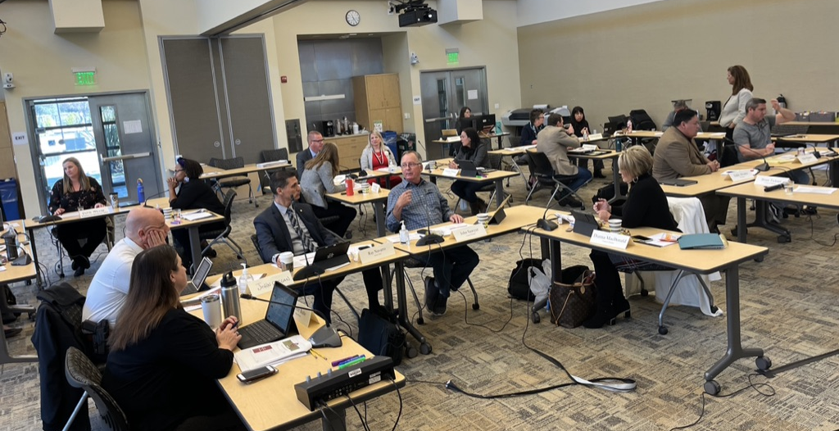
Nancy posed two discussion questions to small groups to reflect on and report back to the larger group. The groups identified the following factors contributing to the success of the organization.

What contributes to our success?
- Clarity
- Strong and engaged City Council
- Experienced, engaged, motivated leadership team
- Being adaptable
- Dedicated employees
- Collaboration
- Community engagement
- Applying an equity lens
- Communication
- Making progress addressing homelessness issues
- Integrating DEI into all that we do; reflecting the community we serve
- Having our city manager, Councilmember, other key roles filled
- Putting the City first (even with districts)
- High quality presentations for city council decision-making

The following were identified as factors that can get in the way.

What gets in the way of our success?
- “Shiny object syndrome”
- Overwhelm creating silos
- Great resignation/retention of staff
- Staying on the hamster wheel – being reactive rather than strategic
- Lack of metrics
- When we’re not adaptable; resistance to change
- Funding
- Limited staff capacity
- Uninformed community; insufficient access to information
- Forgetting to celebrate success

Reflect on the City’s Mission, Vision and Values
Following a short break, the topic shifted to strategic planning and discussion of the City’s mission, vision, and values. This portion of the agenda began with a short ice-breaker activity.

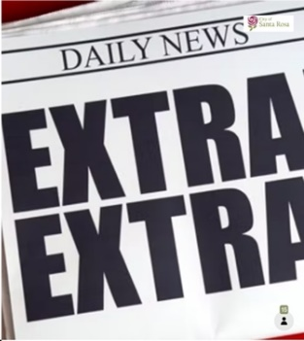
Headline Exercise
Participants were invited to participate in the ice breaker using a feedback tool, Mentimeter, to reflect on their hopes for the City by writing a headline they would like to see in the paper/ online in five years. The individual responses scrolled across the screen at the front of the room as they were submitted. Below are the headlines submitted by participants.
- Santa Rosa reaches 2030 climate goals 3 years early
- Santa Rosa values and supports all parts of the community and finally lifts up those who have been marginalized and silenced
- Santa Rosa the #1 place to live, work and play in the USA
- John Sawyer elected to 7th term
- Why should you move to Santa Rosa? Vibrant, safe, inclusive
- City opens Roseland Community Center
- 12-story building in Downtown Santa Rosa ready for occupancy
- Santa Rosa voted #1 Inclusive City in the World
- Santa Rosa ends homelessness!
- Most cutting-edge city in California attracts working families across state. Becomes statewide economic engine.
- City of Santa Rosa Leads the Way Across the Board
- City of Santa Rosa Transforms Mental Health Response
- Santa Rosa infrastructure receives an A Grade
- Santa Rosa voted #1 city to live, work, play!
- Santa Rosa. Best. City. Ever!

Mission
Nancy reviewed the existing mission of Santa Rosa, which was affirmed by the group.
To provide high-quality public services and cultivate
a vibrant, resilient and livable City.

Vision
Nancy then reviewed the existing vision of Santa Rosa, which was affirmed by the group.
Santa Rosa – Leading the North Bay
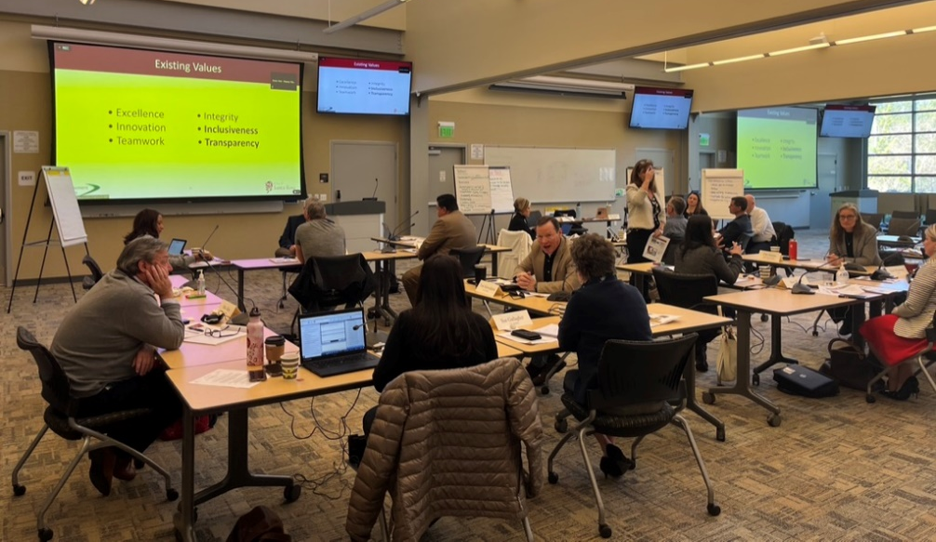

Values
Next was a discussion about organizational values. Nancy identified values specifically mentioned during Council interviews.
- Transparency
- Diversity, Equity and Inclusion
- Applying an Environmental Lens (Sustainability)
- Engagement
These overlapped with the City’s existing values as listed below.
- Excellence
- Innovation
- Teamwork
- Integrity
- Inclusiveness
- Transparency
In small groups, participants discussed the desired mix of values, how they look in practice, and how they can be integrated and promoted in all the City does.
Key themes from the values discussion are presented below.
Potential Key Core Values
- Sustainability – both an environmental and fiscal focus
- Resilience
- Integrity – the “golden rule;” using an ethical approach
- Inclusiveness
  - Broaden to be Diversity, Equity and Inclusion + Belonging
  - Define our “why”
- Environment, Equity, Economy (the three Es)
- Engagement
- Customer service
- Teamwork – collaboration
- Transparency

Operationalize the Values
- Provide focus
- Universal
  - Resonate with Council, staff, and the community
  - Integrate into City culture
  - Align with personal values
- Accountability and performance metrics
  - Evaluate for values/organizational competencies
- Communicate values to the community
  - Define on website (clarity)
  - Make them accessible
  - Keep it simple
  - Memorable
- Consider using an acronym to make it memorable (e.g., R.O.S.E. or R.O.S.A. acronym) (need to be aware of translation limitations)
  - Resilience
  - Opportunity
  - Sustainability
  - Equity, economy, etc.; or Accountability

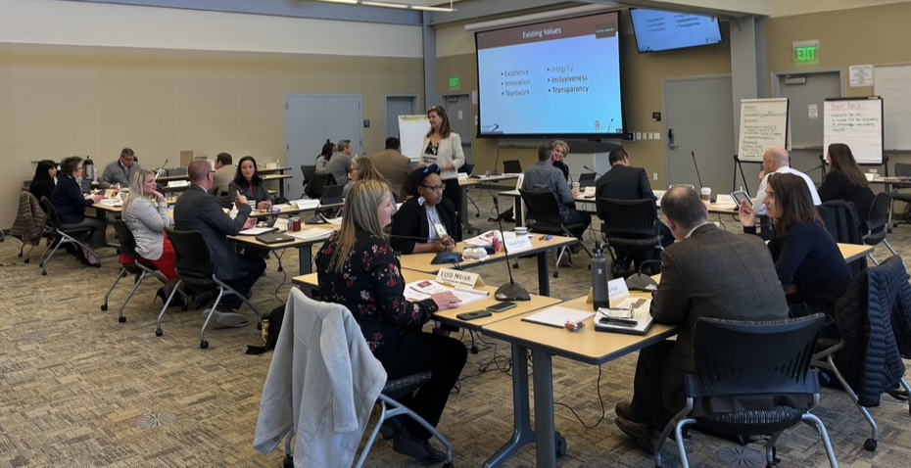

Establish Goals and Strategies
Following a lunch break, the group reconvened for the goal-setting portion of the workshop. Nancy began by reviewing the themes heard during individual Council interviews, which are listed below.

- Pursue housing for all
- Address issues and causes of homelessness
- Strengthen organizational effectiveness
- Facilitate economic development (i.e., business support, community investment, vibrant downtown)
- Maintain infrastructure
- Ensure public safety using modern practices
- Promote community resilience (including childcare)
- Apply an environmental lens in all we do
- Foster an engaged and connected community
- Embrace diversity, equity, and inclusion as a core value

Using the Strategic Plan framework, the facilitator provided a definition for goals. Goals provide direction and focus of the organization, including resource decisions; are multi-year in nature; and are achieved through a range of strategies.
Participants reviewed and discussed proposed goals along with potential strategies. Below is the agreed upon set of City Council goals. These reflect the changes discussed and affirmed during the workshop. There was agreement by Council that these goals should last longer than one year.
Council Goals
- Deliver housing for all
Pursue housing options for residents of all income levels

- Reduce homelessness and its impacts
Partner with key stakeholders to offer housing and support services to the unsheltered and address the issues and causes of homelessness

- Ensure a healthy and safe community for all
Ensure the public’s safety by engaging residents and using a broad range of proactive approaches

- Promote economic and community vibrancy
Sustain and develop a diverse and thriving economy that benefits Santa Rosa residents and businesses and contributes to the community’s economic health

- Build and maintain sustainable infrastructure
Invest in and maintain infrastructure that supports environmental sustainability and supports a vibrant City

- Achieve organizational excellence
Create a high performing organization that is proactive; fiscally sound; promotes diversity, equity, and inclusion; and reliably delivers outstanding services to the community
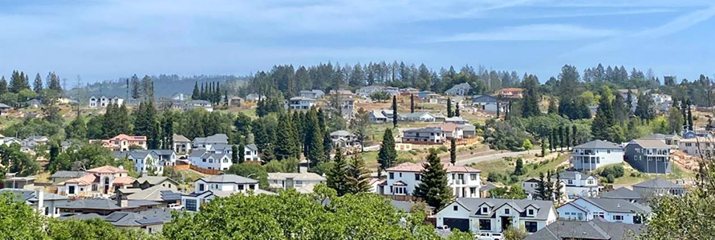
Potential strategies are presented on the following pages. Refinements made by Councilmembers during the workshop are noted in red font. The City Manager and her team will use these potential strategies as they evaluate available resources and develop a proposed budget and workplan for the coming year. The City Council will have an opportunity to affirm the plan for the next year.

FY 2022-23 City Council Goals and Potential Strategies
Strategic Goal | Potential Strategies
Deliver Housing for all  Pursue housing options for residents of all income levels | - Update the City’s Housing Action Plan  - Reduce barriers to ownership and access to housing opportunities through education, awareness, and financial assistance  - Encourage higher density housing development in the downtown, expand housing stock options  - Encourage innovation in achieving increased inclusionary housing  - Streamline the approval process; be nimble and quick  - Consider annexation opportunities
Reduce Homelessness and its Impacts  Partner with key stakeholders to offer housing and support services to the unsheltered and address the issues and causes of homelessness | - Maintain the City’s commitment to the Housing First Strategy in partnership with the Sonoma County Continuum of Care (Home Sonoma County)  - Fund programs that enable emergency shelter and deliver wrap-around services to assist people experiencing homelessness  - Support temporary housing options like the Safe Parking Pilot Program  - Invest in prevention and intervention programs to prevent vulnerable individuals from becoming homeless  - Improve and expand coordinated outreach and engagement (i.e., Homeless Outreach Services Team, Downtown Enforcement Team)  - Use a compassionate approach to address the health, safety and shelter needs of those living in encampments and ease the impacts on surrounding communities  - Rely on evidence-based or best practices
Ensure a Healthy and Safe Community for All  Ensure the public’s safety by engaging residents and using a broad range of proactive approaches | - Increase community partnerships and engagement, using an equity lens  - Utilize data-driven strategies and tactics to deploy resources and reduce crime  - Engage neighborhoods  - Develop and implement strategies for mental health response  - Invest in prevention and intervention programs  - Implement the Fire Resiliency and Response Strategic Plan
Promote Economic and Community Vibrancy  Sustain and develop a diverse and thriving economy that benefits Santa Rosa residents and businesses and contributes to the community’s economic health | - Retain, attract, and expand businesses citywide  - Develop business incentives and tools for underserved neighborhoods  - Promote open dialogue with education partners  - Engage private employers and the business community in workforce development and job placement  - Support and engage local businesses and workers  - Establish Santa Rosa as a desired destination for business  - Create spaces for residents to gather, learn and connect  - Support access to childcare, including preschool and early childhood support and recreational and summer camp programming  - Encourage public-private partnerships
Build and Maintain Sustainable Infrastructure  Invest in and maintain infrastructure that supports environmental sustainability and supports a vibrant City | - Be responsive and competent stewards of public infrastructure and the environment  - Identify and implement strategies to achieve carbon neutrality by 2030  - Establish policies that support environmental sustainability in building and infrastructure investment to facilitate carbon neutrality (electric fleet, bikeways, SWOT analysis of PG&E independence)  - Safeguard the City’s assets by anticipating, planning, and allocating resources for infrastructure upgrades and replacement as needed (i.e., set a policy threshold for desired Pavement Condition Index)  - Educate the public about water usage impacts and long-term water-saving strategies to meet conservation goals  - Develop strategies that allow multi-modal improvements to reduce reliance on vehicles  - Complete solid waste system improvements (engage businesses)  - Adopt Climate Action Plan update  - Finalize the Roseland Creek Community Park Master Plan
Achieve Organizational Excellence  Create a high performing organization that is proactive; fiscally sound; promotes diversity, equity and inclusion; and reliably delivers outstanding services to the community | - Sustain fiscal health by maintaining reserves, forecasting and monitoring expenditures and revenues, and creatively leveraging other funding sources  - Plan for asset and technology maintenance needs (i.e., streets, facilities, technology, capital assets, adjust facilities for gender accommodation, include supporting cost for public safety, such as recreation, sheltering, water, building safety, etc.)  - Utilize data-driven strategies and tactics  - Implement process improvements and best practices that prioritize customer experience (i.e., multilingual approach to website as the portal to the City)  - Invest in staff training and professional development  - Create a culture of that cultivates diversity, equity, inclusion, safety and belonging  - Optimize organization structure to strengthen teamwork through interdepartmental collaboration to deliver results

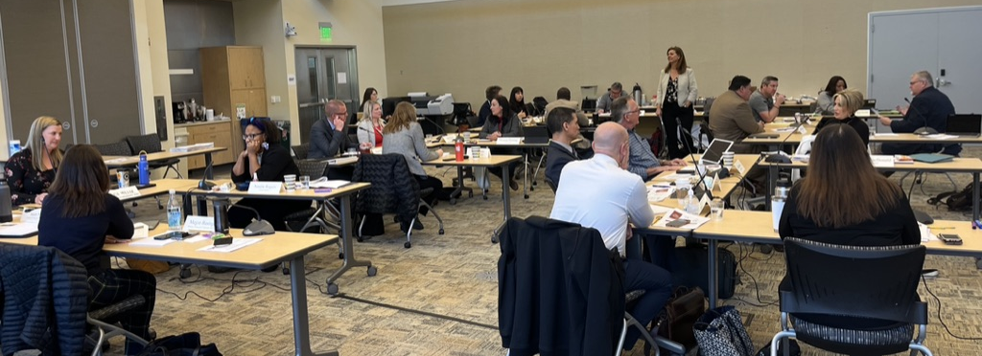

Discuss Working Together to Achieve Results
Nancy reiterated that working together is a team sport with specific roles. Council sets policy; staff implements. Participants discussed what the City Council needs from the City Manager and staff to feel informed and prepared and what the City Manager and staff need from City Council to be most successful in achieving results. A summary of the discussion is below.

City Council needs from Staff
- Clear flow of information/timelines (facilitate constituent services, district-specific),
- Realistic cautions about policies in development,
- Keep apprised of “add to bucket” impacts on staff capacity,
- Awareness of fiscal/staff impacts of alternative decisions,
- No surprises, and
- Keep informed about staff departures and staff successes.

Staff needs from City Council
- Trust,
- Listen to staff needs,
- Drive policy,
- Communicate,
- Support initiatives/alignment, and
- Appreciate staff work.

Updates and Communication
A discussion was held about preferred methods of communication between Council and staff. Below is a summary of the items discussed.

City Councilmembers complimented the following methods of communication and would like them to continue.
- Regular, good communication, access to staff,
- Staff reports are thorough (questions, presentations),
- City Clerk’s Office is helpful with transparency, and
- Event promotion in specific districts (representative focus is going well).

The following ideas were presented to improve communication.
- Provide a data dashboard on the website (for example, showing rebuild numbers),
- Be sure to include new Councilmember MacDonald on all communications,
- Prepare bullet point takeaways from committee meeting report outs,
- Provide talking points for status updates, and
- Provide open and honest feedback.

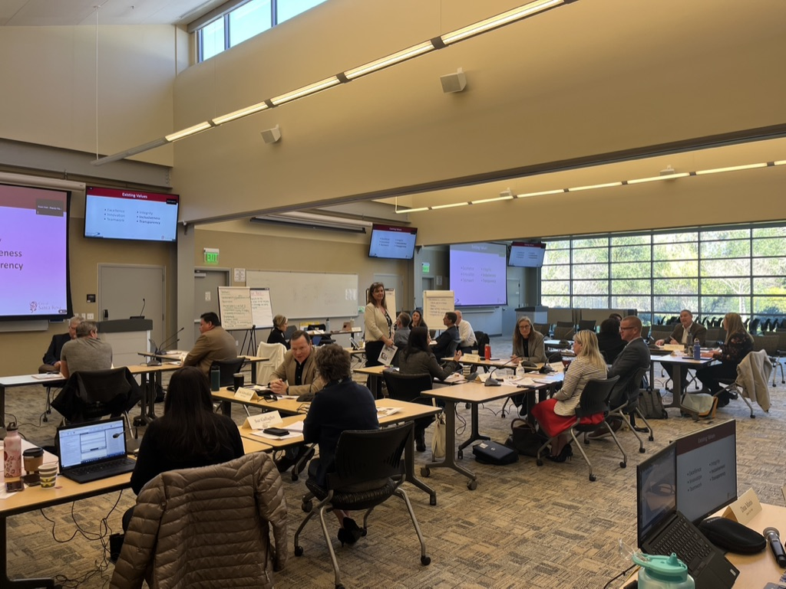

Wrap up and Next Steps

Recap
A recap of the goals discussion emphasized that goals are multi-year in nature. Prioritizing strategies and initiatives will occur when staff returns to Council with the report.

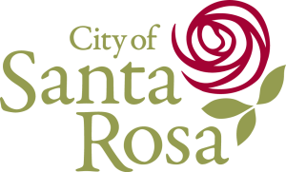
Closing Comments
Councilmembers and staff spent time reflecting on their key takeaways from the workshop. The comments offered are listed below.
- Do we have enough resources and staff capacity to accomplish all of these goals?
- Ensure health and safety for all.
- Council sets aspirational goals and staff will return with what they can accomplish this year.
- Staff will evaluate workplans to implement goals and strategies, while incorporating core services and delivery timelines.
- Study sessions and staff reports can also be used to guide policy direction on specific items.

Additional final thoughts that were offered to conclude the workshop are listed below.

- We are a team that is already going in the same direction,
- Missed the dot exercise,
- Prioritization/policy direction,
- Thank you for all the hard work, and
- Staff dedication to the community is appreciated.

Overall, participants expressed the value of being together face-to-face for the workshop and were grateful for a collaborative and productive day. A summary of the workshop evaluations is included as an attachment.
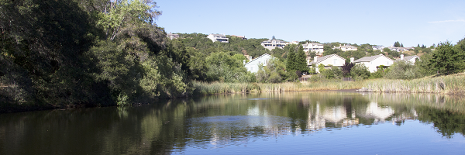

Next Steps
This report will be used by the City Manager and Executive Team to build the workplan and establish metrics to measure success. The intent is for the City Council to affirm and adopt the strategic goals and strategies identified during the workshop.

Attachment – Workshop Evaluation
At the end of the workshop participants were asked to complete a workshop evaluation form. The following responses are a compilation of answers from fifteen of the workshop participants.

Overall usefulness of the workshop (4.69 average score)
Not Useful Very Useful
1 2 3 4 5

Overall quality of the workshop (4.75 average score)
Poor Quality High Quality
1 2 3 4 5

The best thing about this session was...
Participants valued the interactive nature of the workshop and that it provided an opportunity for both Council and staff to participate with open and free dialogue. One respondent shared that the willingness to be transparent with each other builds trust.
Some things that could have been better...
Two respondents noted core services could have been emphasized better. Others wished for more time to prioritize the goals and a room arrangement that allowed for the group to face one another.
What elements of the session will be most useful to you?
Most respondents said that establishing high-level Council goals and the strategy discussion are the most useful takeaways. Others said that the workshop enabled Council and staff to both be “on the same page” to clarify expectations.
I’m glad that the facilitators…
Participants complimented the facilitators on their positive and friendly demeanor. They appreciated that the facilitators helped move the conversation forward and worked to clarify any confusion. Providing space for everyone’s comments and capturing detailed notes was helpful.
I wish the facilitators would have…
Most respondents did not feel there was anything to improve. One wish was that the facilitators would have been more direct about the definition of goals and strategies. Another was to incorporate more fun Mentimeter exercises in the afternoon when energy wanes.
Other Comments…
Some participants noted that the energy of the workshop was higher in the morning than in the afternoon. Some mentioned they were ok not having dot voting, while others missed it.

